**ASSIGNMENT – 15.1**

PROBLEM STATEMENT:

Perform wordcount operation in local mode (In windows environment). Share the code, explain the execution steps, and attach the output screenshot.

PROGRAM :

**DRIVER CLASS:**

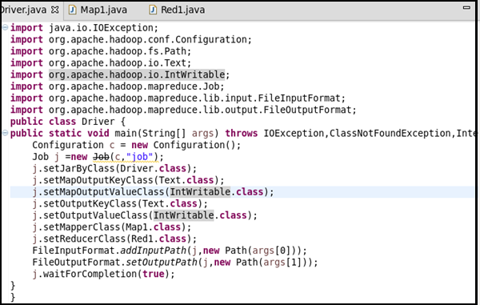

**MAPPER CLASS :**

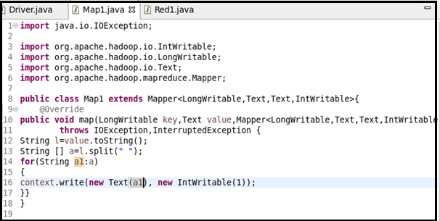

**REDUCER CLASS :**

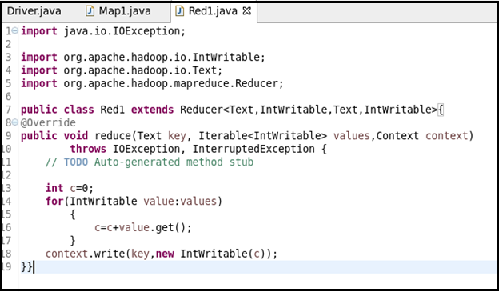

**RUNNING JAR FILE:**

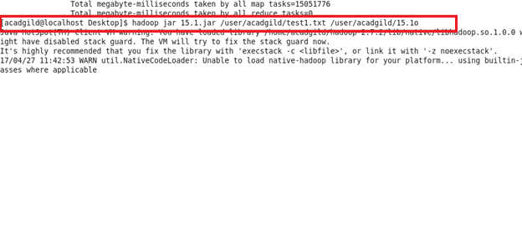

**RESULT:**

