**ASSIGNMENT – 15.4**

**Build and Deploy Hadoop word count program using Maven :**

I am creating a Maven Project named Hadoop and in the src/main/java folder, I am creating the Wordcount class. Also I am attaching the WordCount.java and pom.xml files for your reference.

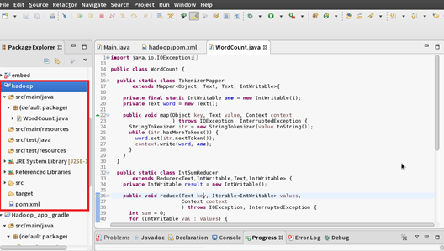

**Tree Diagram: After Creating the maven project the pom.xml file is created**

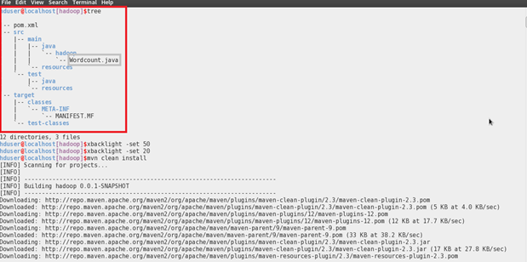

**Adding the dependencies to the Pom.xml:**

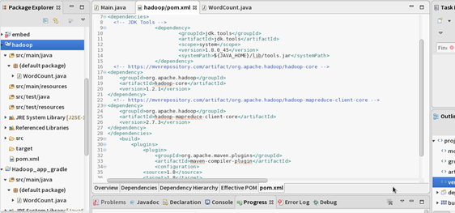

**Building the project by giving the mvn clean install in the project folder:**

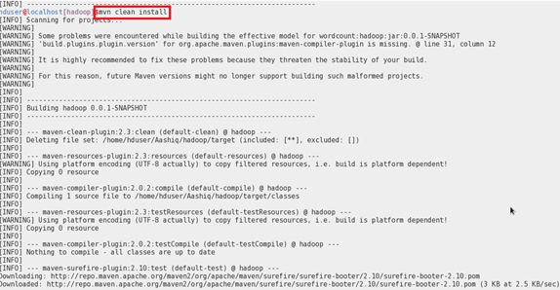

**Project successfully build message:**

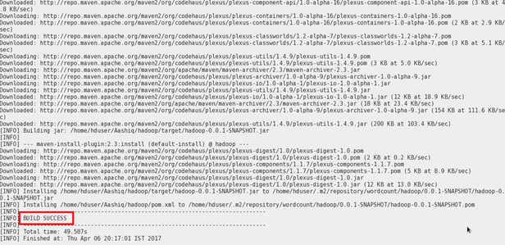

**Snapshot.jar file created after the Build:**

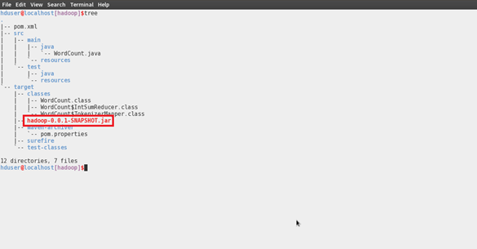

**Running the Snapshot.jar file:**

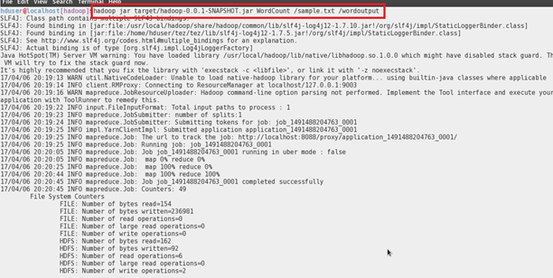

**WordCount Output:**

