**ASSIGNMENT – 16.1**

**PROBLEM STATEMENT :**

Using Distributed cache join the two datasets and find out the number of temperature variations in each country using mapreduce.

Building.csv – BuildingID, BuildingMgr, BuildingAge, HVACproduct,Country

HVAC.csv – Date, Time, TargetTemp, ActualTemp, System, SystemAge, BuildingID

PROGRAM:

**DRIVER CLASS :**

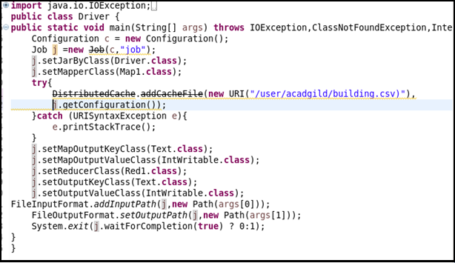

**MAPPER CLASS :**



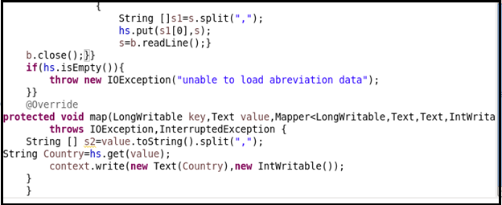

**REDUCER CLASS :**



**OUTPUT:**

