**ASSIGNMENT – 16.2**

1. Use reduce side join to join the two datasets and find what kind of problems are prevalent, and in which state?

**DRIVER CLASS :**

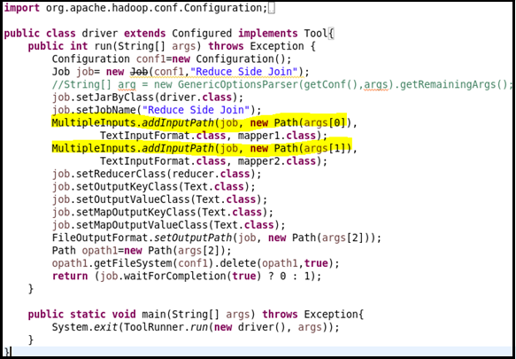

**MAPPER CLASS 1:**

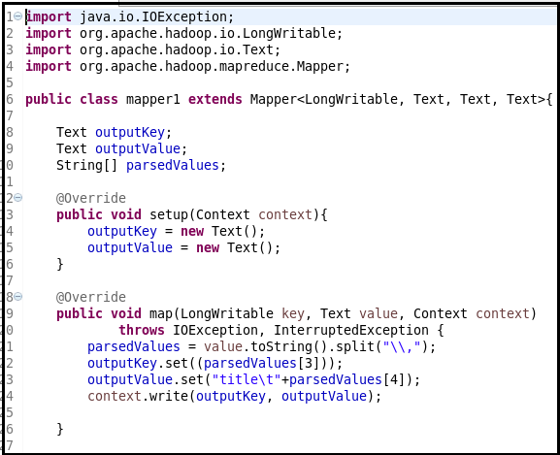

**MAPPER CLASS 2:**

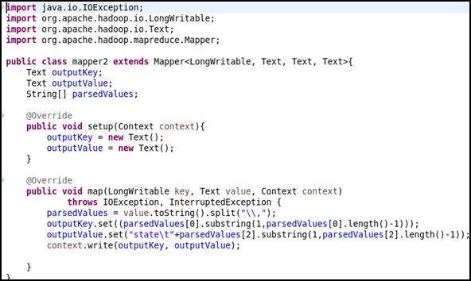

**REDUCER CLASS :**

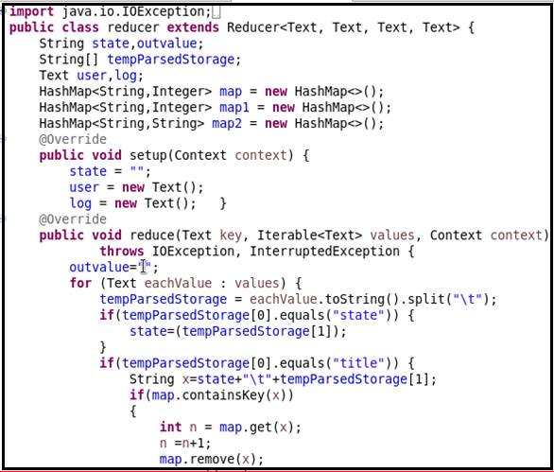

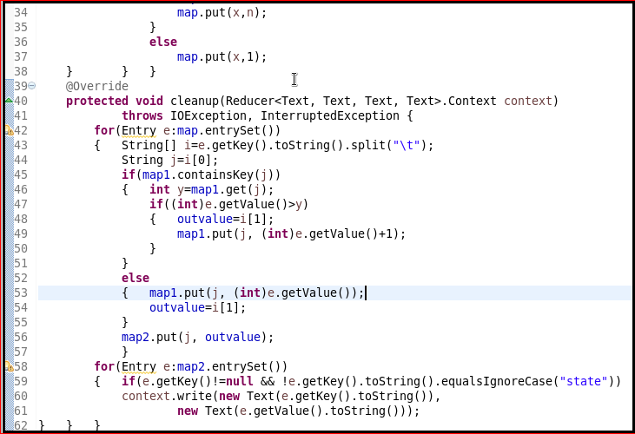

**RUNNING JAR :**

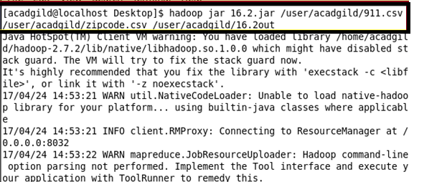

**OUTPUT :**

