**ASSIGNMENT – 16.3**

1. Execute Session 16 - Assignment 1 (Machine and Sensor data analysis) using Reduce side join and compare which join is faster in normal conditions.

**DRIVER CLASS :**

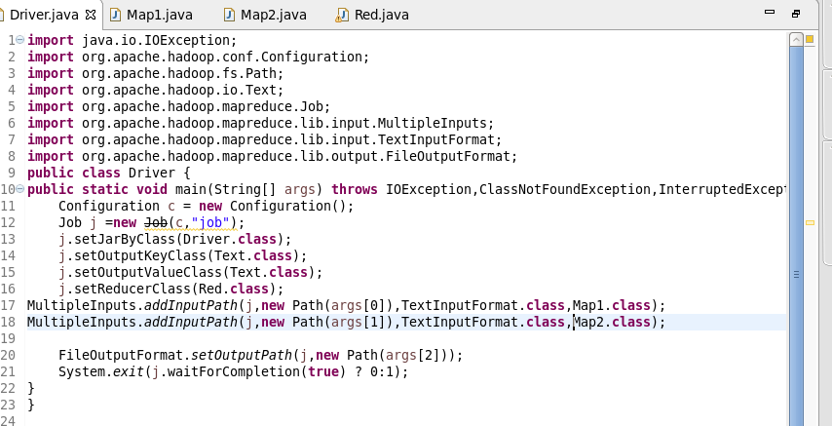

**MAPPER CLASS 1 :**



**MAPPER CLASS 2 :**

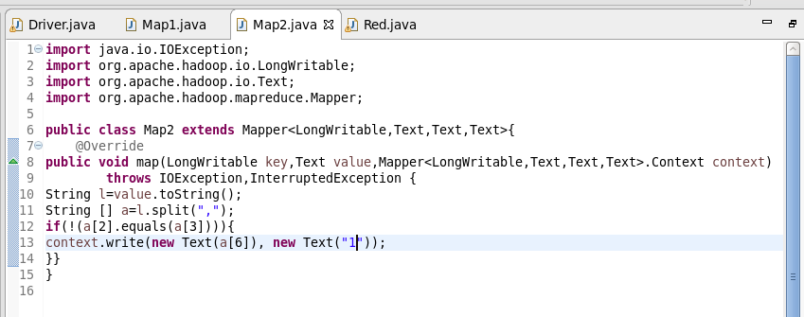

**REDUCER CLASS :**

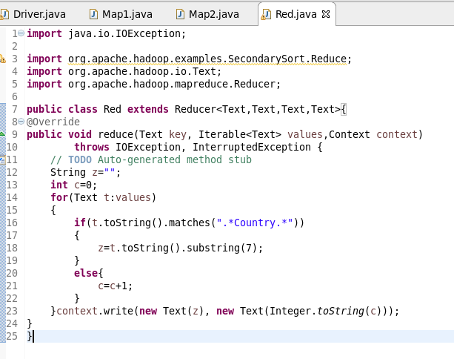

**RUNNING JAR :**

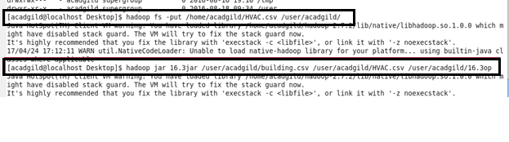

**OUTPUT :**

