**ASSIGNMENT -16.4**

**Problem statement :**

Write a mapreduce program use map side join to join the two datasets and find What kind of problems are prevalent, and in which state?

**DRIVER CLASS :**

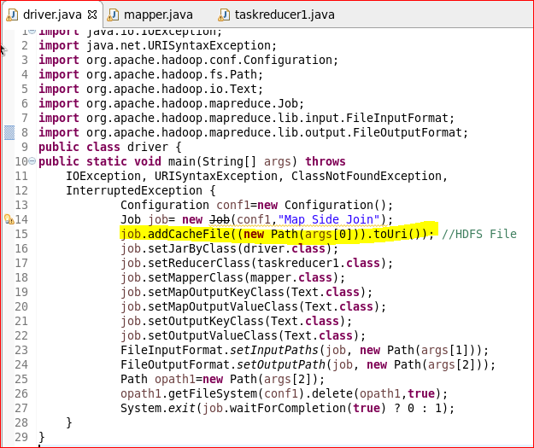

**MAPPER CLASS :**

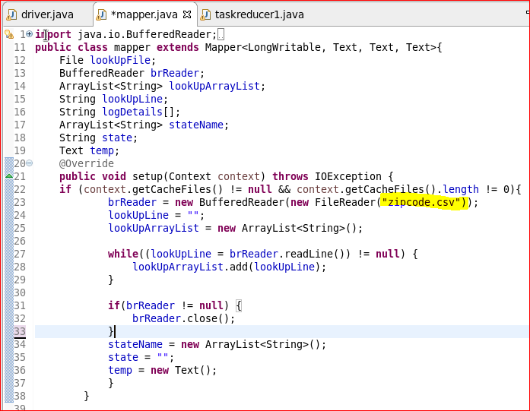

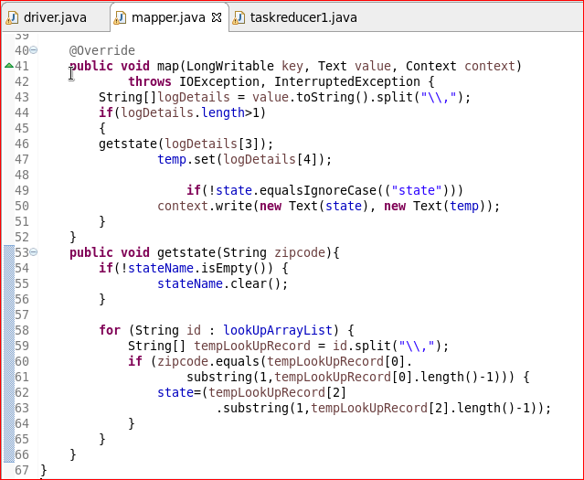

**REDUCER CLASS :**

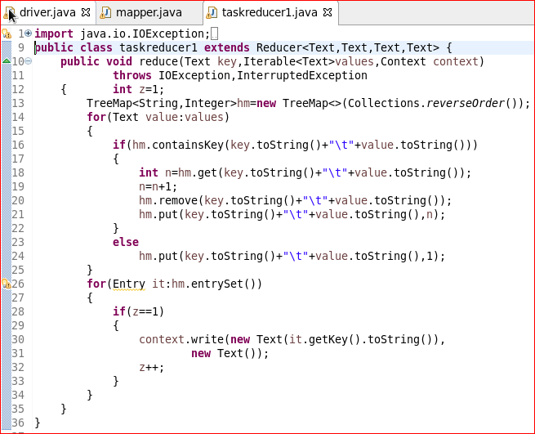

**RUNNING JAR :**

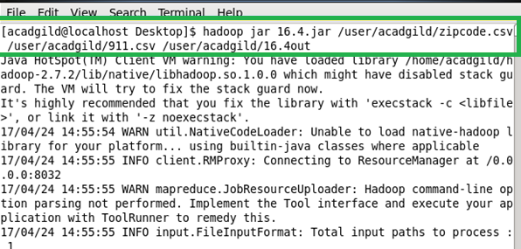

**OUTPUT :**

