**ASSIGNMENT – 16.6**

1. Write a map reduce program to join the below given two datasets using Reducer side join.

**DRIVER :**

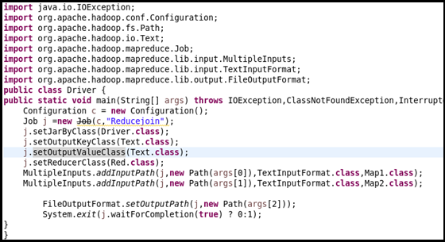

**Mapper class 1:**

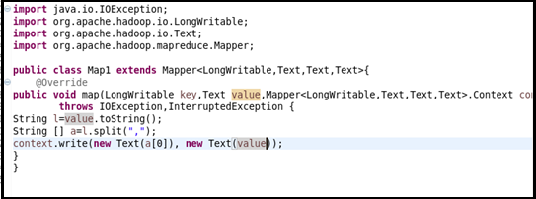

**Mapper class 2:**

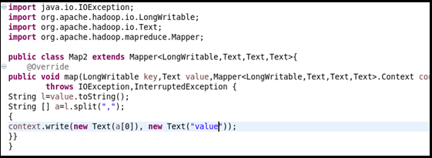

**Reducer class:**

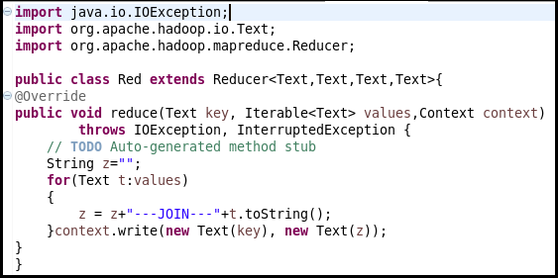

**Running jar :**

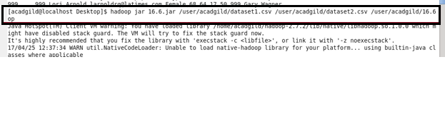

**Output:**



