**ASSIGNMENT - 17.1**

1. A program that accepts the job id as argument and returns a custom counter and a system counter (total records input to the map tasks) associated with that job.

Running job using custom counter :

History server User Interface:

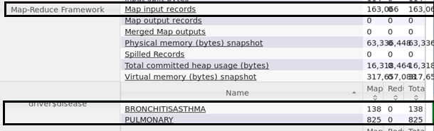

From Terminal:

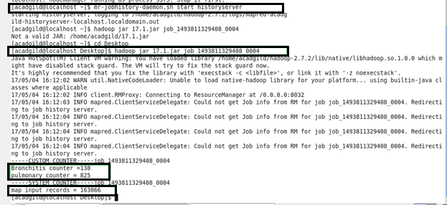

We can see that for the job id 1493811329408_0004 there is 138 **Bronchitis** counter and 825 **Pulmonary** counter for 163066 map input records.

**Find counter class :**

The code below is used to display the custom counter and system counter for the corresponding job id 1493811329408_0004.

