**ASSIGNMENT – 17.2**

Write a secondary sort program to generate the top 2 maximum temperatures corresponding to every year from the temperature dataset.

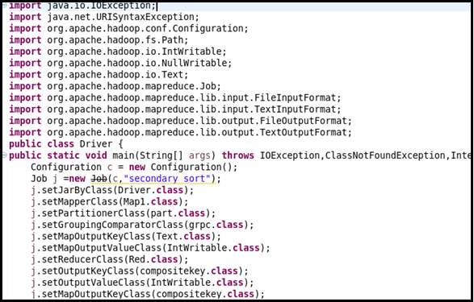

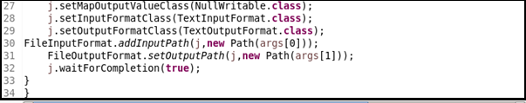

In DRIVER class, setting MAPPER CLASS,PARTITIONER CLASS, GROUP COMPARATOR CLASS , COMPOSITE KEY CLASS as MAP OUTPUT CLASS, REDUCER CLASS.

**MAPPER CLASS :**

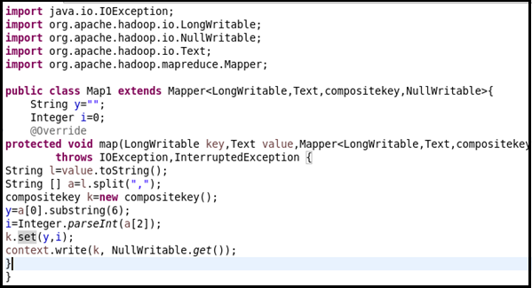

Here, In mapper class splitting the data by comma and then sending compositekey as key and value as nullwritable.

**COMPOSITE KEY CLASS :** 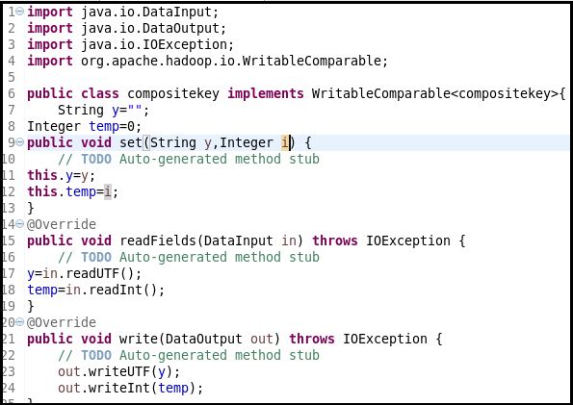

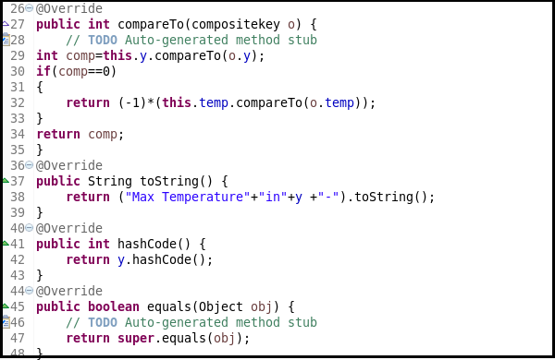

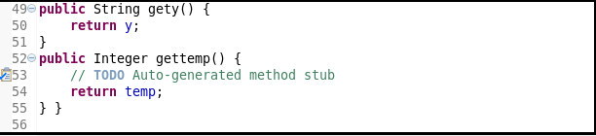

**PARTITION CLASS :**

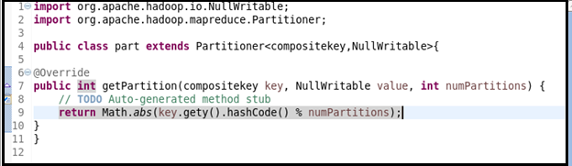

Here, in partition class sending the key-value pair from mapper to reducer.

**GROUP COMPARATOR CLASS :**

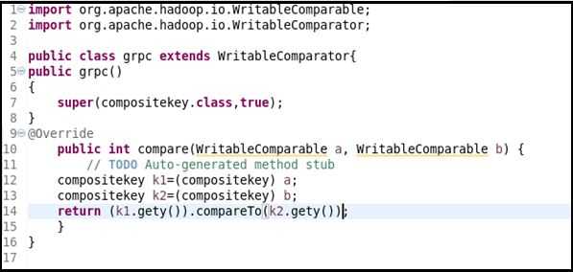

**REDUCER CLASS :**

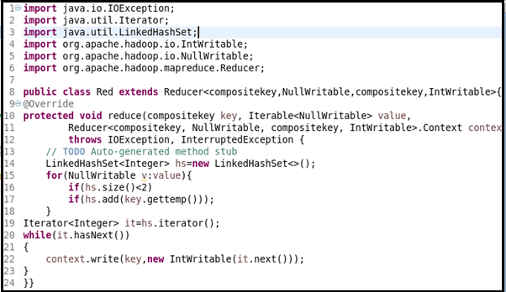

To get two maximum temperature I am using linkedhashmap of size 2.

**OUTPUT :**

