**ASSIGNMENT – 17.5**

1.Write a map reduce program to using a custom counter to count number of people are affected with 'PULMONARY' disease and 'BRONCHITIS & ASTHMA' in the state 'CA'.

**DRIVER CLASS:**

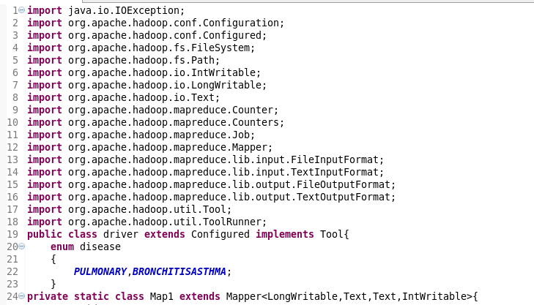

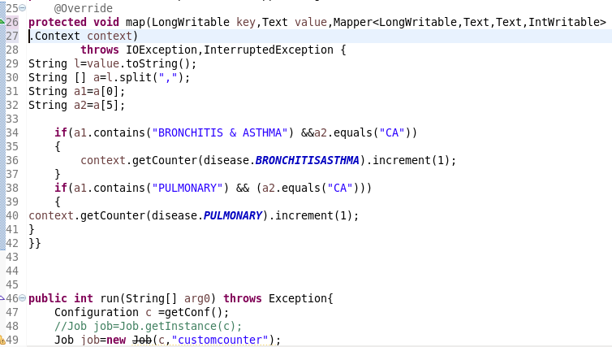

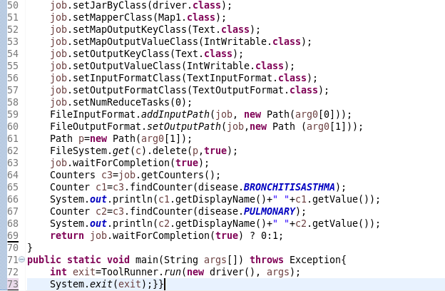

The custom counter BRONCHITIS and PULMONARY has been created and incremented.

**OUTPUT :**

