**ASSIGNMENT – 19.3**

1. **Write a MapReduce program that takes the output of Task 5 (refer session 7, assignment 1) as input, and produce output which is sorted on the total units sold. You may use a single reducer for the sorting. Use Sequence File formats as an output of Task 5 and as input for this task**

**Logic:**

* *Output of 7th assignment is the sales list of companies in a random order.*
* *Since we’ll have to sort by descending order, composite key is used.*
* *7th assignment o/p is of sequence file format which is fed as i/p to 19.3*
* *By using composite key we can sort the sales count in descending order and display the o/p in whatever the way we want.*
* *Overriding compare to method since we have to sort by descending order*
* *Overriding tostring method because we have to display ouput in company size format*

**DRIVER CLASS:**

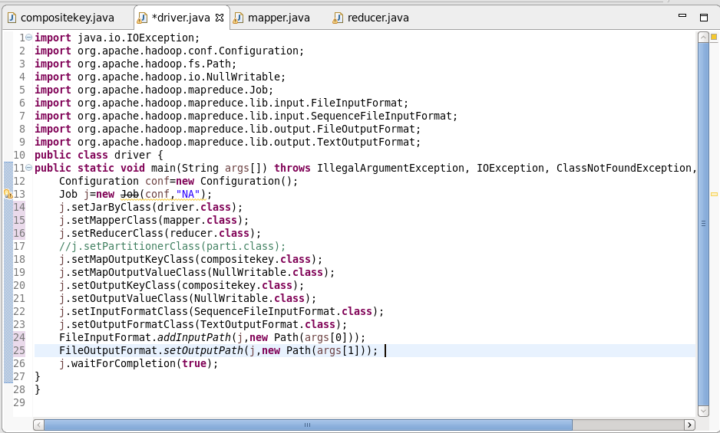

**MAPPER CLASS:**

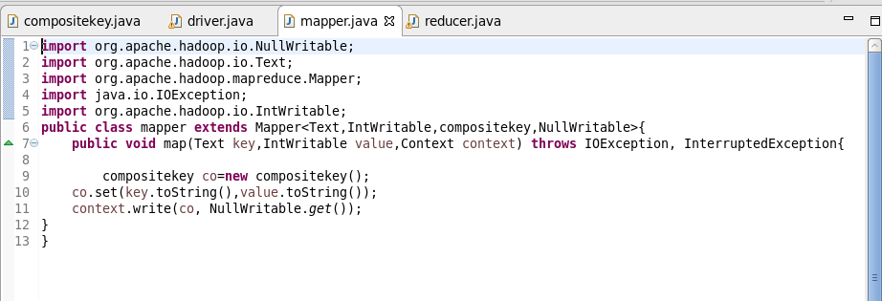

**COMPOSITE KEY:**

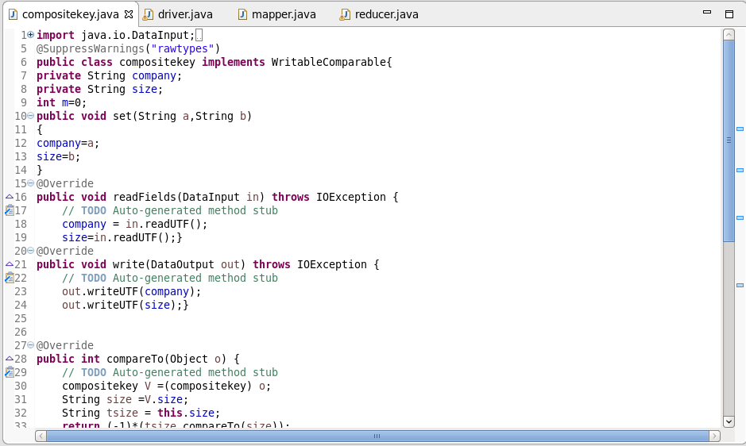

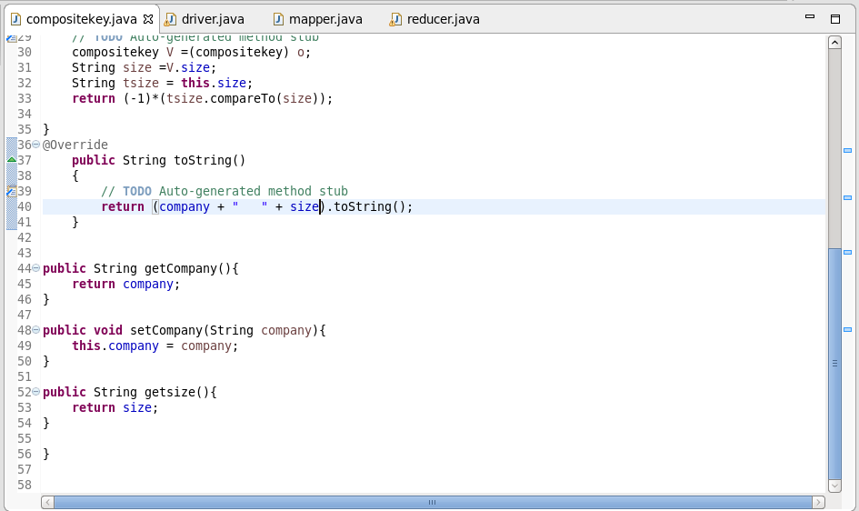

**REDUCER CLASS:**

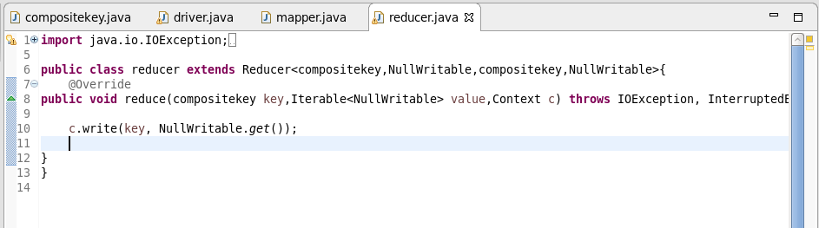

**OUTPUT:**

