**ASSIGNMENT – 20.2**

**Problem Statement :**

Task 10: Enhance the task 8 (refer session 19, assignment 1) to calculate the top 3 state-wise sales for each company. You may use multiple reducers for this activity.

**DRIVER CLASS :**

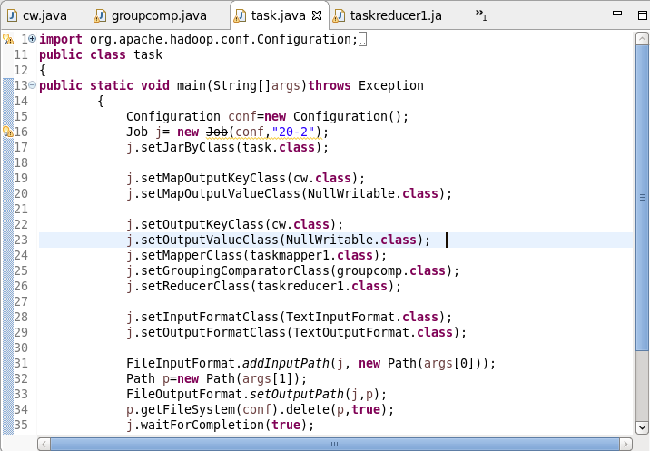

**MAPPER CLASS :**

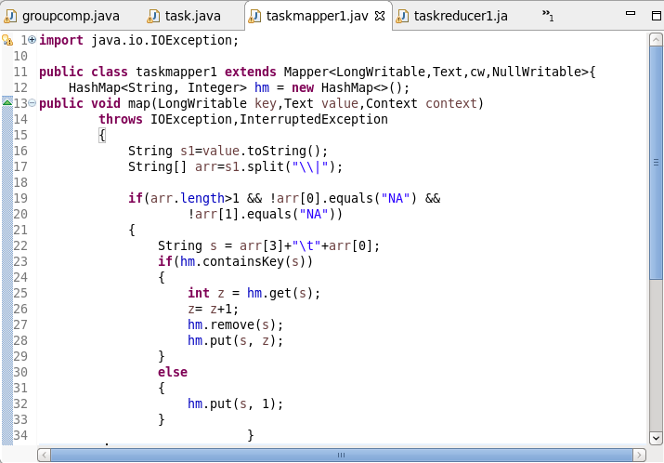

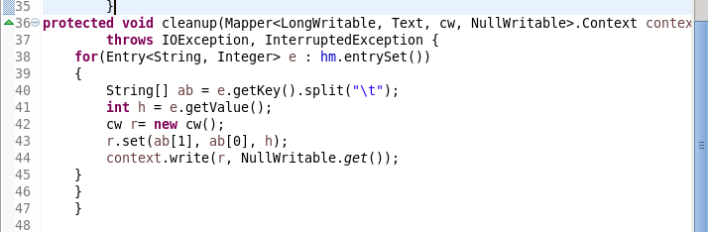

**REDUCER CLASS :**

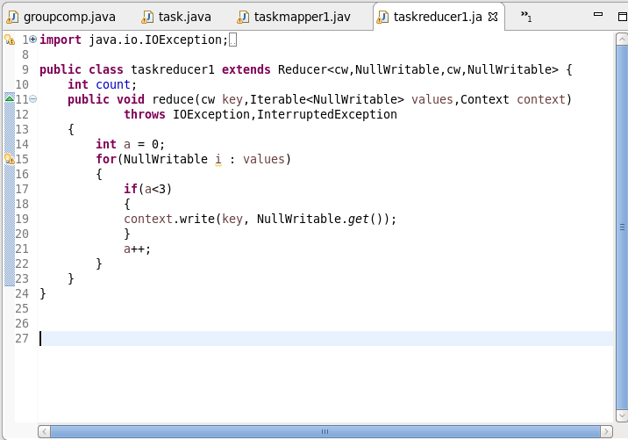

**WRITABLE COMPARATOR CLASS :**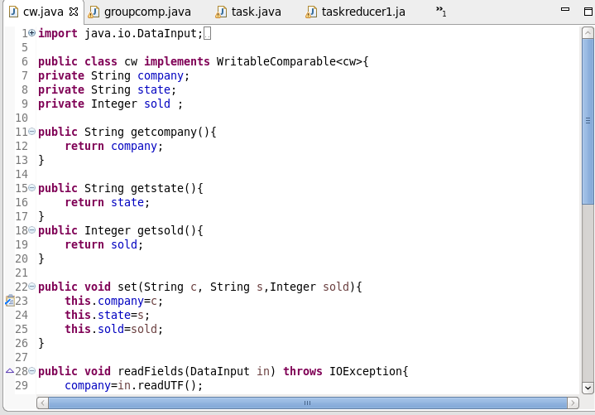

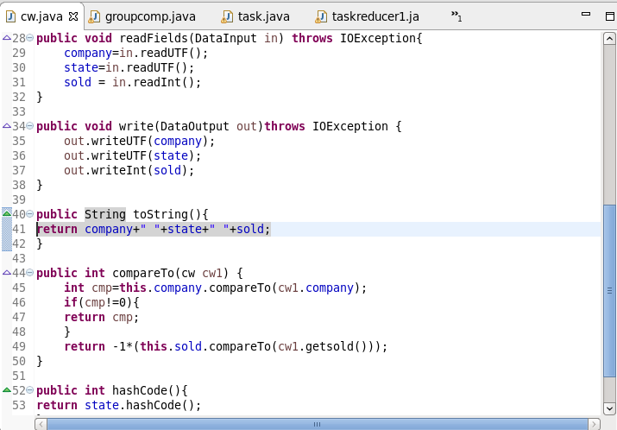

**GROUP COMPARATOR CLASS :**

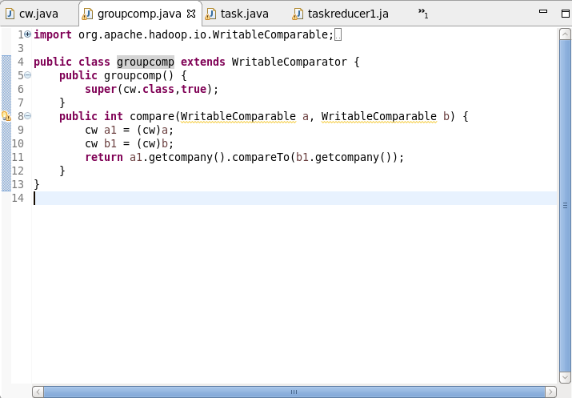

**EXCECUTION COMMAND :**

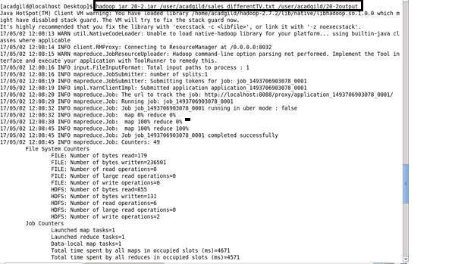

**OUTPUT :**

