Assignment 23.1

1.Problem Statement Create a database named 'custom'. Create a table named temperature_data inside custom having below fields:

1. date (mm-ddyyyy) format

2. zip code

3. temperature.

The table will be loaded from comma-delimited file.

Load the dataset.txt (which is ',' delimited) in the table.

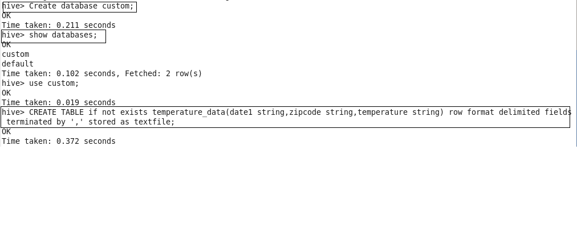

I have loaded the dataset in temperature_data and displayed the output

