**ASSIGNMENT – 24.1**

1.Explain with an example in brief.

● Hive Data Definitions

● Hive Data Manipulations

● HiveQL Manipulations

* Hive supports Data definition Language(DDL), Data Manipulation Language(DML) and User defined functions.

**Hive DDL Commands**

-Create database

-Drop database

-Create table

-Drop table

-Alter table

-Create index

-Create views

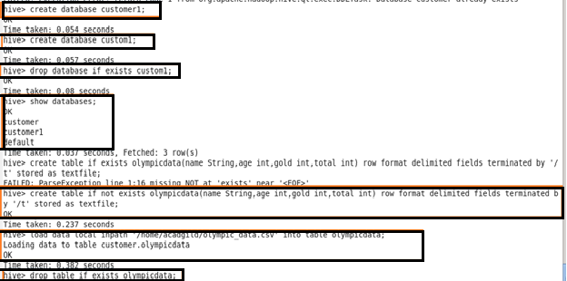

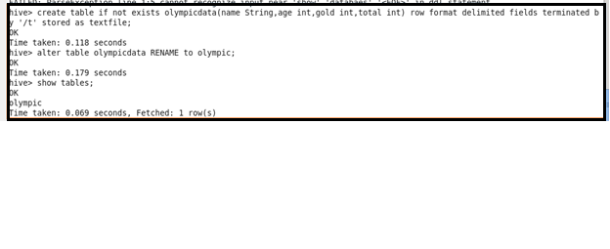

**Hive DML Commands and hiveql manipulations are:**

-Select

-Where

-Group By

-Order By

-Load Data

