Assignment 24.3

1. Calculate the number of employees corresponding to each skill from the table 'employee' which is loaded in the Demo.

First we are creating a table and loading data into it .And we are using COUNT function to calculate number of employees.

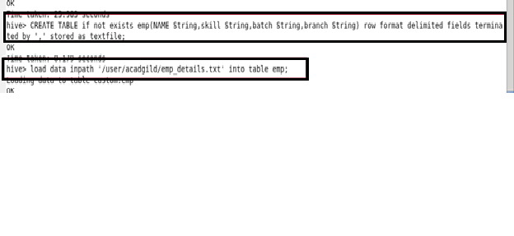

Command and output:

