**ASSIGNMENT – 24.4**

1. Write a hive query find the average age of male and female persons died in the titanic tragedy.

Here we are first creating a table “titanic” and then loading the dataset into it. Then we are using AVG function to calculate the average of male and female persons died in the titanic tragedy.

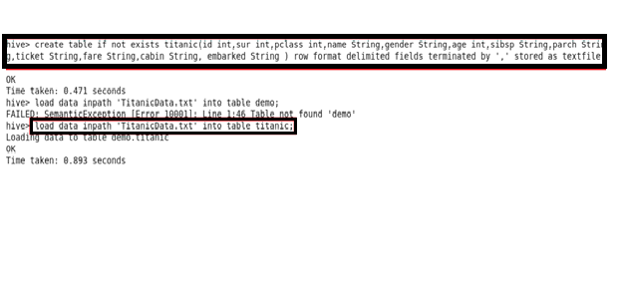

*Command and output:*

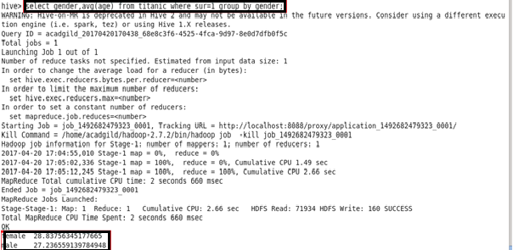

1. Write a hive query to find the number of people died and survived in each class.

Here we are using COUNT function.

*Command and output :*

