**ASSIGNMENT – 24.5**

1.Create a hive table and load the dataset into the table and evaluate the below problem statements .

First create the table and load dataset into it.

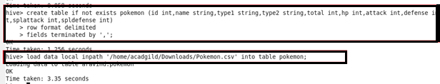

2. Find out the average HP (Hit points) of all the Pokemon.

Using AVG function finding HP of all the pokemon.

Command and output :

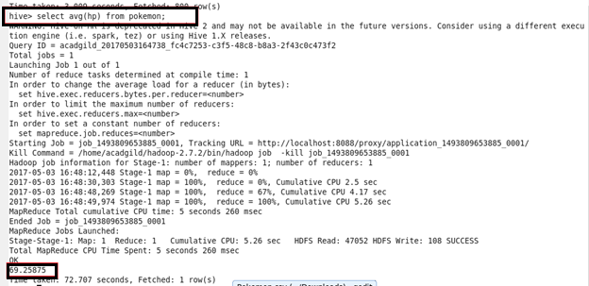

3 . Find out the average Defense of all the pokemon.

Using AVG function.

Command and output :

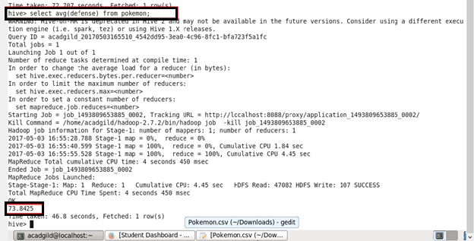

1. Find out the average Sp.Atk of all the pokemons.

Command and output:

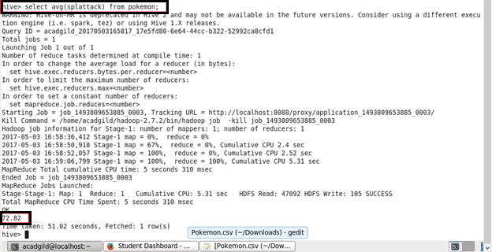

1. Find out the average sp.Def of all the pokemons.

Command and output :

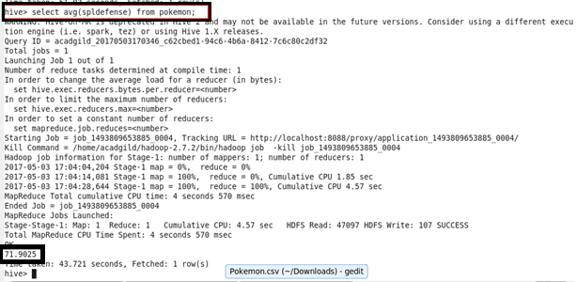

1. Find out the average Speed of all the pokemons .

Command and output :

