**ASSIGNMENT – 24.6**

1. Write a hive query to find the minimum temperature observed in a given weather station in a particular year.

Here we are first creating table temp then loading the dataset into the table. Then using MIN function we give result.

*Commands and result :*

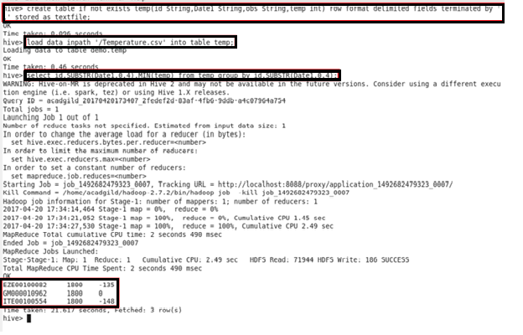

1. Write a hive query to find the maximum temperature observed in a given weather station in a particular year.

Here we are using MAX function.

*Commands and result :*

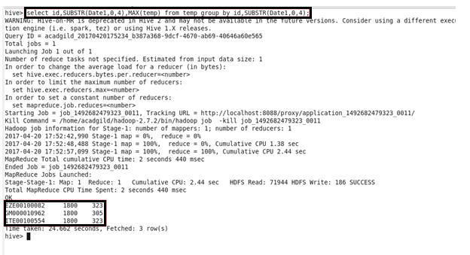

1. Write a hive query to find the number of readings given by each weather station according to the dataset.

Here we are using COUNT.

*Commands and result :*

