**ASSIGNMENT – 25.1**

1. Write a Hive program to find the number of medals won by each country in swimming.

**COMMAND:**

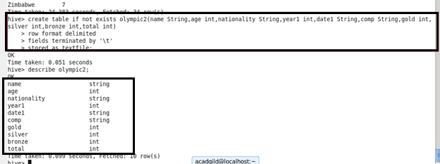



First ,we are creating table olympic2 and then loading the given dataset into the table.

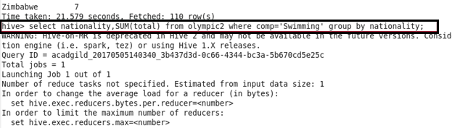

Here we are using SUM function.

**OUTPUT:**

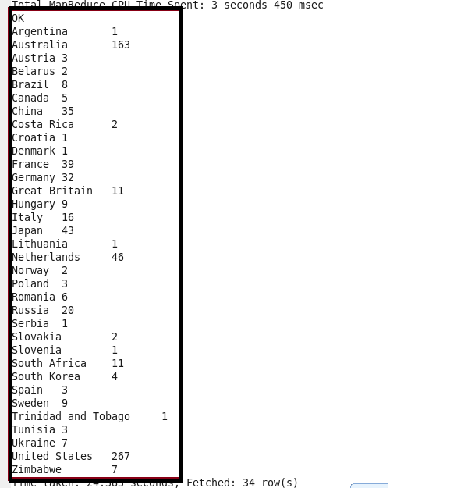

1. Write a Hive program to find the number of medals that India won year wise.

Here we are using COUNT function.

**COMMAND AND OUTPUT :**

