**ASSIGNMENT – 25.2**

1. Write a Hive Program to find the total number of medals each country won.

Here, command is to find the total number of medals each country won using SUM function.

**COMMAND :**

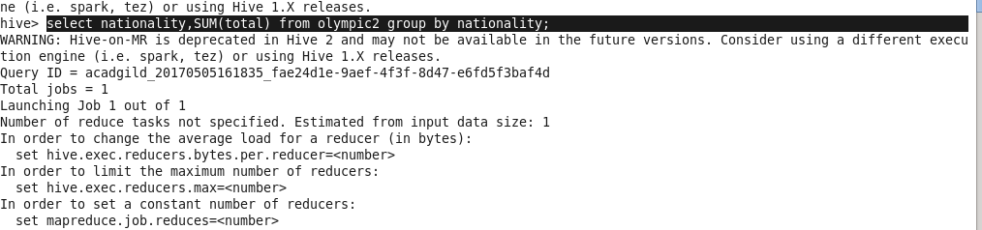

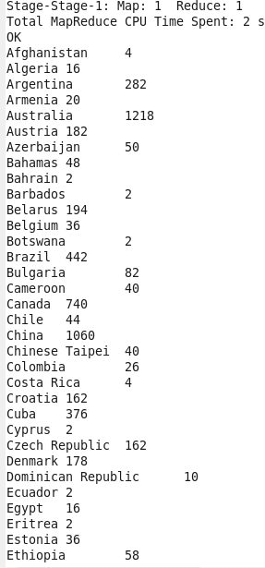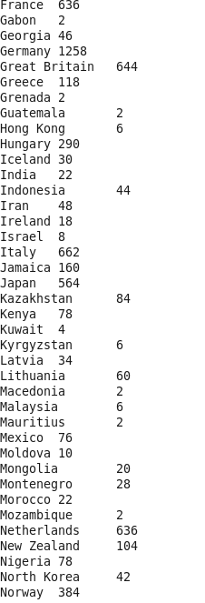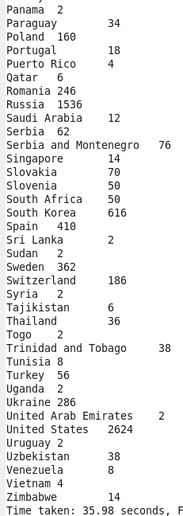

1. Write a Hive program to find the number of gold medals each country won.

Here we are using SUM function.

