**ASSIGNMENT – 25.3**

1. Get a list of employees who receive a salary less than 100, compared to their immediate employee with higher salary in the same unit Hive commands.

**COMMAND:**

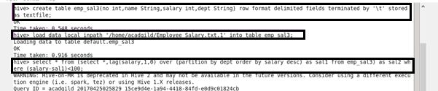

First, creating a table emp_sal3 then loading the given data into created table.

Now, using lag function it is finding that subtraction of employee salary and the salary of previous employee is less than 100 or not. If it is less than 100 it will display the desire output.

**OUTPUT:**

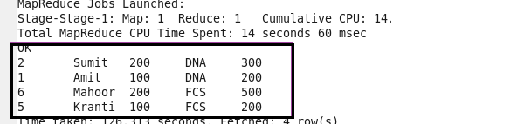

2**.** List of all employees who draw higher salary than the average salary of that department.

Here we are using AVG function to find out average function.

**COMMAND AND OUTPUT :**

