**ASSIGNMENT – 25.4**

1. Write a hive query to find the top 20 destination people travel the most: Based on the given data.

Here, first creating the table travel_table and then loading the data of the given dataset into the table.

Here we are using SUM function and LIMIT function .

**COMMAND:**

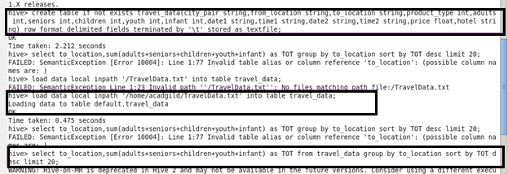

**OUTPUT :** 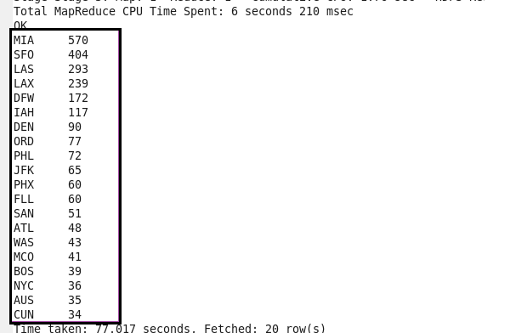

1. Write a hive query to find the top 20 locations from where people travel the most.

Using SUM function to calculate the total locations from where people travel the most and then limiting to 20 using limit function so as to get the top 20 locations.

**COMMAND AND OUTPUT :**



