ASSIGNMENT – 25.5

- Write a hive query to list top 5 residency details which lie in the budget of 60000-120000, an area more than 1450, sold after 17th may, min bedroom 3 and, min bathroom 2.

First, creating the table real_state and then loading the data given in the dataset into the table.
Now we want top 5 residential details, filtering by flat_type as residential and price between 60000 to 120000 and sq_ft > 1450 and beds >=3 and baths>=2 and since we want items sold after 17th may but we have used date as string so using unix_timestamp function to convert to timestamp and used to_date function to convert to date and used datediff function which compares each date with the date 17 may and return positive value if sold after 17 may hence filter by datediff greater than 0 and ordered by price and limited by 5.

COMMAND AND OUTPUT :
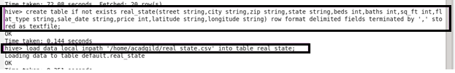

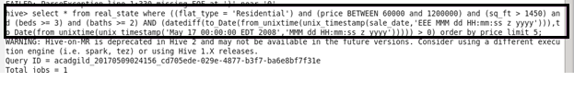

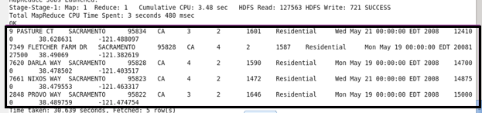

- Write a hive query to separate list of residential apartments with more than 2 beds. Also include columns in following order City, Baths, Sq_feet ,Price, flat_type, Beds respectively.

First creating a table named separate_list then inserting data using ‘insert’ using subquery from created table real_state. Using describe checking created table columns and their datatype.

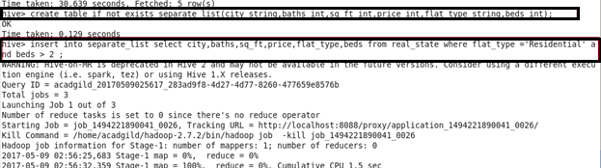

OUTPUT :
