**ASSIGNMENT – 26.1**

Problem Statement:

● link: WC_emp_details

**● Perform word count in Hive for above given dataset.**

Create the table wordc then loading the dataset into it.

**COMMAND AND OUTPUT :**

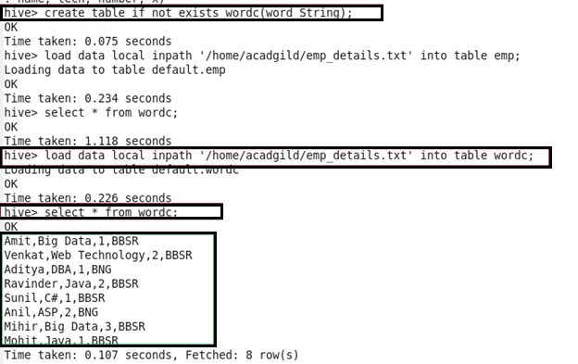

Explode is used to see each and every word even if it present more than one time in the table. As the data in the dataset is separated by comma I am splitting the words by using ‘,’ and naming it as eachword.

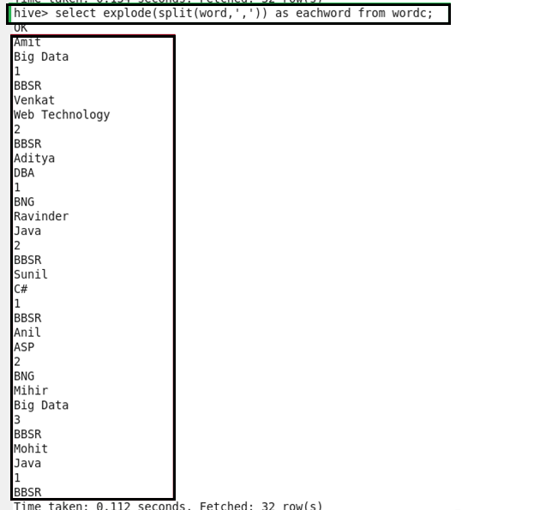

Here we are using COUNT function.

**COMMAND :**

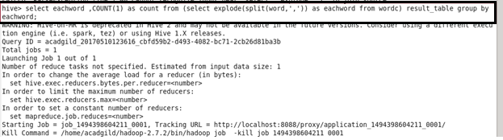

**OUTPUT:**

