**ASSIGNMENT – 26.4**

1. Implement view in hive by following the steps in the below blog.

The main reason for having a view of a table is to simplify some of the complexities of a larger table into a more Flat structure.

When a query becomes long or complicated, a view may be used to hide the complexity by dividing the query into smaller, more manageable pieces; similar to writing a function in a programming language or the concept of layered design in software.

First, creating view of already created table real_state1 and then displaying it by selecting all from the table.

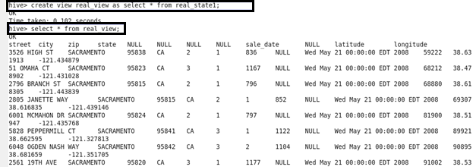

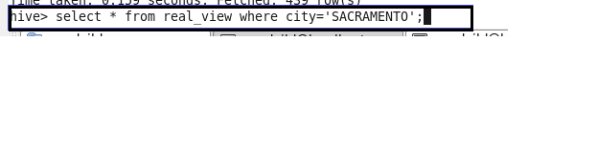

**OUTPUT :**

It fetched 439

