**ASSIGNMENT – 27.4**

1. **Run parallel jobs in hive by following the steps in the below blog link.Hive can converts a query into one or more stages and to save time executes multiple jobs parallely.**

To understand parallel job on hive better first showing non parallel job so that its key concept can be well understood.

NON –PARALLEL JOB :

Firstly, creating 4 tables and then loading the data into the created tables.

Then, describing tables to see whether table is created correctly or not.

Then, displaying the data of the tables using select keyword.

**Created table – customer1**

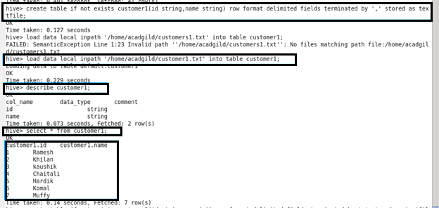

**Created table – customer2**

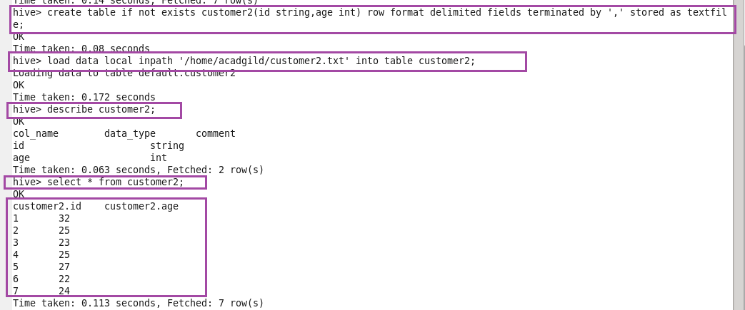

**Created table – customer3**

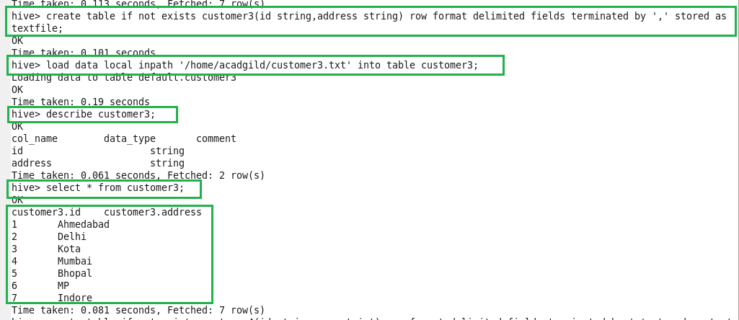

**Created table – customer4**

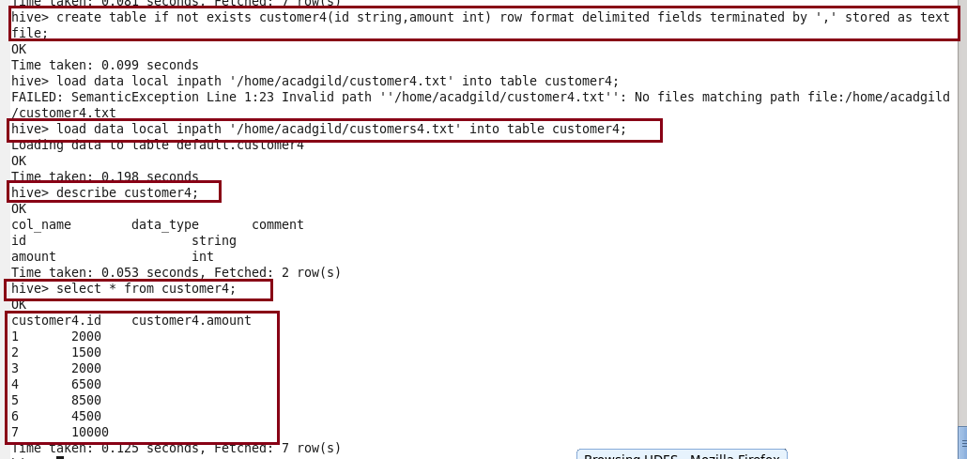

**Performing join non parallely**

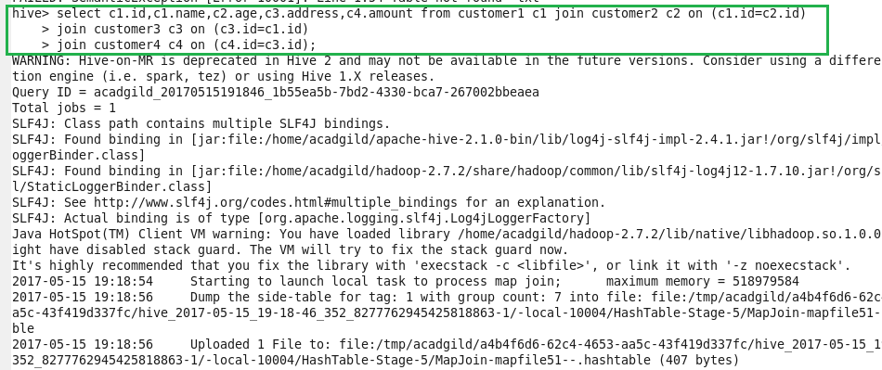

**OUTPUT :**

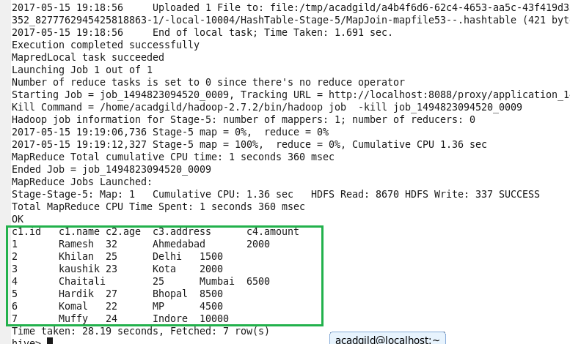

**Performing join parallel:**

**Before running it we need to set configuration:**

**Set hive.exec.parallel = true;**



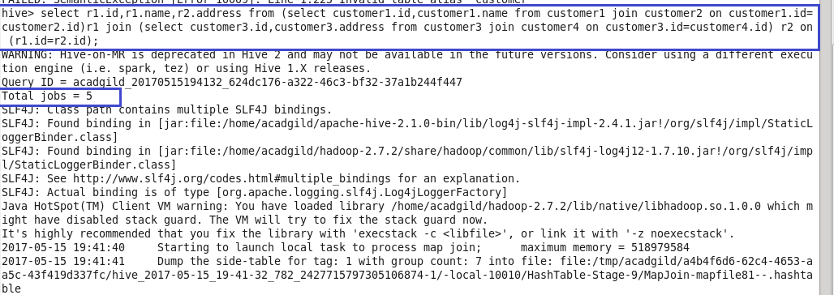

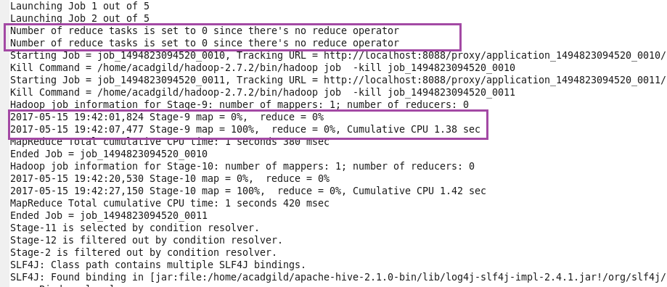

**OUTPUT :**

