**ASSIGNMENT – 28.1**

1. **What are ACID properties and Explain Transactions in Hive.**

ACID stands for Atomicity, Consistency, Isolation, and Durability.

**Atomicity:**

Atomicity means, a transaction should complete successfully or else it should fail completely i.e. it should not be left partially.

**Consistency:**

Consistency ensures that any transaction will bring the database from one valid state to another state.

**Isolation:**

Isolation states that every transaction should be independent of each other i.e. one transaction should not affect another.

**Durability:**

Durability states that if a transaction is completed, it should be preserved in the database even if the machine state is lost or a system failure might occur.

These ACID properties are essential for a transaction and every transaction should ensure that these properties are met.

**TRANSACTIONS IN HIVE:**

Transactions are provided at the row-level in Hive 0.14. The different row-level transactions available in Hive 0.14 are as follows:

1. Insert
2. Delete
3. Update

There are numerous limitations with the present transactions available in Hive 0.14. ORC is the file format supported by Hive transaction. It is now essential to have ORC file format for performing transactions in Hive. The table needs to be bucketed in order to support transactions.

The below properties needs to be set appropriately in ***hive shell***, order-wise to work with transactions in Hive:

## Then, Creating a Table That Supports Hive Transactions

After that, inserting the values in the created table.

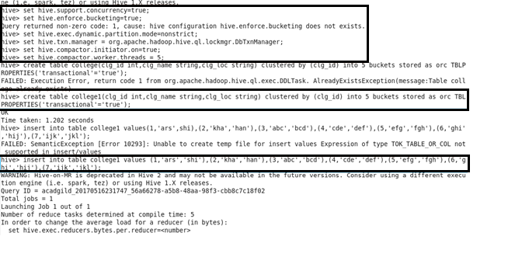

Then using ‘select’ keyword displaying the data of the created table.

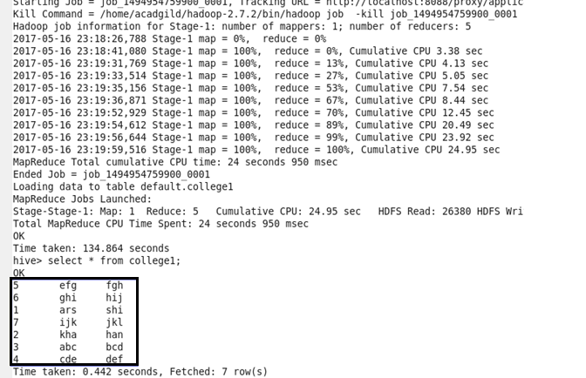

On again inserting the values in the table will append the data. Attached screenshot is showing Appended data using select keyword.

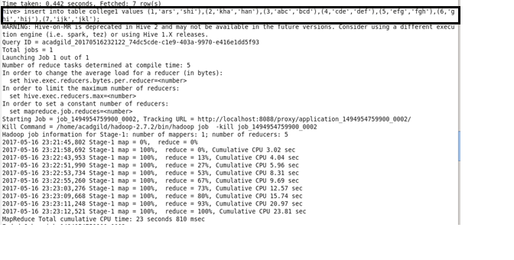

**Appended data :**

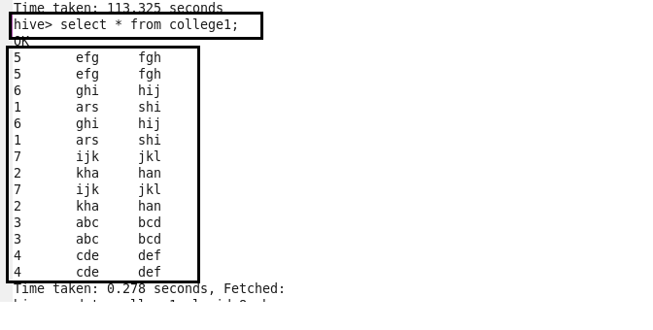

**Updating the table :**

From the above image, we can see that we have received an error message. This means that the Update command is not supported on the columns that are bucketed.

In this table, we have bucketed the **‘clg_id’** column and performing the Update operation on the same column, so we have got the error.

Then, performing the update operation.

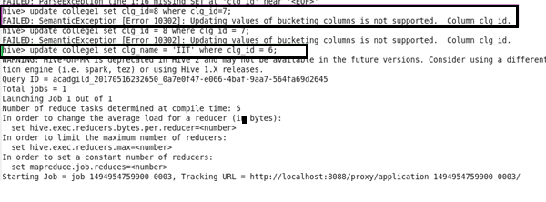

In the screenshot we can viewed that table is updated.

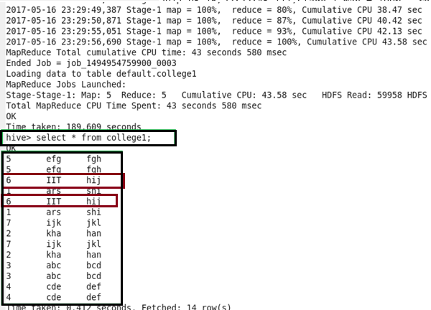

**Deleting the row from the table :**

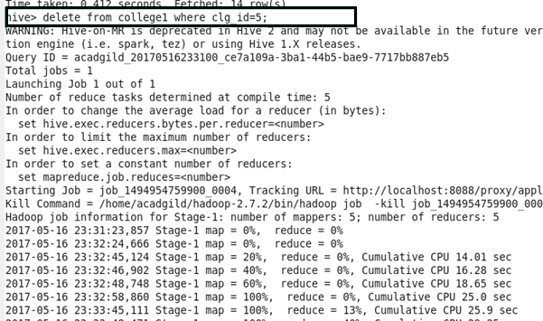

Here, we can see that rows where clg_id=5 got deleted.

