**ASSIGNMENT – 33.1**

**Problem statement:**

Write Java client API to perform following operations:

1. Create the method name get record and use get class to retrieve one record at a time record from company table.

**Here is the Java code :**

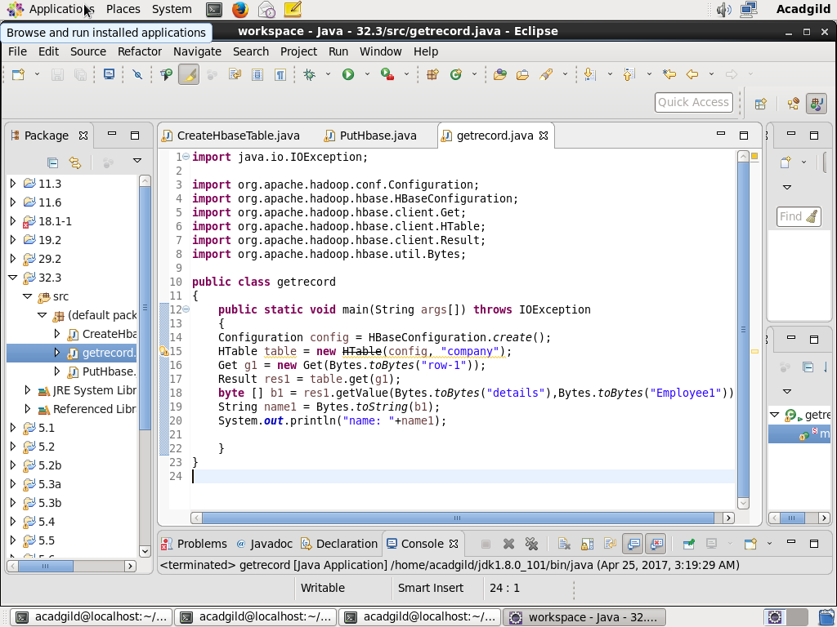

**CONSOLE OUTPUT :**

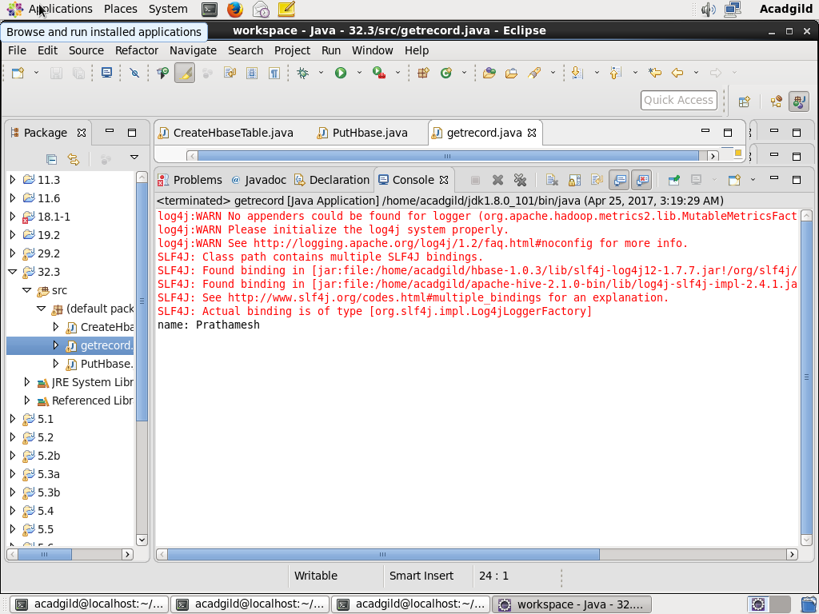

**Checking contents of company table using scan command:**

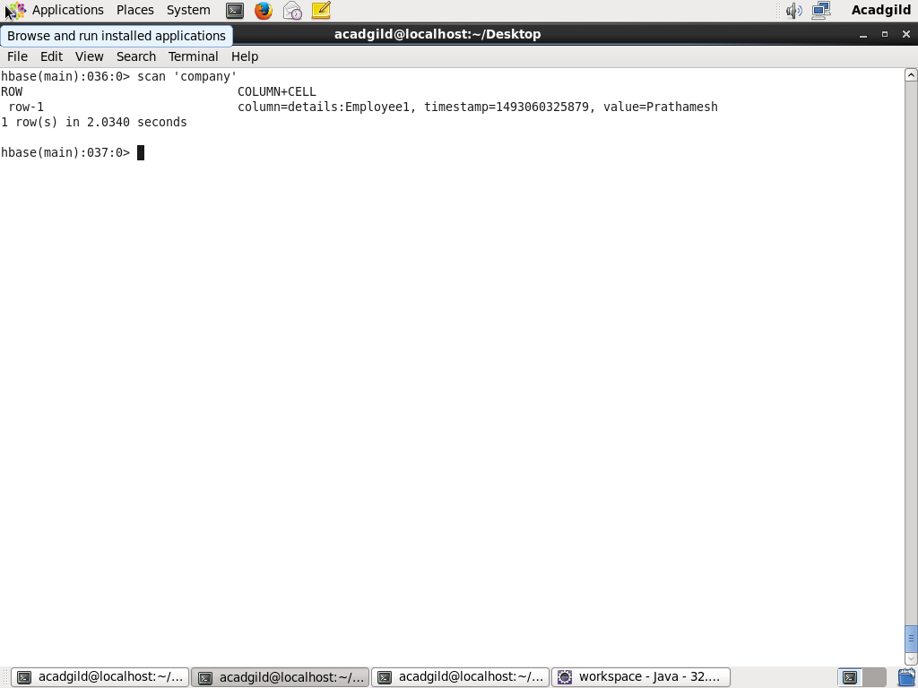

1. Create the method name display and use scan class to display all records from company table.

**Here is the Java code:**

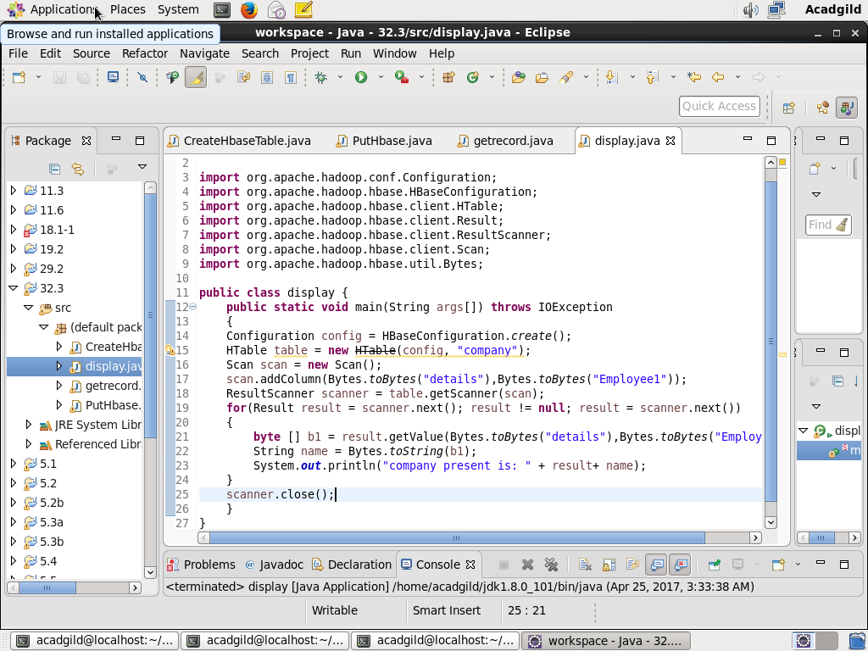

**CONSOLE OUTPUT :**

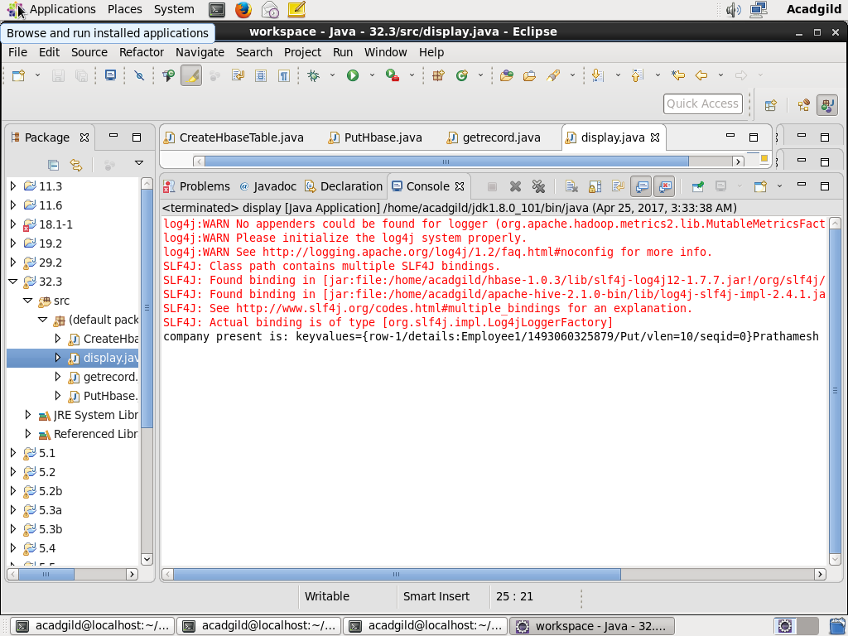

**Checking contents of company table using get command:**

