**ASSIGNMENT – 33.2**

**Problem Statement:**

● Integrate Hbase with Hive

● Load Data (Bulk Load) from Hive table to Hbase Table

● Explain the procedures and code implemented with screenshots.

● Note: Candidates should Load their own data into Hbase table.

1. **Integrate Hbase with Hive**

**Creating hbase table:**

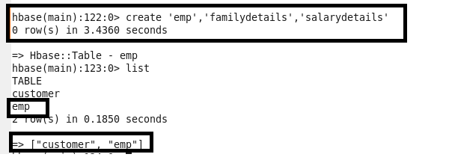

**Insert the data into HBase table:**

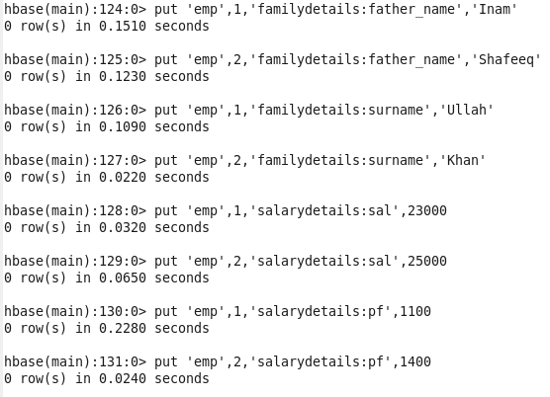

1. **Create the Hive table for each column family pointing to HBase table and displaying the contents of the hive table:**

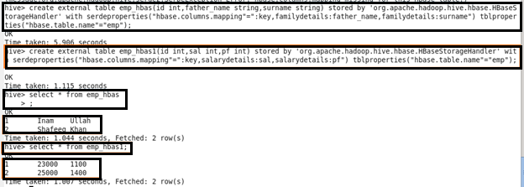

**Load Data (Bulk Load) from Hive table to Hbase Table:**

**Creating hbase table and scan the table(no data is loaded):**

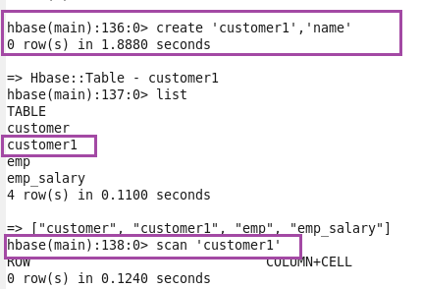

1. **Create table in hive and load the data and display the contents of the table:**

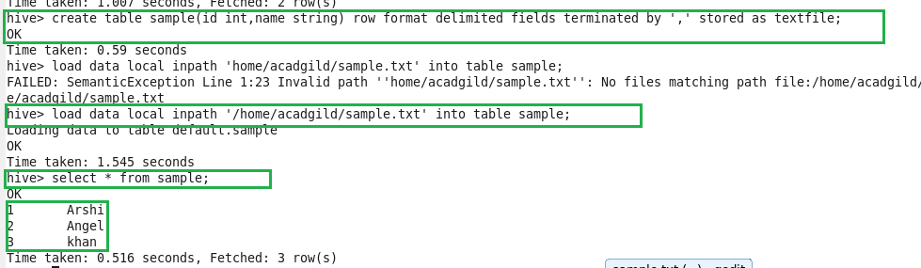

1. **Create external table and the loading the data from the above table:**

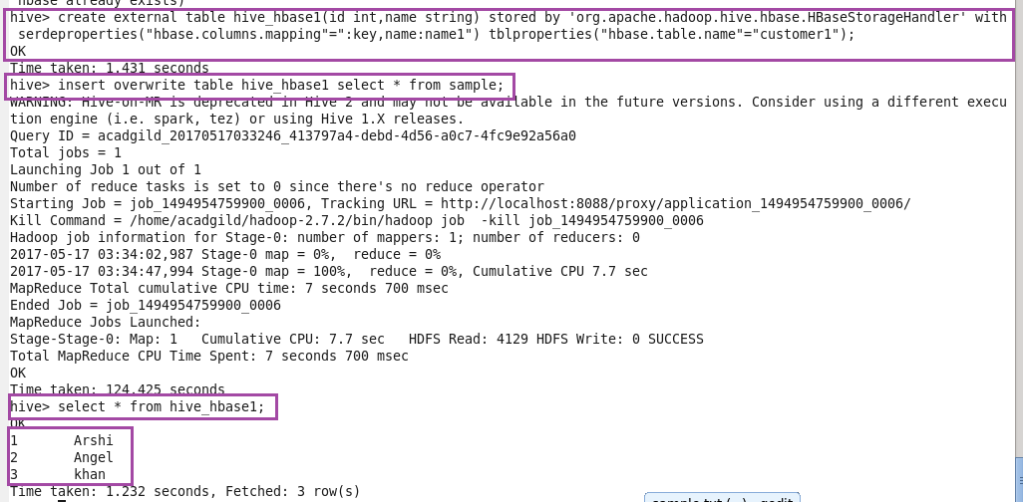

**Now scan the hbasetable(data is loaded):**

