**ASSIGNMENT- 35.2**

**Problem Statement:**

● Explain and perform Sqoop Incremental Import operation to load data from Mysql To HDFS using Sqoop

● Explain the procedures performed, Share the screenshots of commands and results for the same.

To perform Sqoop Incremental Import operation to load data from Mysql To HDFS using Sqoop we need to create a table.

Creating a table named Employee and inserting the values using insert command

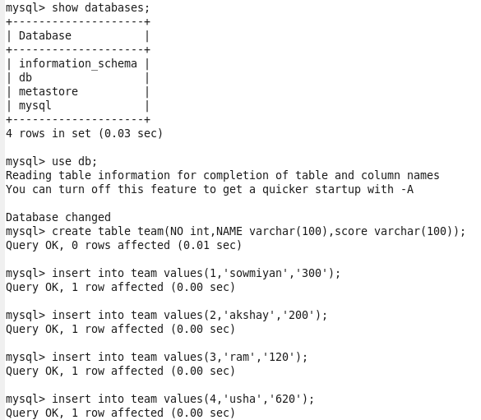

Now we are using select command to display all content :

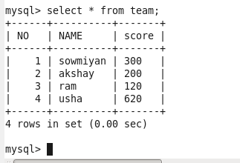

We are importing file from mysql to HDFS using sqoop command :

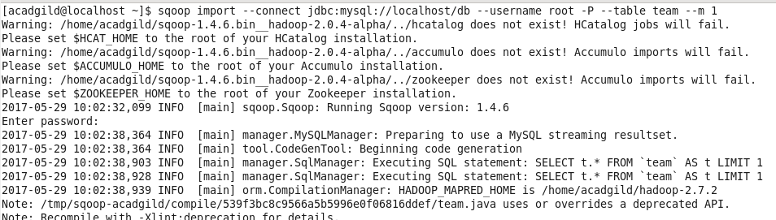

Now showing the success command :

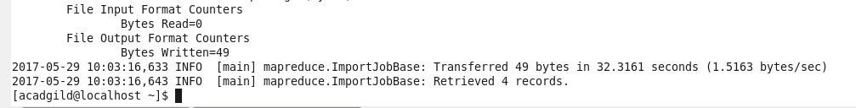

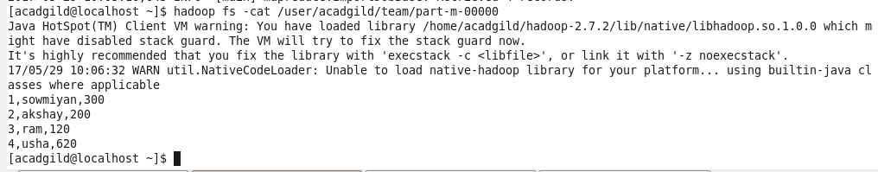

Now we are adding additional data into table TEAM using mysql :

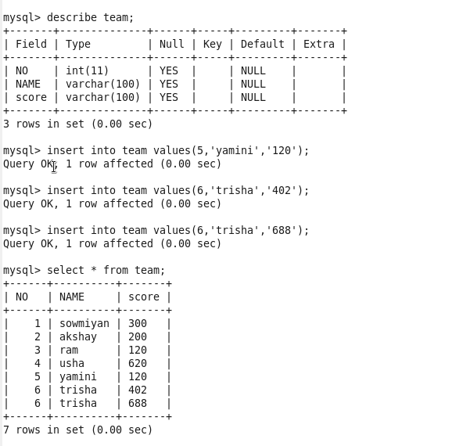

Now we are using APPEND command in sqoop to import the edited data :

COMMAND:

