**ASSIGNMENT- 35.3**

1. **Explain and perform Importing table contents from Mysql to Hive using Sqoop.**

**CREATING A TABLE IN HIVE**

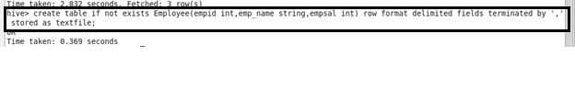

CREATING A TABLE “SAMPLE1” AND INSERTING INTO THE TABLE “SAMPLE1” in MYSQL

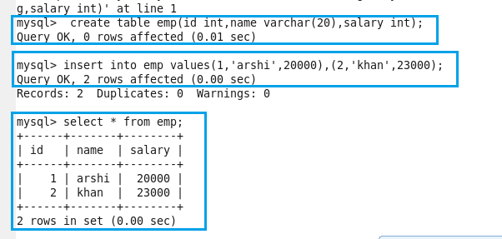

PERFORMING IMPORT USING SQOOP(we have to transform the data from mysql to hive )

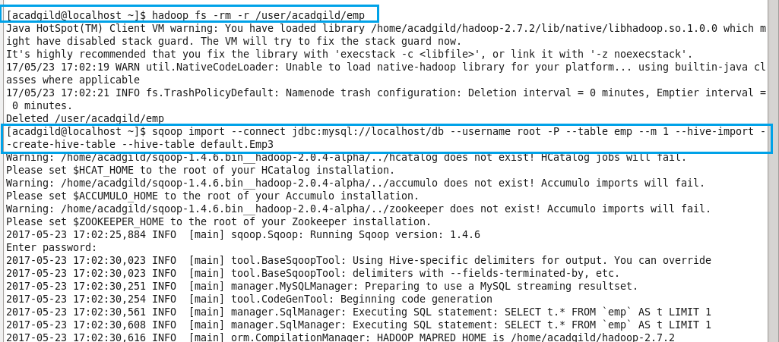

Before running the import command we should close the hive shell, otherwise we’ll get an error

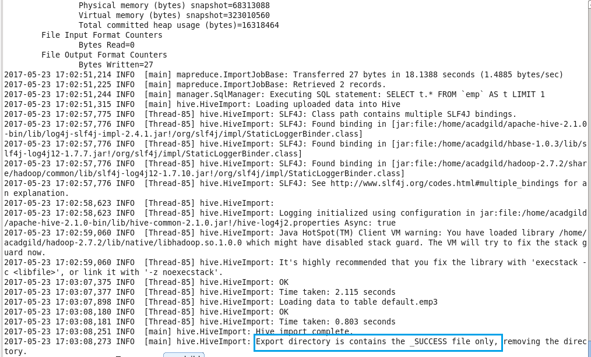

previously “emp3” is empty, now after running import command it is loaded with data

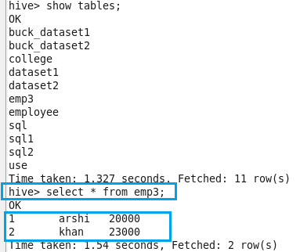

**Explain and perform Importing table contents from Mysql to HBase using Sqoop.**

create a table “hivesql” with “Detail” as column family in HBASE

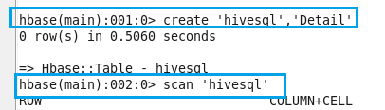

performing import from mysql to hbase

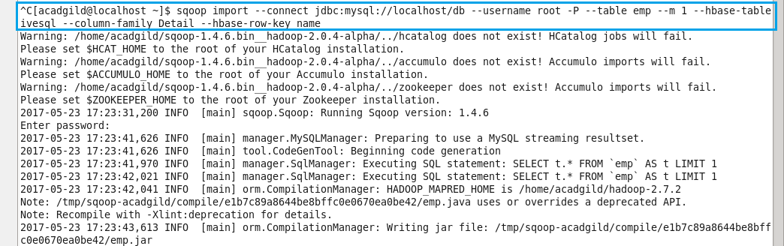

successfully transferred data from mysql to hbase

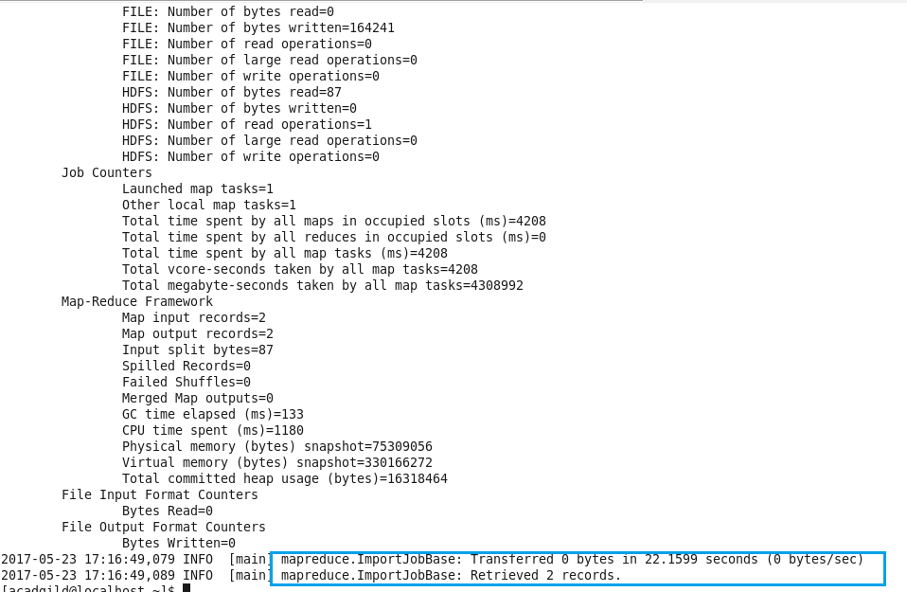

scan ‘hivesql’ gives the full details about the table(transferred data)

