ASSIGNMENT 9.2

COMMAND SCRIPT :

1. LOAD :

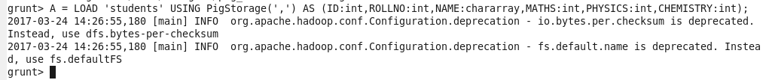

1. DUMP :



Output :

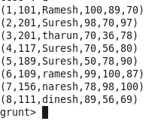

1. DESCRIBE :



1. FOREACH :

Input:



Output:

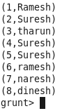

1. STORE :

Input:



Output:

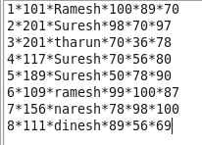

1. FILTER :

Input:



Output:

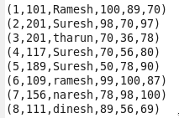

1. GROUP BY:

Input:



Output:

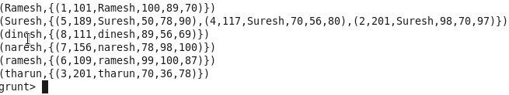

1. ORDER BY :

Input:



Output:

