ASSIGNMENT - 9.3

FULL OUTER JOIN

Input:



Output:

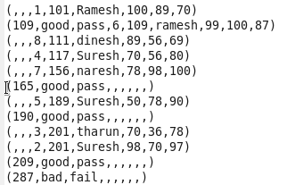

INNER JOIN:

Input:



Output:



OUTER RIGHT JOIN:

Input:



Output:

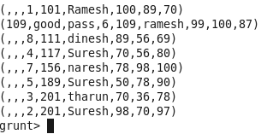

OUTER LEFT JOIN:

Input:



Output:

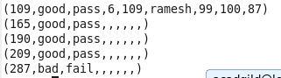

SELF-JOIN:

Input:



Output:

