**Exercise No 1  
 Statistics using R**

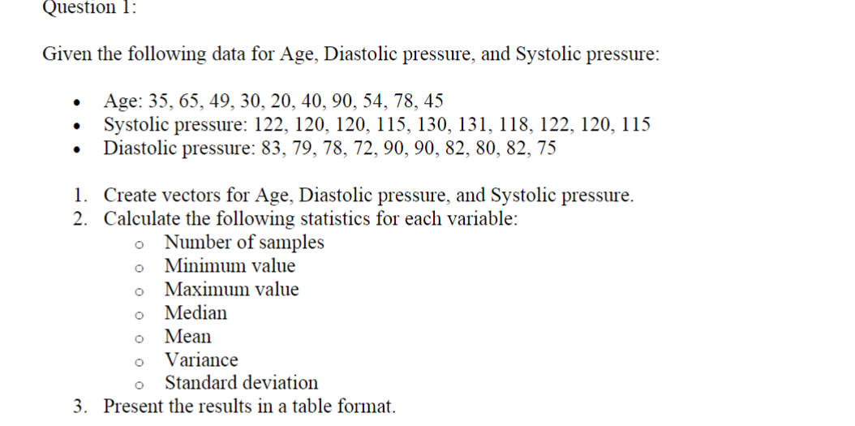

Age<-c(35, 65, 49, 30, 20, 40, 90, 54, 78, 45)

Systolie<-c( 122, 120, 120, 115, 130, 131, 118, 122, 120, 115)

Diastolie<-c( 83, 79, 78, 72, 90, 90, 82, 80, 82, 75)

length(Age)

length(Systolie)

length(Diastolie)

min(Age)

mean(Age)

max(Age)

median(Age)

sd(Age)

var(Age)

dataset <-data.frame(Age = Age,Systolie = Systolie,Diastolie = Diastolie)

print(dataset)

OUTPUT:

>length(Systolie)

[1] 10

> min(Age)

[1] 20

> max(Age)

[1] 90

> mean(Age)

[1] 50.6

> median(Age)

[1] 47

> sd(Age)

[1] 21.78787

> var(Age)

[1] 474.7111

> dataset <-data.frame(Age = Age,Systolie = Systolie,Diastolie = Diastolie)

> print(dataset)

Age Systolie Diastolie

1 35 122 83

2 65 120 79

3 49 120 78

4 30 115 72

5 20 130 90

6 40 131 90

7 90 118 82

8 54 122 80

9 78 120 82

10 45 115 75

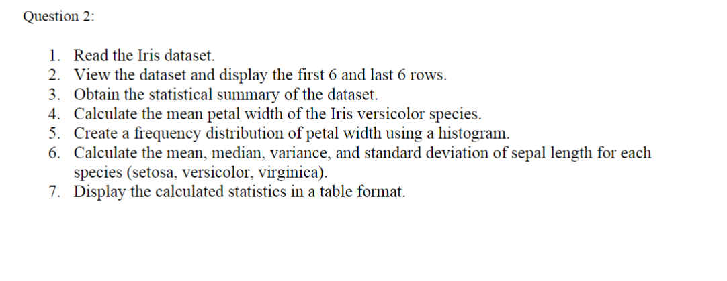

* demo<-read.csv("Iris (1).csv")

> demo<-read.csv("Iris (1).csv")

* head(demo)

> head(demo)

Sepal.Length Sepal.Width Petal.Length Petal.Width Species

1 5.1 3.5 1.4 0.2 setosa

2 4.9 3.0 1.4 0.2 setosa

3 4.7 3.2 1.3 0.2 setosa

4 4.6 3.1 1.5 0.2 setosa

5 5.0 3.6 1.4 0.2 setosa

6 5.4 3.9 1.7 0.4 setosa

* tail(demo)

> tail(demo)

Sepal.Length Sepal.Width Petal.Length Petal.Width

145 6.7 3.3 5.7 2.5

146 6.7 3.0 5.2 2.3

147 6.3 2.5 5.0 1.9

148 6.5 3.0 5.2 2.0

149 6.2 3.4 5.4 2.3

150 5.9 3.0 5.1 1.8

Species

145 virginica

146 virginica

147 virginica

148 virginica

149 virginica

150 virginica

* summary(demo)
* summary_stats <- summary(demo)

> summary(demo)

Sepal.Length Sepal.Width Petal.Length Petal.Width

Min. :4.300 Min. :2.000 Min. :1.000 Min. :0.100

1st Qu.:5.100 1st Qu.:2.800 1st Qu.:1.600 1st Qu.:0.300

Median :5.800 Median :3.000 Median :4.350 Median :1.300

Mean :5.843 Mean :3.057 Mean :3.758 Mean :1.199

3rd Qu.:6.400 3rd Qu.:3.300 3rd Qu.:5.100 3rd Qu.:1.800

Max. :7.900 Max. :4.400 Max. :6.900 Max. :2.500

Species

setosa :50

versicolor:50

virginica :50

* mean(demo$Sepal.Length & demo$Species=='setosa')

> mean(demo$Sepal.Length & demo$Species=='setosa')

[1] 0.3333333