**UNVEILING MARKET INSIGHTS: ANASLYSING SPENDING BEHAVIOUR AND IDENTIFYING OPPORTUNITIES FOR GROWTH.**

**1. INTRODUCTION:**

**1.1 OVERVIEW:**

**F**irst I created an EMPATHY MAP.A map has four quadrants says, Thinks Does and feels. What are the fear, frustrations, needs and hopes of customers. Next, I created an BRAIN STORM. Here me and my team members give one problem statement and also give the solution to that problem. Next I created the data analysis-Dashboard and story after I publish my dashboard and story in Tableau public.

**1.2 PURPOSE:**

Data Analysis is essential as it helps businesses understand their customers better, improves sales, improves customer targeting, reduces costs, and allows for the creation of better problem-solving strategies. Data is of much importance nowadays. Data helps you understand performance providing the clarity needed for better results. Data helps you improve processes so that you can reduce wasted money and time and also to understand consumers well.

**2. PROBLEM DEFINITION & DESIGN THINKING**

**2.1 EMPATHY MAP:**

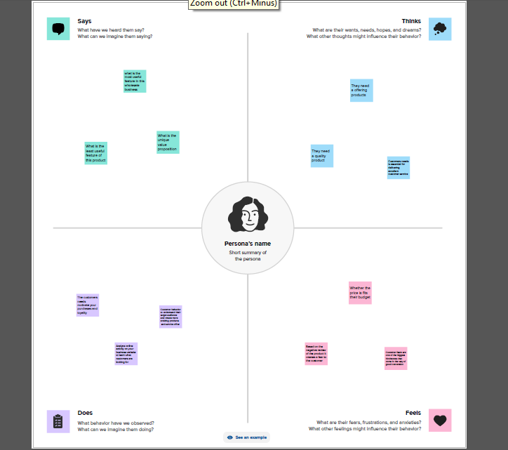

**2.2 BRAIN STORM:**

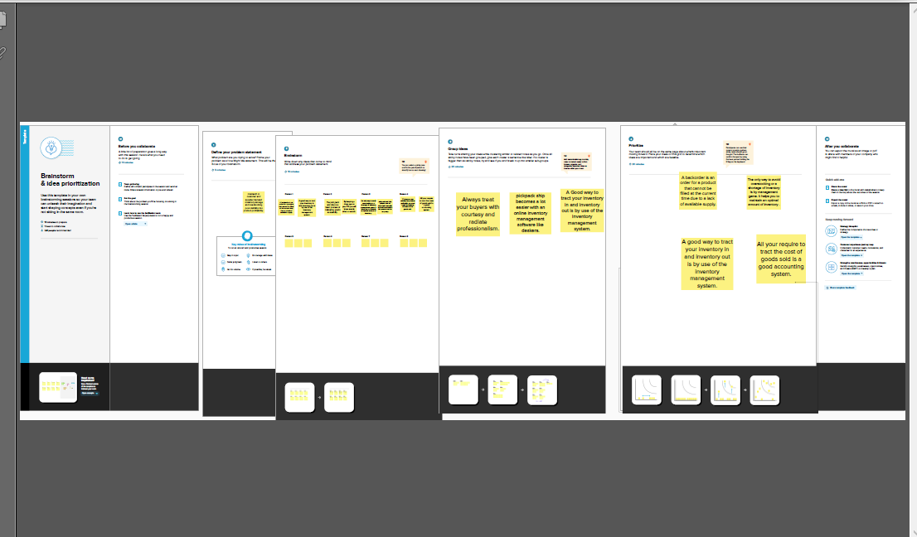

**3. RESULT:**

**DASHBOARD**

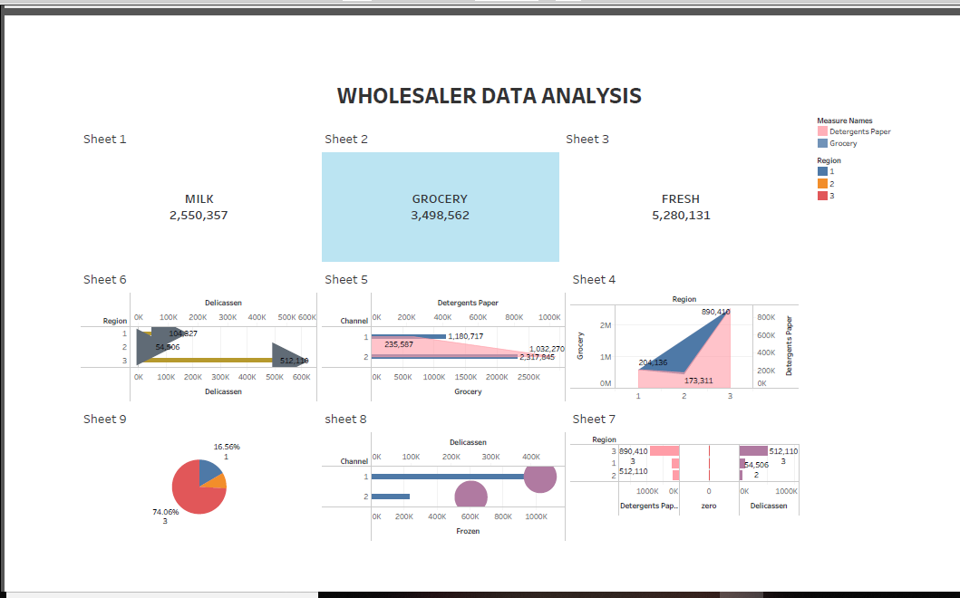

**STORY**

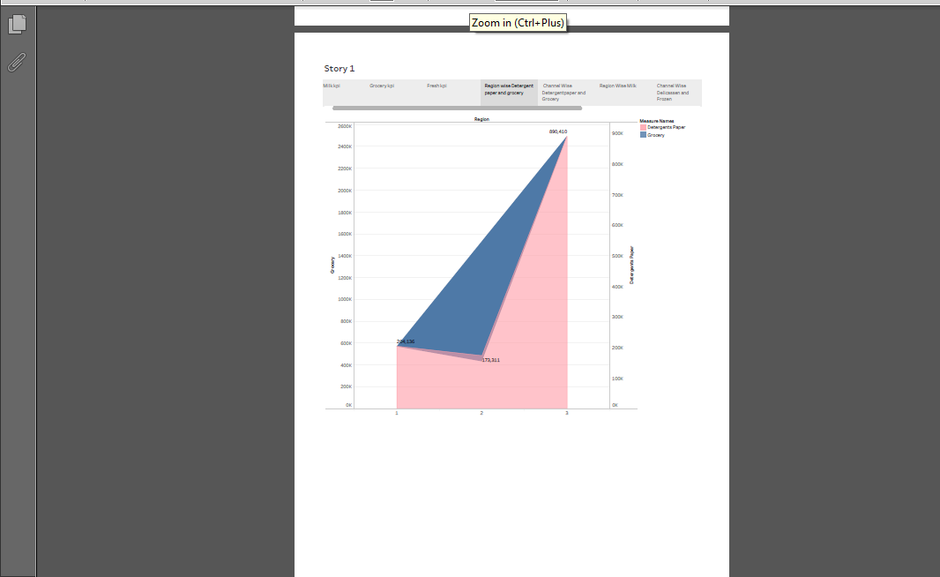

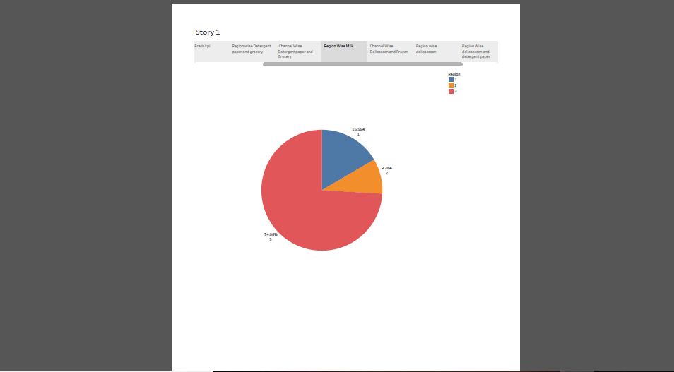

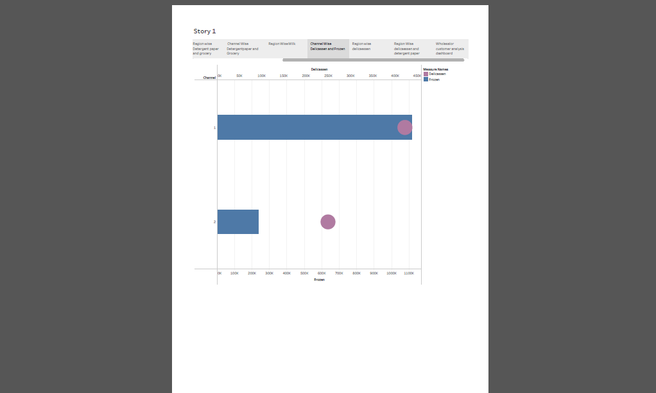



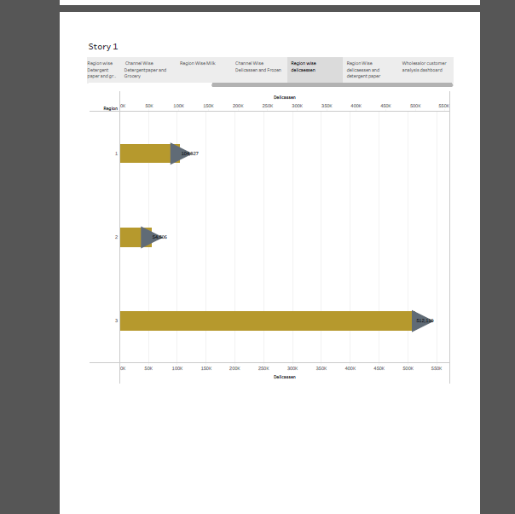

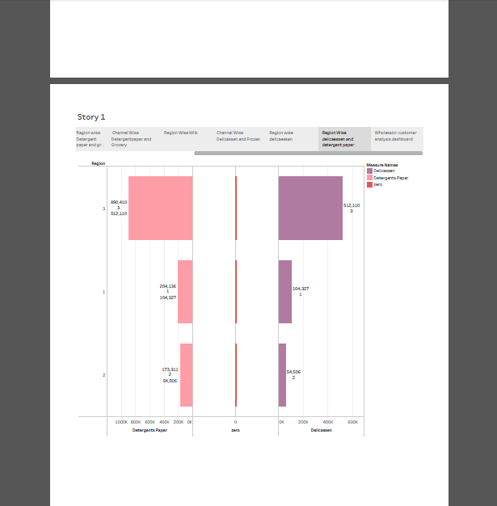

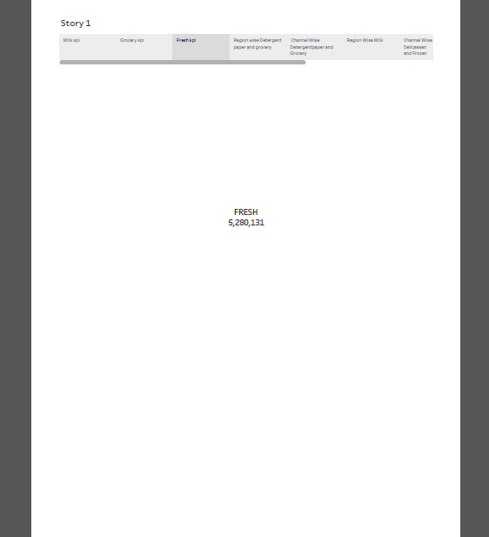

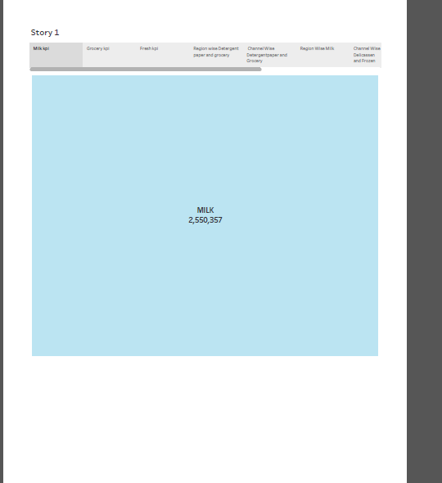

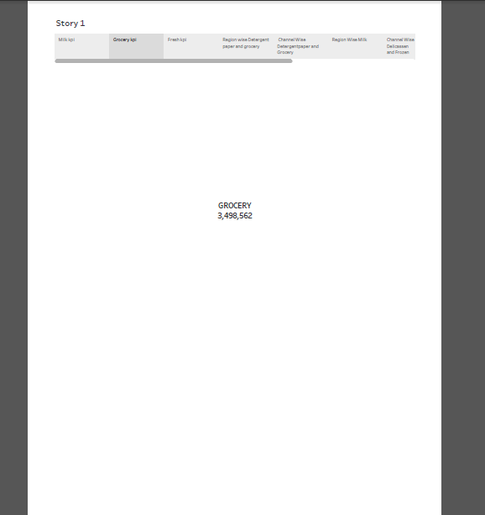

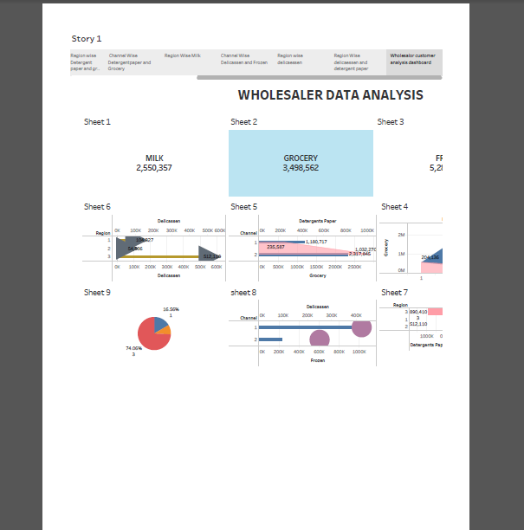

**ADVANTAGES & DISADVANTAGES:**

**ADVANTAGE:**

Wholesale offers numerous merits, including cost savings, increased profit margins, a wide product range, streamlined supply chain management, relationship building, market insights, business support, and opportunities for market expansion.

Wholesalers buy large quantity of goods from manufactures. They can receive cash discount and quantity discount because of bulk buying. It helps to reduce buying cost and increase profit. So, wholesale business enjoys the benefit of large scale buying.

Using sophisticated data analytics techniques, companies can better understand their market and customers, which can lead to effective digital marketing tactics, more personalized customer interactions, greater customer satisfaction, higher efficiency and bigger profit.

**DISADVANTAGE:**

Since wholesale order tends to have a large quantity, the shipping and delivery fee can be pretty expensive for manufacturers and distributors. By applying the amount restricted, they can ensure the profit of each order is enough to reach a certain level that can cover the cost of shipping and fulfillment.

One of the most common issues in marketing analytics is a surplus of incoming data. This forces you to spend a lot of time and effort to identify which information is most relevant. More data means more time to sort, so there might be delays in results.

**5. APPLICATIONS:**

Wholesalers can sell their items at a lower price because they buy in bulk, which cuts down on processing time and costs. They normally deliver large amounts of items, although they can also accept smaller orders. The wholesaler can be the manufacturer or producer, but this is not always necessary.

Primary advantage of the wholesale business model is that it enables other businesses to purchase products at reduced costs and in greater quantities. This, in turn, helps them enhance their profitability while simultaneously cutting down on expenses.

Data analytics provides the opportunity for companies and marketing teams to gain more insight to help make their business more relevant and establish themselves within saturated markets. Standing out is the biggest goal for your brand to attract your customers. Instead of a more broad outreach, with analytics, you can leverage more precise information to target your brand strategies and the user experience.

When the essential aspects of your marketing are available, it creates an established roadmap for growth and boosts [sales development](https://smith.ai/blog/9-ways-to-effectively-outsource-sales-development-sales-outsourcing-101). You can easily scale your products or services to further meet your audience's needs. Understanding what trends are about to happen and being able to jump on them almost as soon as they occur is vital to your marketing strategy

**6. CONCLUSION:**

As a conclusion, the marketing concept is the philosophy where each and every firms should analyze the needs of their customers and makes good decisions in order to satisfy their needs. This also can enhance a good relationship between the customers. Besides, the marketing concept developed as an alternative to the selling concept as the way business firms fundamentally approach the market. The guiding theme for marketing practice under the selling concept insists that given enough selling and advertising, customers can be convinced to buy the product. Marketing is not just flogging product and putting a spin on everything but it’s about serious organization and business planning.

**FUTURE SCOPE:**

Marketing management encompasses the promotion and marketing of products and services. This involves conducting market research to understand customer needs and preferences, developing product/service offerings that align with market demands, and creating marketing campaigns to generate awareness and drive sales.