Case Study Report



**Tech Saksham**

Data Analytics with Power BI

**360-DEGREE BUSINESS ANALYSIS of ONLINE DELIVERY APPS using power bi**

**Government Arts College – Dharmapuri**

**NAME : R.SOWMIYA**

**NM ID : 360A5F49A0BB79794B0498F9CBDFF529**

|  |  |
| --- | --- |
|  |  |
|  | **Master Trainer**  **R.UMAMAHESWARI** |
|  |  |

**ABSTRACT**

In the digital age, data has become an invaluable asset for businesses, particularly in the business sector. The proposed project, “ **360-Degree Business Analysis** ” aims to leverage PowerBI, a leading business intelligence tool, to analyze and visualize real-time customer data. This project will enable business to gain deep insights into customer behavior, preferences, and trends, thereby facilitating data-driven decision-making and enhancing customer satisfaction. The real-time analysis will allow to respond promptly to changes in customer behavior or preferences, identify opportunities for cross-selling and up-selling, and tailor their products and services to meet customer needs. The project will also contribute to the broader goal of digital transformation in the business sector, promoting efficiency, innovation, and customer-centricity.

By integrating different restaurants and allowing customers to select restaurants, leave reviews and check listings and accessibility according to their choice of food, Zomato’s s business strategy has changed the food business sector. It offers analytical information for numerous eateries in 24 countries around the world. These analyses serve to improve the business of eateries.

We’ll uncover the fundamental characteristics of the Business Model of Zomato in this article and discover how it manages all its activities and generates income. Let’s start immediately by knowing more about the company.

Zomato is an Indian multinational restaurant aggregator and food delivery company founded by Pankaj Chaddah and Deepinder Goyal in 2008. Zomato provides information,menus and user-reviews of restaurants aswell as food delivery options from partner restaurants in select cities.

**INDEX**

|  |  |  |
| --- | --- | --- |
| **Sr. No.** | **Table of Contents** | **Page No.** |
| 1 | Chapter 1: Introduction | 4 |
| 2 | Chapter 2: Services and Tools Required | 9 |
| 3 | Chapter 3: Project Architecture | 11 |
| 4 | Chapter 4: Modeling and Result | 13 |
| 5 | Conclusion | 19 |
| 6 | Future Scope | 20 |

**CHAPTER 1**

**INTRODUCTION**

The story of Zomato started in the office of Bain & Company in Delhi. Deepinder and Pankajworked at this company when they thought of this idea. They saw people standing in a queueat lunchtime and give the order for their food when their turn came. From there they got anidea of “Foodiebay” which became a prologue to Zomato.At first, they started scanning all the menu items of the restaurant and listed them on their intranet website Foodiebay.com. Later on, after seeing a huge surge in their traffic, they decided to launch their website open to the public. They began listing restaurants from Deli NCR on their portal and quickly expanded to other cities like Kolkata and Mumbai. In November 2010 they changed the name Foodiebay to Zomato.

Their idea germinated in the form of Foodiebay.com they put up scanned copies of the food court menu onto their company’s private network. Everyone at the company soon started using this service and there was a sudden surge in the website traffic. By now this wasn’t just confined to the walls of their office. Everyone else around their vicinity also started using these scanned copies. The first professional restaurant menu that Deepinder and Pankaj uploaded onto their site was that of Hauz Khas in Delhi. After this, they started expanding this idea into other metropolitan cities of the country including Kolkata, Mumbai, and Bangalore.

And once a word was around, thousands of people started using their website to get to knowabout the best restaurants around. It was this interest from people around that encourage both Pankaj and Deepinder to think of going PAN India with this idea. This is when the idea of renaming the site came into their minds. They wanted something with more of a punch and something easier to remember and hence came the word ZOMATO in November 2010. The founders then wanted to make life a little easier for their users and hence came the idea of building a mobile application. With this growth in their business and their ideas arose a need for funding.

* 1. **Problem Statement**

“Different food delivery applications often provide different offers or discounts. Users are also not satisfied with their delivery time and random cancellations. Suggest an app which can solve these problems and increase user interaction.”The current food delivery applications provide different discounts on the same item but in different platform. It is also seen that delivery time of an item is not same in all the applications. Adding all the discounts and estimated delivery time of different food joints under a single interface will be economical and less time consuming.

**Analyzing the problem statement**

* The age group of the users are mostly 18–40 years. In this age group, users are mostly busy and engrossed in their work. So going through all the discounts and price ranges are difficult and time consuming.
* Users prefer to order food during their lunch time which is of a very small duration mostly 40 mins.
* Users likes to order the food that they are comfortable with. So, a detailed ingredients list is a plus point, in case the users are prone to allergies of a certain element.
* Users also prefers those food joints which provide faster and smoother delivery.
* Users would also like to have a no-cancellation guarantee before they place their order. This would build a trust between the users and the food joints.
* Users would like to trust the food joints by seeing the review (probably by stars) and feedback).
* Users also prefers re-ordering their orders. So once the orders are placed, the order history must be saved in the app.
  1. **Proposed Solution**

Zomato targets people of the age group of 18-35 years who are comfortable using smartphones The people of this age group are tech-savvy and can use mobile applications. The target audience of Zomato is of 2 categories.

• Customers who want to dine out

The customers in the “dine out” category use the Zomato app to check the ratings and reviews of various restaurants and cafes they are interested in. These are the kind of customers wh want to make sure that they get a good experience in terms of food and ambiance and check the restaurant listings on Zomato before visiting. This category also gets incentives like Zomato Gold Program, where they get extra benefits if they have a membership.

• Customers who are ordering food online

The customers of the “order food online” category likes to have food delivered at their home or workplace. These customers do not prefer to go out. The customers of this category are mostly professionals who order food for the office, students who live in a hostel or flat, and people who just don’t wish to cook

* Maintaining accurate timing.
* Converting new leads.
* Upscaling services.
* Ensuring instant delivery.
* Ensuring quality experiences.
* Making delivery profitable.
* Handling issues related to location
  1. **Feature**

. Zomato is one of the top food delivery and restaurant finder app around the world. Currently, they are providing food delivery service in India, Lebanon and UAE. **They spread across as a restaurant finder in 24 countries and available in 10 languages globally.**

Zomato has lots of unique features that address customer needs. They provide you with the best app that helps you with dining out, table booking, takeaway and discoveries. Here are some unique features of Zomato that you should know.

* **Table Booking**

Table booking is one of the most significant features which is required to build a successful restaurant business. The user can easily book tables whenever they want. Table booking provides convenience to the user as well as prevent disappointment.

**Zomato has more than 1.4 million restaurants in their list where you can find a suitable restaurant to book table for your need.** Most of the restaurants allow table booking from 2–8 persons.

* **Follow Your Friends**

Everyone loves to eat their favorite food. Zomato provides an option for foodies to follow their friends so that they can know what their friends eat and what they like. They can also discover more from the places nearby.

* **Self PickUp**

You can enjoy offers and promos as well as no need to wait for your delivery. Zomato provides you with a feature that you can order your food online pick it up from the restaurant by yourself. This option saves your time as well as you can have your food on the go.

* **Restaurant Profile**

The restaurant has full control over their profile in the Zomato. They can provide useful information to their user to help them out. The restaurant has the option to provide details like food menu, images, phone number, direction to the restaurant and reviews.

* 1. **Advantages**
* **Convenience:**

The primary advantage of ordering food online through Zomato is convenience. With just a few clicks, you can order your favorite food from your preferred restaurant, and it will be delivered to your doorstep within a short time. You don’t have to worry about traffic or parking or waiting in long lines. You can simply relax at home while enjoying a delicious meal.

* **Wide range of options:**

Zomato has a vast network of restaurants and food outlets, which means you can order food from anywhere. Whether you’re in the mood for Indian, Chinese, Italian, or any other cuisine, you can find a restaurant that serves it. Moreover, Zomato offers a variety of options, including vegetarian, non-vegetarian, vegan, and gluten-free meals, which means there is something for everyone.

* **Saves time:**

Ordering food online through Zomato saves you a significant amount of time. You don’t have to spend time commuting to the restaurant, waiting for a table, or waiting for your food to be prepared. You can place your order in a matter of minutes, and your food will be delivered to your doorstep. This means you can spend your time doing other important things, such as working or spending time with your family.

* **Easy to use:**

Zomato’s platform is user-friendly, which means you can easily navigate the website or the app. You can search for restaurants by location, cuisine, or restaurant name. You can also read reviews from other customers to help you make an informed decision. Once you’ve selected your restaurant, you can choose your meal, customize it if necessary, and place your order.

* **Offers deals and discounts:**

Zomato offers deals and discounts on its platform regularly. You can take advantage of these offers and save money on your orders. Moreover, Zomato has a loyalty program called Zomato Gold, which offers exclusive discounts and perks to its members. With Zomato Gold, you can get up to 1+1 on food and drinks at select restaurants.

* **Safe and hygienic:**

In the current scenario, safety and hygiene are of utmost importance. Zomato ensures that its partner restaurants follow all safety protocols and guidelines. The delivery executives wear masks and gloves and follow contactless delivery procedures to ensure the safety of customers. Moreover, Zomato allows you to opt for a no-contact delivery, which means the delivery executive will leave the food at your doorstep and notify you when it is done.

* 1. **Scope**

**Zomato** is a fastest growing restaurant discovery website, established in 2008 by Deepinder Goyal and Pankaj Chaddah. Initially, it was named as Foodiebay but in 2010, it was renamed as Zomato. It provides not only information related to nearby restaurants but also provides facilities such as online ordering, table reservations and management. Zomato currently serves in 10,000 cities across 36 countries having 1.2 million popular restaurants with 80 million foodies every month. It is available in 10 different languages and has 10 million reviews with 18 million bookmarks. It gives a platform to the restaurants owners to serves a large number of users a good quality of food.

**CHAPTER 2**

**SERVICES AND TOOLS REQUIRED**

**2.1 Services Used**

* **Data Collection and Storage Services**: Zomato need to collect and store customer data in real-time. This could be achieved through services like Azure Data Factory, Azure Event Hubs, or AWS Kinesis for real-time data collection, and Azure SQL Database or AWS RDS for data storage.
* **Data Processing Services**: Services like Azure Stream Analytics or AWS Kinesis Data Analytics can be used to process the real-time data.
* **Machine Learning Services**: Azure Machine Learning or AWS SageMaker can be used to build predictive models based on historical data.

**2.2 Tools and Software used**

**Tools**:

* **PowerBI**: The main tool for this project is PowerBI, which will be used to create interactive dashboards for real-time data visualization.
* **Power Query**: This is a data connection technology that enables you to discover, connect, combine, and refine data across a wide variety of sources.

**Software Requirements**:

* **PowerBI Desktop**: This is a Windows application that you can use to create reports and publish them to PowerBI.
* **PowerBI Service**: This is an online SaaS (Software as a Service) service that you use to publish reports, create new dashboards, and share insights.
* **PowerBI Mobile**: This is a mobile application that you can use to access your reports and dashboards on the go.

**CHAPTER 3**

**PROJECT ARCHITECTURE**

**3.1 Architecture**

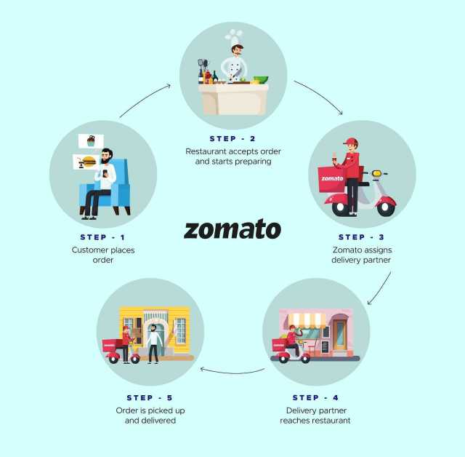

Here’s a high-level architecture for the project:

1. **Data Collection**: Real-time customer data is collected from various sources like food deliverys, customer interactions, etc. This could be achieved using services like Azure Event Hubs or AWS Kinesis.
2. **Data Storage**: The collected data is stored in a database for processing. Azure SQL Database or AWS RDS can be used for this purpose.
3. **Data Processing**: The stored data is processed in real-time using services like Azure Stream Analytics or AWS Kinesis Data Analytics.
4. **Machine Learning**: Predictive models are built based on processed data using Azure Machine Learning or AWS SageMaker. These models can help in predicting customer behavior, detecting fraud, etc.
5. **Data Visualization**: The processed data and the results from the predictive models are visualized in real-time using PowerBI. PowerBI allows you to create interactive dashboards that can provide valuable insights into the data.
6. **Data Access**: The dashboards created in PowerBI can be accessed through PowerBI Desktop, PowerBI Service (online), and PowerBI Mobile.

This architecture provides a comprehensive solution for real-time analysis of zomto customers. However, it’s important to note that the specific architecture may vary depending on the zomato’s existing infrastructure, specific requirements, and budget. It’s also important to ensure that all tools and services comply with relevant data privacy and security regulations.

**CHAPTER 4**

**MODELING AND RESULT**

**Manage relationship**

The “disp” file will be used as the main connector as it contains most key identifier (account id, client id and disp id) which can be use to relates the 8 data files together. The “district” file is use to link the client profile geographically with “district id”

* **Manage the Relationship**

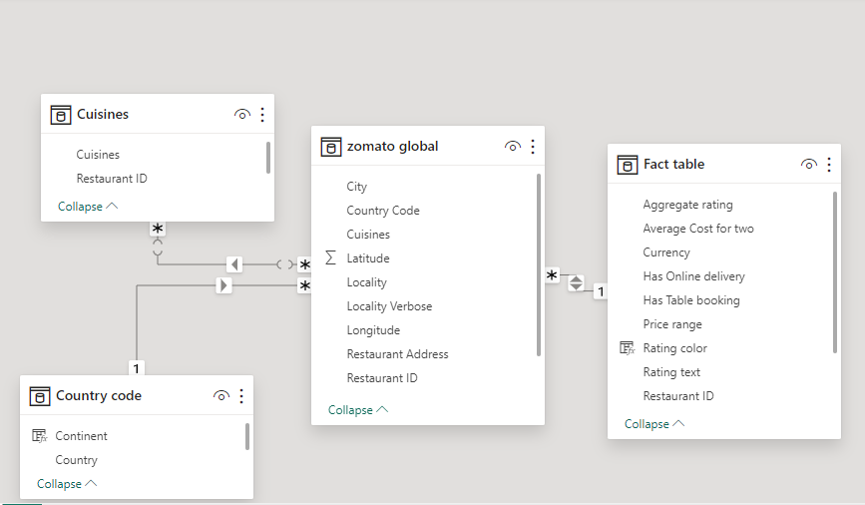

* **Combining the Datasets**

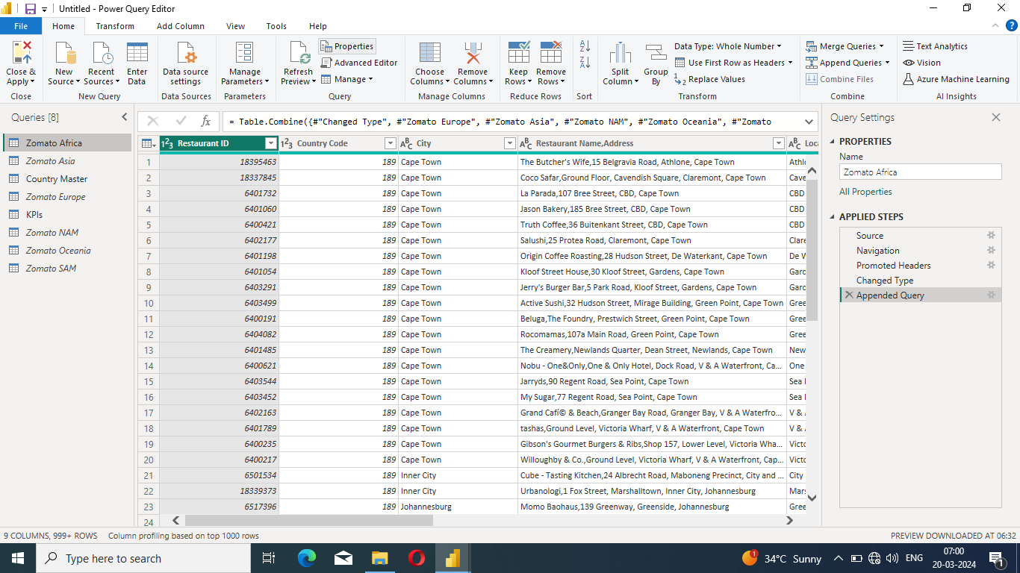

* **Add cards to find total restaurants**

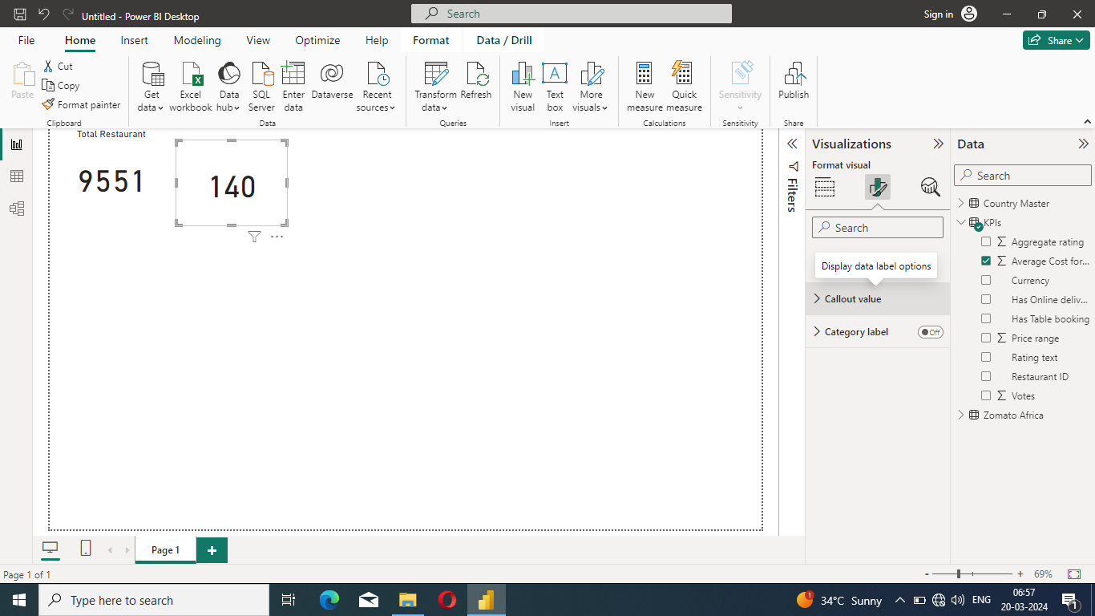

* .**Rating Colour**

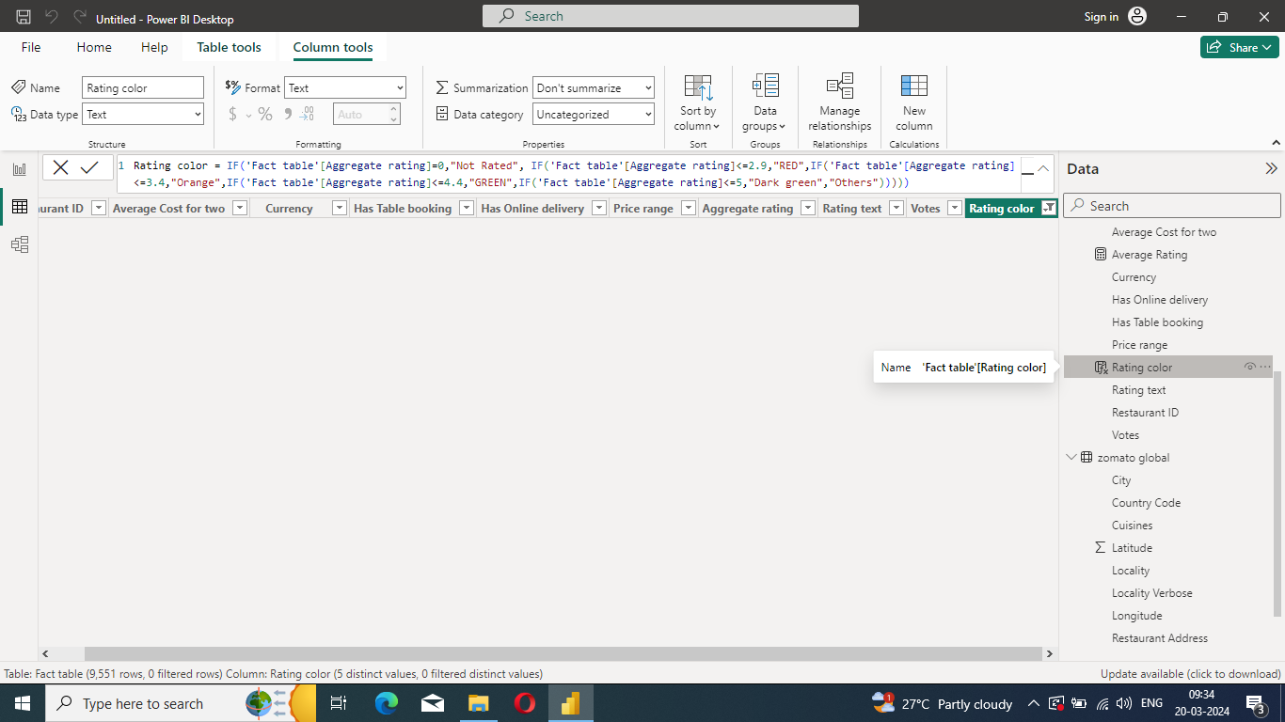

* **Bar chart to find restaurant count by color**

.

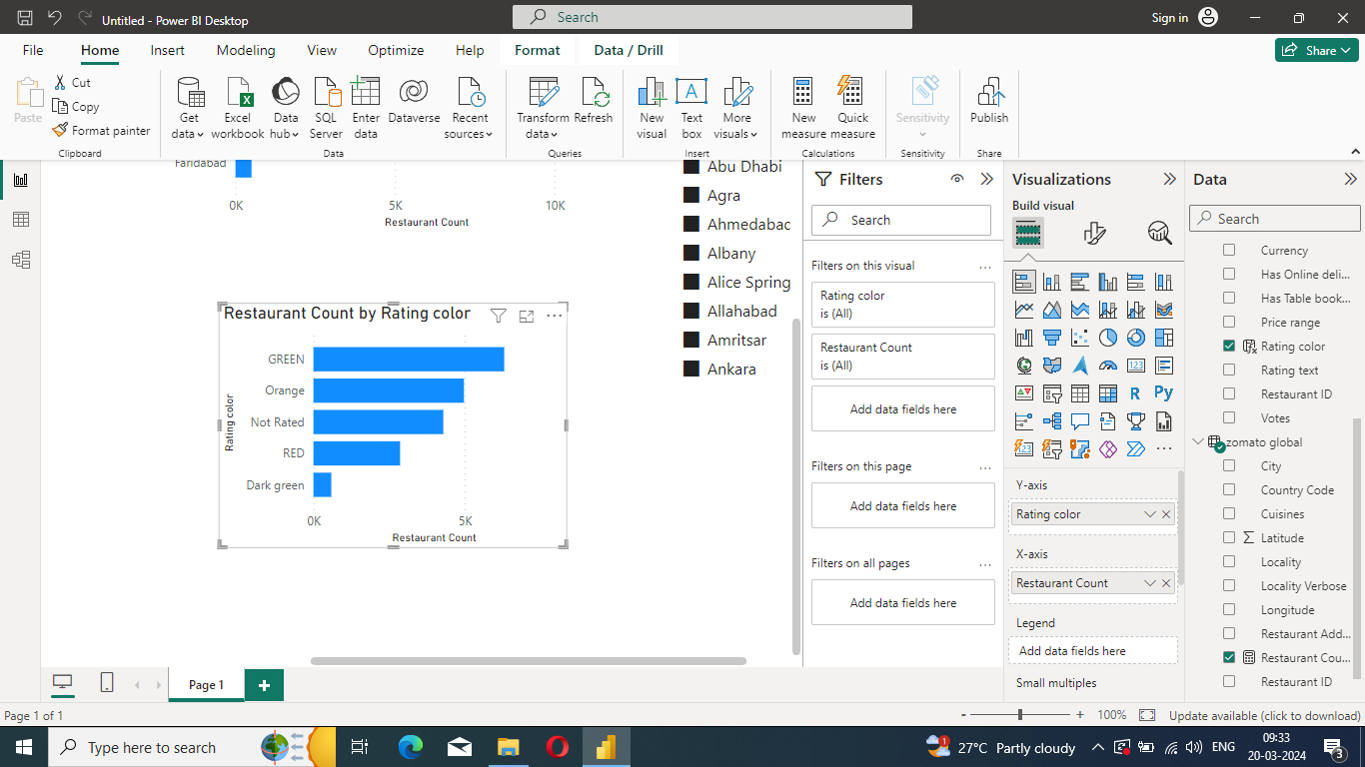

* **Restaurant count by city**

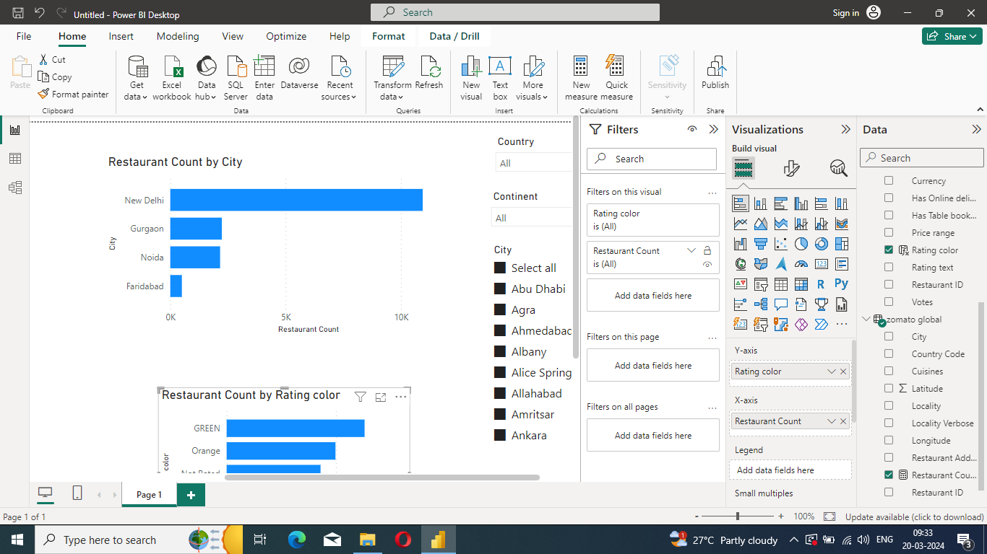

**Dashboard**

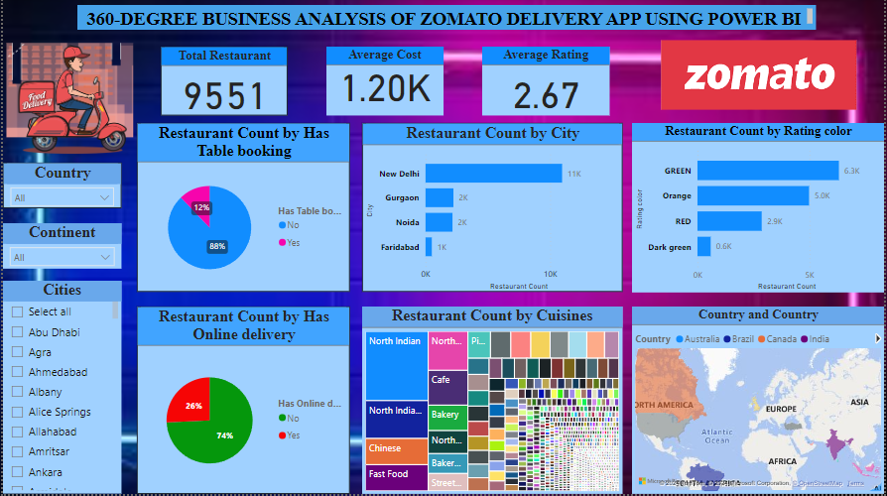

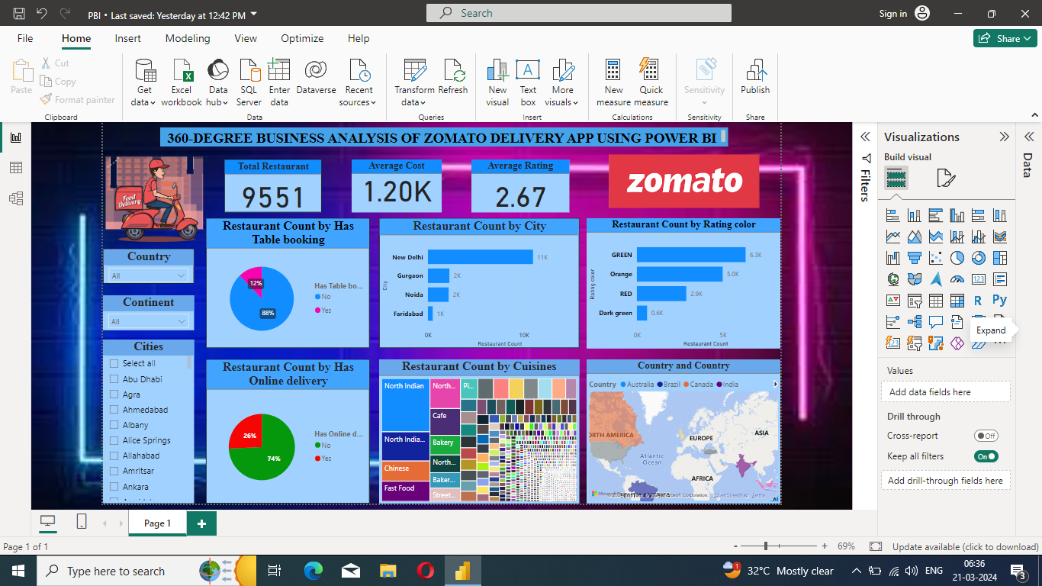

**CONCLUSION**

The project “ 360-degree business analysis of zomato ” using PowerBI has successfully demonstrated the potential of data analytics in the food delivery sector. The real-time analysis of customer data has provided valuable insights into customer behavior, preferences, and trends, thereby facilitating informed decision-making. The interactive dashboards and reports have offered a comprehensive view of customer data, enabling the identification of patterns and correlations. This has not only improved the efficiency of data analysis but also enhanced the zomato’s ability to provide personalized services to its customers. The project has also highlighted the importance of data visualization in making complex data more understandable and accessible. The use of PowerBI has made it possible to present data in a visually appealing and easy-to-understand format, thereby aiding in better decision-making.

**FUTURE SCOPE**

The future scope of this project is vast. With the advent of advanced analytics and machine learning, PowerBI can be leveraged to predict future trends based on historical data. Integrating these predictive analytics into the project could enable the bank to anticipate customer needs and proactively offer solutions. Furthermore, PowerBI’s capability to integrate with various data sources opens up the possibility of incorporating more diverse datasets for a more holistic view of customers. As data privacy and security become increasingly important, future iterations of this project should focus on implementing robust data governance strategies. This would ensure the secure handling of sensitive customer data while complying with data protection regulations. Additionally, the project could explore the integration of real-time data streams to provide even more timely and relevant insights. This could potentially transform the way banks interact with their customers, leading to improved customer satisfaction and loyalty.