**Assignment-2**

**ATLANTA POPULATION**

1.

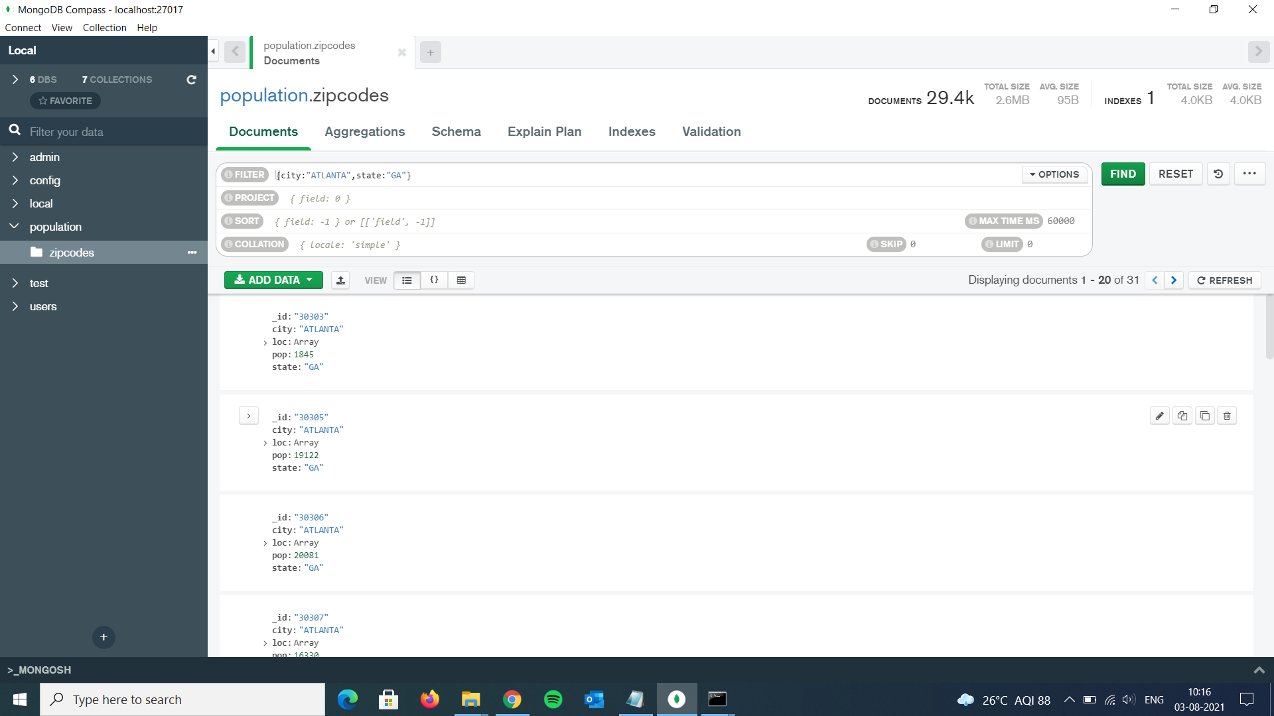

2.

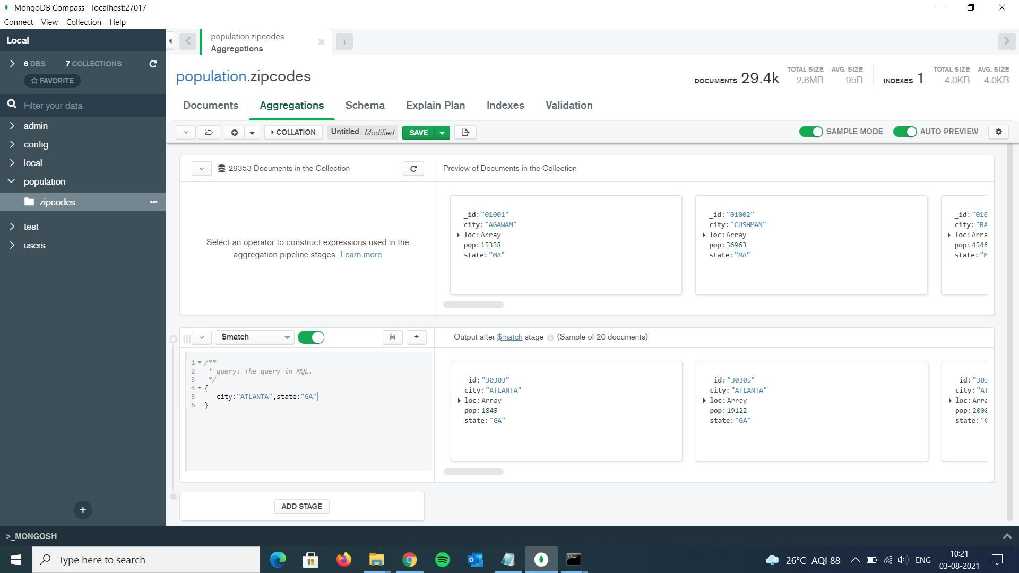

3.

> db.zipcodes.aggregate( { $match:{city:"ATLANTA"} }, { $group: { _id:"$state",zipcodes:{$sum:1}}});

{ "_id" : "KS", "zipcodes" : 1 }

{ "_id" : "NE", "zipcodes" : 1 }

{ "_id" : "NY", "zipcodes" : 1 }

{ "_id" : "TX", "zipcodes" : 1 }

{ "_id" : "IL", "zipcodes" : 1 }

{ "_id" : "GA", "zipcodes" : 31 }

{ "_id" : "IN", "zipcodes" : 1 }

{ "_id" : "MI", "zipcodes" : 1 }

{ "_id" : "MO", "zipcodes" : 1 }

{ "_id" : "LA", "zipcodes" : 1 }

{ "_id" : "ID", "zipcodes" : 1 }

------------------------------------------------------------------------------------------------------------------

4.

> db.zipcodes.aggregate( { $match:{city:"ATLANTA"}}, { $group: {_id:{city:"$city"}, population:{$sum:"$pop"}}});

{ "_id" : { "city" : "ATLANTA" }, "population" : 630046 }

-------------------------------------------------------------------------------------------------------------------

**POPULATIONS BY STATE**

1.

> db.zipcodes.aggregate(

... {$group:

... {

... _id: { state:"$state"},

... population:{$sum:"$pop"}

... }

... });

{ "_id" : { "state" : "OH" }, "population" : 10846517 }

{ "_id" : { "state" : "ND" }, "population" : 638272 }

{ "_id" : { "state" : "MO" }, "population" : 5110648 }

{ "_id" : { "state" : "LA" }, "population" : 4217595 }

{ "_id" : { "state" : "NE" }, "population" : 1578139 }

{ "_id" : { "state" : "AR" }, "population" : 2350725 }

{ "_id" : { "state" : "WY" }, "population" : 453528 }

{ "_id" : { "state" : "NY" }, "population" : 17990402 }

{ "_id" : { "state" : "NJ" }, "population" : 7730188 }

{ "_id" : { "state" : "MT" }, "population" : 798948 }

{ "_id" : { "state" : "MD" }, "population" : 4781379 }

{ "_id" : { "state" : "CT" }, "population" : 3287116 }

{ "_id" : { "state" : "ME" }, "population" : 1226648 }

{ "_id" : { "state" : "GA" }, "population" : 6478216 }

{ "_id" : { "state" : "IN" }, "population" : 5544136 }

{ "_id" : { "state" : "AL" }, "population" : 4040587 }

{ "_id" : { "state" : "KS" }, "population" : 2475285 }

{ "_id" : { "state" : "NM" }, "population" : 1515069 }

{ "_id" : { "state" : "CA" }, "population" : 29754890 }

{ "_id" : { "state" : "HI" }, "population" : 1108229 }

Type "it" for more

---------------------------------------------------------------------------------------------------------------

2.

> db.zipcodes.aggregate( {$group: { _id: { state:"$state"}, population:{$sum:"$pop"} } },{$sort:{population:-1}});

{ "_id" : { "state" : "CA" }, "population" : 29754890 }

{ "_id" : { "state" : "NY" }, "population" : 17990402 }

{ "_id" : { "state" : "TX" }, "population" : 16984601 }

{ "_id" : { "state" : "FL" }, "population" : 12686644 }

{ "_id" : { "state" : "PA" }, "population" : 11881643 }

{ "_id" : { "state" : "IL" }, "population" : 11427576 }

{ "_id" : { "state" : "OH" }, "population" : 10846517 }

{ "_id" : { "state" : "MI" }, "population" : 9295297 }

{ "_id" : { "state" : "NJ" }, "population" : 7730188 }

{ "_id" : { "state" : "NC" }, "population" : 6628637 }

{ "_id" : { "state" : "GA" }, "population" : 6478216 }

{ "_id" : { "state" : "VA" }, "population" : 6181479 }

{ "_id" : { "state" : "MA" }, "population" : 6016425 }

{ "_id" : { "state" : "IN" }, "population" : 5544136 }

{ "_id" : { "state" : "MO" }, "population" : 5110648 }

{ "_id" : { "state" : "WI" }, "population" : 4891769 }

{ "_id" : { "state" : "TN" }, "population" : 4876457 }

{ "_id" : { "state" : "WA" }, "population" : 4866692 }

{ "_id" : { "state" : "MD" }, "population" : 4781379 }

{ "_id" : { "state" : "MN" }, "population" : 4372982 }

-------------------------------------------------------------------------------------------------------

3.

> db.zipcodes.aggregate( {$group: { _id: { state:"$state"}, population:{$sum:"$pop"} } },{$sort:{population:-1}},{$limit:3});

{ "_id" : { "state" : "CA" }, "population" : 29754890 }

{ "_id" : { "state" : "NY" }, "population" : 17990402 }

{ "_id" : { "state" : "TX" }, "population" : 16984601 }

----------------------------------------------------------------------------------------------------------------

POPULATIONS BY CITY

1.

> db.zipcodes.aggregate( {$group: { _id: { city:"$city",state:"$state"}, population:{$sum:"$pop"} } });

{ "_id" : { "city" : "PERRY", "state" : "NY" }, "population" : 6218 }

{ "_id" : { "city" : "SUMMIT HILL", "state" : "PA" }, "population" : 3332 }

{ "_id" : { "city" : "DURHAM", "state" : "CT" }, "population" : 5737 }

{ "_id" : { "city" : "CLOVER BOTTOM", "state" : "KY" }, "population" : 8071 }

{ "_id" : { "city" : "NEW SITE", "state" : "MS" }, "population" : 1187 }

{ "_id" : { "city" : "WILLIAMSPORT", "state" : "KY" }, "population" : 295 }

{ "_id" : { "city" : "KENNEDY", "state" : "NY" }, "population" : 2719 }

{ "_id" : { "city" : "RICHARDTON", "state" : "ND" }, "population" : 1091 }

{ "_id" : { "city" : "SPAULDING", "state" : "IL" }, "population" : 3921 }

{ "_id" : { "city" : "PFEIFER", "state" : "KS" }, "population" : 123 }

{ "_id" : { "city" : "CALLAO", "state" : "MO" }, "population" : 878 }

{ "_id" : { "city" : "PRINCETON", "state" : "LA" }, "population" : 1914 }

{ "_id" : { "city" : "PARADE", "state" : "SD" }, "population" : 819 }

{ "_id" : { "city" : "VINITA", "state" : "OK" }, "population" : 8987 }

{ "_id" : { "city" : "HAMPTON", "state" : "AR" }, "population" : 3505 }

{ "_id" : { "city" : "DANA", "state" : "IL" }, "population" : 257 }

{ "_id" : { "city" : "GLENDORA", "state" : "NJ" }, "population" : 5205 }

{ "_id" : { "city" : "BRUNER", "state" : "MO" }, "population" : 737 }

{ "_id" : { "city" : "SPRINGFIELD", "state" : "OR" }, "population" : 59905 }

{ "_id" : { "city" : "DUBLIN", "state" : "CA" }, "population" : 23275 }

Type "it" for more

--------------

2.

> db.zipcodes.aggregate( {$group: { _id: { city:"$city",state:"$state"}, population:{$sum:"$pop"} } },{$sort:{population:-1}});

{ "_id" : { "city" : "CHICAGO", "state" : "IL" }, "population" : 2452177 }

{ "_id" : { "city" : "BROOKLYN", "state" : "NY" }, "population" : 2300504 }

{ "_id" : { "city" : "LOS ANGELES", "state" : "CA" }, "population" : 2102295 }

{ "_id" : { "city" : "HOUSTON", "state" : "TX" }, "population" : 2095918 }

{ "_id" : { "city" : "PHILADELPHIA", "state" : "PA" }, "population" : 1610956 }

{ "_id" : { "city" : "NEW YORK", "state" : "NY" }, "population" : 1476790 }

{ "_id" : { "city" : "BRONX", "state" : "NY" }, "population" : 1209548 }

{ "_id" : { "city" : "SAN DIEGO", "state" : "CA" }, "population" : 1049298 }

{ "_id" : { "city" : "DETROIT", "state" : "MI" }, "population" : 963243 }

{ "_id" : { "city" : "DALLAS", "state" : "TX" }, "population" : 940191 }

{ "_id" : { "city" : "PHOENIX", "state" : "AZ" }, "population" : 890853 }

{ "_id" : { "city" : "MIAMI", "state" : "FL" }, "population" : 825232 }

{ "_id" : { "city" : "SAN JOSE", "state" : "CA" }, "population" : 816653 }

{ "_id" : { "city" : "SAN ANTONIO", "state" : "TX" }, "population" : 811792 }

{ "_id" : { "city" : "BALTIMORE", "state" : "MD" }, "population" : 733081 }

{ "_id" : { "city" : "SAN FRANCISCO", "state" : "CA" }, "population" : 723993 }

{ "_id" : { "city" : "MEMPHIS", "state" : "TN" }, "population" : 632837 }

{ "_id" : { "city" : "SACRAMENTO", "state" : "CA" }, "population" : 628279 }

{ "_id" : { "city" : "JACKSONVILLE", "state" : "FL" }, "population" : 610160 }

{ "_id" : { "city" : "ATLANTA", "state" : "GA" }, "population" : 609591 }

Type "it" for more

-----------------------------

3.

> db.zipcodes.aggregate( {$group: { _id: { city:"$city",state:"$state"}, population:{$sum:"$pop"} } },{$sort:{population:-1}},{$limit:3});

{ "_id" : { "city" : "CHICAGO", "state" : "IL" }, "population" : 2452177 }

{ "_id" : { "city" : "BROOKLYN", "state" : "NY" }, "population" : 2300504 }

{ "_id" : { "city" : "LOS ANGELES", "state" : "CA" }, "population" : 2102295 }

--------------------

4.

> db.zipcodes.aggregate( {$group: { _id: { city:"Texas",state:"$state"}, population:{$sum:"$pop"} } },{$sort:{population:-1}},{$limit:3});

{ "_id" : { "city" : "Texas", "state" : "CA" }, "population" : 29754890 }

{ "_id" : { "city" : "Texas", "state" : "NY" }, "population" : 17990402 }

{ "_id" : { "city" : "Texas", "state" : "TX" }, "population" : 16984601 }

-----------------------------------------

1.

> db.zipcodes.aggregate( {$group: { _id: { city:"$city",state:"$state"},avg_population:{$avg:"$pop"} } });

{ "_id" : { "city" : "SODDY DAISY", "state" : "TN" }, "avg_population" : 19646 }

{ "_id" : { "city" : "CAT CREEK", "state" : "MT" }, "avg_population" : 155 }

{ "_id" : { "city" : "MADISON", "state" : "KS" }, "avg_population" : 1430 }

{ "_id" : { "city" : "CLINTON", "state" : "MS" }, "avg_population" : 25262 }

{ "_id" : { "city" : "PAMPLICO", "state" : "SC" }, "avg_population" : 6291 }

{ "_id" : { "city" : "RIDGEWAY", "state" : "CT" }, "avg_population" : 17839 }

{ "_id" : { "city" : "LINEBORO", "state" : "MD" }, "avg_population" : 94 }

{ "_id" : { "city" : "RAPHINE", "state" : "VA" }, "avg_population" : 2238 }

{ "_id" : { "city" : "SHORT HILLS", "state" : "NJ" }, "avg_population" : 12129 }

{ "_id" : { "city" : "CANTRIL", "state" : "IA" }, "avg_population" : 490 }

{ "_id" : { "city" : "DEDHAM", "state" : "IA" }, "avg_population" : 562 }

{ "_id" : { "city" : "BALD KNOB", "state" : "AR" }, "avg_population" : 5132 }

{ "_id" : { "city" : "BIG WELLS", "state" : "TX" }, "avg_population" : 882 }

{ "_id" : { "city" : "BARTONSVILLE", "state" : "PA" }, "avg_population" : 553 }

{ "_id" : { "city" : "SCOTLAND", "state" : "MD" }, "avg_population" : 356 }

{ "_id" : { "city" : "CARLTON", "state" : "GA" }, "avg_population" : 2046 }

{ "_id" : { "city" : "HENDERSON", "state" : "MI" }, "avg_population" : 534 }

{ "_id" : { "city" : "QUINNESEC", "state" : "MI" }, "avg_population" : 1313 }

{ "_id" : { "city" : "JESSUP", "state" : "PA" }, "avg_population" : 4349 }

{ "_id" : { "city" : "NEW BOSTON", "state" : "OH" }, "avg_population" : 33275 }

Type "it" for more

---------------------

2.

> db.zipcodes.aggregate( {$group: { _id: { city:"$city",state:"$state"},avg_population:{$avg:"$pop"} } },{$sort:{avg_population:-1}},{$limit:3});

{ "_id" : { "city" : "BELL GARDENS", "state" : "CA" }, "avg_population" : 99568 }

{ "_id" : { "city" : "NORWALK", "state" : "CA" }, "avg_population" : 94188 }

{ "_id" : { "city" : "ARLETA", "state" : "CA" }, "avg_population" : 88114 }