FDE Assignment — Detailed Implementation Plan
Project: Cold Call Companion — A real-time call guidance and tracking application
Role: Forward Deployed Engineer (FDE) assignment for DeepThought CultureTech
Available time: Approximately 30 hours
Our objective: Build a functional, deployed, end-to-end application that helps a caller navigate a cold call, capture what happens at each stage, save the call, and review the results later. The application must use an LLM, a persistent database, a backend API, and a frontend deployed publicly.
1. Problem statement
Cold calls are difficult to manage because the caller has to perform several tasks simultaneously:
- Follow a structured conversation.
- Explain the purpose of the call.
- Listen to the prospect and respond appropriately.
- Handle objections and identify potential interest.
- Record what the prospect actually said.
- Decide the next step and record the final outcome.
When all of this is done manually, the caller may lose track of the conversation, miss important information, or record an inaccurate outcome.
The challenge is to build a Cold Call Companion that acts as a lightweight, real-time guide beside the caller's phone. It should help the caller understand where they are in the conversation, capture the important details without interrupting the call, and preserve an accurate record for future reference.
This is not a chatbot that talks to the prospect, nor is it a CRM that merely stores contacts. It is a stage-by-stage calling interface with structured data capture, persistent history, and useful AI assistance.
2. What DeepThought expects us to build
The assignment requires a working product with two primary screens and a complete backend.
Screen 1 — Active Call
- Show the current stage and its purpose.
- Show examples of what a prospect might say at that stage.
- Provide quick-action buttons to record what happened.
- Allow the caller to enter the prospect's exact words.
- Let the caller navigate to another stage.
- Allow the caller to end the call early or complete it.
Screen 2 — Call History
- List previously saved calls.
- Show the prospect and company.
- Show the furthest stage reached.
- Show the final outcome and summary.
- Allow the user to open a past call and review its recorded stages.
The product must also include:
- Database: Supabase to persist calls, stage results, notes, and outcomes.
- Backend: Render-hosted API for starting calls, saving stage results, closing calls, listing calls, and health checks.
- Frontend: A working web application deployed to Vercel.
- LLM: A supported model using a free API key, with the exact required functionality confirmed from the assignment instructions.
- Submission materials: Public GitHub repository, deployed URLs, README, and a Google Drive demo video of at least six minutes with you visible on camera.
The eight stages we will implement are:
1
Opening
Establish who has answered and whether we reached the right person.
2
Purpose
Explain why we are calling and respond to initial questions.
3
Permission
Establish whether the prospect can speak now.
4
Their business
Understand or discuss the prospect's business.
5
Their need, in their words
Identify their goals, challenges, or needs.
6
Objection
Handle concerns, hesitation, and resistance.
7
Next step
Agree on a follow-up, report, meeting, referral, or no further action.
8
Close
Record the outcome, capture a summary, and finish the call.
The stage content, purpose, and guidance will be based on the assignment's structure and reference pages. The stage order will be navigable rather than strictly locked, because real calls do not always follow a perfect sequence.
3. Our proposed solution
We will build a product called Cold Call Companion.
The central idea is simple: the caller should not need to think about how to use the application while talking to a prospect.
The interface will display one active stage at a time, keep important controls accessible, save information as the call progresses, and allow the caller to move forward, backward, or end the call at any point.
A. Active-call screen
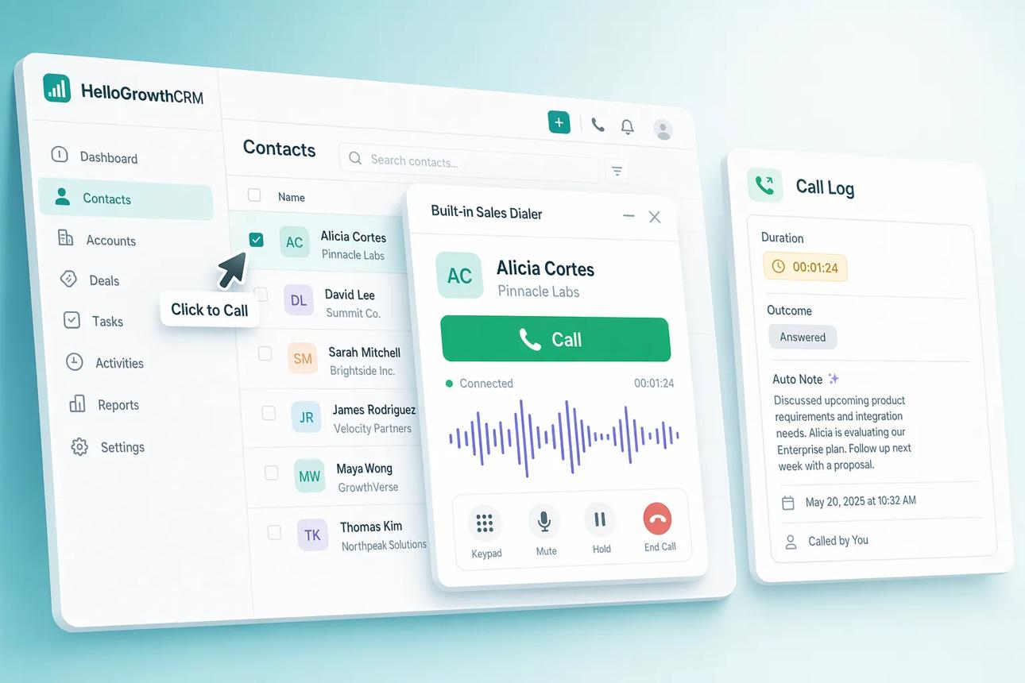
hellogrowthcrm.com
The final interface will be implemented as a functional web application, not copied from this illustrative image.
Header area
The header will contain:
- Application name and navigation.
- Prospect name and company.
- Call duration or elapsed time.
- Save status, such as Saved, Saving, or Retry needed.
- A clear End Call action.
Stage progress
The eight stages will appear as a compact progress indicator.
The caller can select a stage directly if the conversation moves unexpectedly. We will track both the current stage and the furthest stage reached, since they represent different things.
Stage guidance
For each stage, the screen will show:
- Stage name and purpose — what the caller is trying to achieve.
- What the prospect may say — up to three concise, paraphrased examples grounded in the transcripts.
- What happened? — quick-action buttons relevant to the current stage.
- Prospect's exact words — a text field for capturing important statements.
- Navigation — previous stage, next stage, and end call.
The action buttons will change based on the selected stage rather than showing the same generic choices everywhere.
For example, the Opening stage might offer actions such as Reached the right person, Reception answered, or Wrong person. The Next Step stage might offer Meeting agreed, Send report, Follow-up agreed, or No next step.
We will use the assignment's exact stage structure and evidence from the transcripts to refine these options.
B. End-call workflow
The caller must be able to end the call from any stage, not just Stage 8.
When the caller ends a call, the application will open a close-call panel containing:
- Final outcome.
- Agreed next step, if any.
- Optional notes.
- AI-generated summary and outcome suggestion, where available.
- A way to review and correct the AI suggestion before saving.
The caller's chosen outcome will always take precedence over the model's suggestion.
C. Call history screen
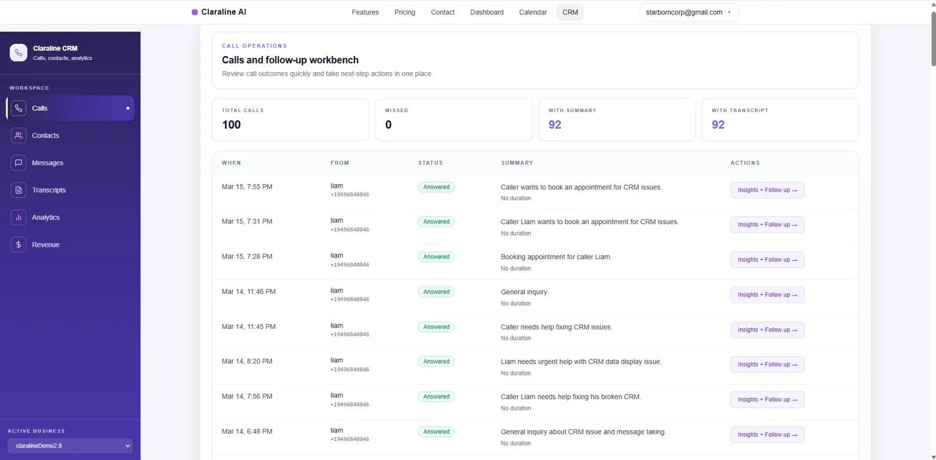
claraline.co
The history page will show a table or list of saved calls with:
Field | Purpose
Prospect | Identify who was called
Company | Identify the prospect's organization
Date and time | See when the call happened
Furthest stage | Understand how far the conversation progressed
Outcome | See the caller's final classification
Next step | See the agreed follow-up, if any
Summary | Quickly understand what happened
Selecting a call will open its details, including the recorded results and notes for each stage.
We will keep this page focused. Advanced CRM features, contact management, scheduling, and analytics are outside our initial scope unless all required features are already complete.
4. Technical architecture
We will use the technologies specified in the assignment.
React + Vite frontend
Active Call · Call History · AI suggestions
Vercel
Node.js + Express API
Validation · Call lifecycle · LLM integration
Render
Supabase
PostgreSQL database
LLM provider
Summary and outcome suggestion
Frontend — React + Vite
Responsibilities:
- Render the active-call and history screens.
- Manage the current call and stage navigation.
- Capture quick actions and notes.
- Display loading, saving, and error states.
- Communicate with the backend through REST APIs.
- Provide sensible fallback behavior when the backend is temporarily unavailable.
Backend — Node.js + Express
Responsibilities:
- Create calls and assign unique IDs.
- Validate all incoming data.
- Save or update stage results.
- Track the furthest stage reached.
- Close calls with a selected outcome.
- Retrieve call history.
- Call the LLM provider securely.
- Return consistent errors and health status.
Database — Supabase PostgreSQL
We will create two main tables.
calls
Stores the overall call record: ID, prospect, company, status, furthest stage, outcome, next step, summary, and timestamps.
stage_results
Stores one record per call and stage, including the stage number, selected action, prospect's words, and last update time.
A unique constraint on (call_id, stage) will prevent duplicate stage records. Updating a stage will update its existing record rather than create a duplicate.
We will also add the necessary indexes, constraints, and SQL schema file to the repository.
Security
- The Supabase service-role key stays on the backend.
- The LLM API key stays on the backend.
- Secrets will be configured through environment variables.
- .env files and private keys will not be committed to GitHub.
- The backend will validate outcomes, stage numbers, IDs, and note lengths.
- The database schema will document the intended security model.
Since this assignment does not specify user authentication, we will avoid building a full login system unless the task explicitly requires it. We will still keep the public endpoints constrained and validate requests.
5. API implementation plan
We will implement the required API endpoints first and test them before connecting every frontend component.
Method | Endpoint | Responsibility
GET | /health | Confirm the Render service is running
POST | /api/calls | Start a new call
PUT | /api/calls/:id/stages/:n | Save or update a stage result
POST | /api/calls/:id/close | Save final outcome and close the call
GET | /api/calls | Retrieve call history
GET | /api/calls/:id | Retrieve one call and its stage results
POST | /api/calls/:id/suggest-close | Generate an AI summary and outcome suggestion
The single-call endpoint is an additional useful feature for opening historical calls. The required endpoints remain the priority.
Backend behavior we will enforce
- A new call starts with an ID, a timestamp, and an initial stage.
- Stage results can be saved repeatedly without duplication.
- Moving backward in the UI will not reduce the furthest stage reached.
- Ending a call early will still save the call and its actual outcome.
- A closed call cannot accidentally be closed again or silently overwritten.
- Invalid data produces meaningful errors rather than server crashes.
- The health endpoint does not depend on the LLM being available.
6. LLM integration plan
The LLM must add useful functionality to the product rather than exist merely to satisfy a checkbox.
Our proposed feature is AI-assisted call closure.
At the end of a call, the model will receive the structured information collected during the conversation and return:
- A concise summary of what happened.
- A suggested outcome from the application's predefined outcome list.
- The reasoning or evidence supporting that suggestion, where appropriate.
For example, if the notes say the prospect requested a report over WhatsApp, the AI might suggest a report-follow-up outcome. The caller can accept or correct that suggestion.
Important rules
- The AI suggestion will never silently replace the caller's selected outcome.
- The LLM will run at call closure, not on every tap, to avoid adding latency during a live call.
- The output will be validated against a fixed schema and allowed outcome values.
- If the provider fails, times out, or returns invalid output, the application will still allow the call to be saved.
- The model will receive only the relevant call notes and structured fields, not the entire transcript archive.
- Raw transcript text will not be copied into the public repository.
Provider selection: We will choose one supported provider after checking the assignment's exact LLM requirements, the current free-tier availability, and the API's behavior. We will not waste time integrating several providers.
The required AI behavior is still subject to the missing section of the assignment instructions; if it specifies a different feature, that requirement takes priority over this proposal.
7. Transcript analysis plan
The supplied ZIP contains 100 anonymized call transcripts. They will inform the application, but they are not intended to be published as raw data.
What we will extract
- Common responses at each of the eight stages.
- Frequent objections and how calls progress afterward.
- Situations in which a prospect requests a follow-up.
- Common reasons calls end early.
- Differences between the recorded outcome and what the conversation appears to indicate.
- Representative calls suitable for demonstrating the product.
How we will use the results
We will create a small, curated stage-guidance dataset containing:
- Stage number and name.
- Stage purpose.
- Up to three paraphrased examples of likely prospect responses.
- A list of stage-specific quick actions.
- References to internal analysis evidence where useful.
The guidance will be versioned in the codebase so it is easy to maintain. We will not publish the original transcripts or reproduce long verbatim excerpts.
Accuracy matters: transcript-derived patterns are evidence, not absolute rules. The model and the UI should help the caller record what actually happened rather than force the conversation into an expected sequence.
8. Exact implementation sequence
We have roughly 30 hours, so we will build in dependency order. We will not spend several hours polishing a screen before confirming that the database and API work.
Phase 1 — Confirm requirements and set up
Hours 0–2
- Confirm the exact LLM requirement.
- Finalize the eight stages and quick-action options.
- Create the GitHub repository and local project structure.
- Set up the Supabase project and database schema.
- Initialize the React/Vite frontend and Express backend.
Phase 2 — Build and test the backend
Hours 2–6
- Implement health, start-call, save-stage, close-call, and history endpoints.
- Add database operations and validation.
- Test stage upserts, early closure, and history retrieval.
- Deploy a minimal backend to Render early.
Phase 3 — Build the frontend
Hours 6–12
- Implement the active-call screen.
- Add all eight stage views and dynamic quick actions.
- Add note entry and stage navigation.
- Connect the call lifecycle to the API.
- Build call history and historical call details.
Phase 4 — Integrate the LLM
Hours 12–15
- Configure one provider and its server-side API key.
- Implement summary and outcome suggestions.
- Validate model output.
- Add a deterministic fallback when the LLM fails.
Phase 5 — Deploy the complete application
Hours 15–19
- Deploy the frontend to Vercel.
- Configure production API URLs and environment variables.
- Connect the deployed app to Render and Supabase.
- Verify the public frontend and backend health URL.
Phase 6 — End-to-end testing and fixes
Hours 19–23
- Test all eight stages.
- Test early call termination and final outcomes.
- Verify saved data appears correctly in history.
- Test Unicode text, validation errors, and LLM failures.
- Check mobile usability, cold starts, and public accessibility.
Phase 7 — Documentation and submission
Hours 23–27
- Complete the README and setup instructions.
- Include the SQL schema and environment-variable documentation.
- Record the six-minute-or-longer demo with you visible on camera.
- Upload the video to Google Drive with the required link permissions.
- Submit the repository and URLs as instructed.
Phase 8 — Final buffer
Hours 27–30
- Re-test the live URLs.
- Verify the GitHub repository contains no secrets or raw transcripts.
- Confirm the demo video is accessible.
- Check all submission fields and send the required notification.
These are target time allocations, not rigid deadlines. If a deployment or integration problem consumes more time than expected, we will protect the core workflow and submission requirements first.
9. Definition of done
The application is not complete merely because the frontend looks good. We will consider it ready only when the following conditions are satisfied.
Completion checklist
0/15 checked
Core application
Start a call with prospect details.
Navigate freely between all eight stages.
Record stage actions and prospect words.
End a call early with a valid outcome.
View saved calls and inspect their stage results.
Data and AI
Stage results persist in Supabase without duplicate records.
Furthest stage and current stage are tracked separately.
LLM generates a validated summary and outcome suggestion.
AI failures do not prevent saving a call.
Deployment and submission
Vercel application works through its public URL.
Render health endpoint responds successfully.
Public GitHub repository includes source, SQL, and README.
No secrets or raw transcript archive are committed.
Google Drive demo is at least six minutes and accessible to reviewers.
All required URLs and submission steps are complete.
10. What we will deliberately avoid
To finish on time, we will not initially build:
- Automatic speech recognition or live transcription.
- An AI voice agent that speaks to prospects.
- A complex CRM with contact management and scheduling.
- Multiple LLM providers.
- Elaborate analytics dashboards.
- Authentication and multi-user administration unless required.
- A large design system or unnecessary animations.
These features do not take priority over reliable stage tracking, saving calls, history, AI integration, deployment, and the demo.
11. Main risks and how we will handle them
Risk | Our response
Render free service starts slowly | Show a loading or waking-up state and keep the UI responsive
LLM quota or API errors | Add timeout handling and a non-AI fallback
Call ends before Stage 8 | Allow closure from any stage
User selects stages out of order | Track current stage separately from furthest stage reached
Notes fail to save | Show save status and provide retry behavior
AI chooses the wrong outcome | Present it as a suggestion; require caller confirmation
Deadline gets tight | Defer optional features and protect testing, video, and submission time
Transcript content leaks | Keep raw transcripts out of the public repository and use paraphrased guidance
12. Final deliverables
At the end, we should have:
- A public GitHub repository containing the frontend, backend, SQL schema, and complete README.
- A live Vercel URL for the Cold Call Companion.
- A live Render health URL demonstrating that the backend is deployed.
- A working Supabase database connected to the deployed backend.
- An integrated LLM feature that meets the assignment's actual requirements.
- A Google Drive demonstration video of at least six minutes, with you visible and explaining a real transcript-based call walkthrough and one design decision.
- Completed submission and notification following the assignment's exact instructions.

