TalentAI

Data Model — Entity-Relationship Diagram
Companion to the TalentAI BRD/FRD, Business Rules & Acceptance Criteria, API Specification, and Business Domains & Business State Model.
Version 1.0
Prepared by: Business Analysis Team
Date: August 30, 2026
Status: Draft — For Solution Design Review

1. Purpose
This document is the logical data model for TalentAI: the 17 core business entities, their key attributes, and their relationships. It is intended for Business Analyst and Solution Design use — it focuses on business entities and relationships rather than physical database details (indexing, data types, storage engine).

2. ER Diagram
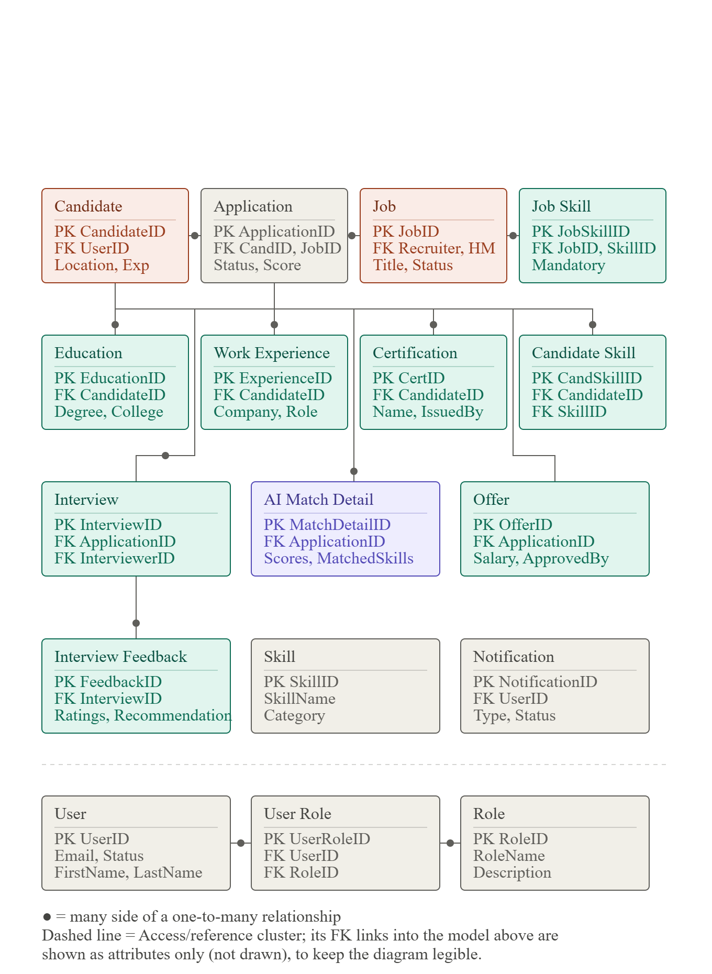
Layout note: the recruitment pipeline (Candidate, Application, Job, Job Skill, and their detail/child tables) is drawn with full relationship lines. The User / User Role / Role access cluster sits below the dashed divider — its FK links into the pipeline (Candidate.UserID, Job.RecruiterID/HiringManagerID, Interview.InterviewerID, Offer.ApprovedBy, Notification.UserID) and Skill's two FK sources (Candidate Skill, Job Skill) are documented as attributes rather than drawn as lines, to keep the diagram legible at this scale. A filled dot marks the many side of a one-to-many relationship.

3. Changes from the Original Reference Model
Interview → Interview Feedback changed from 1:1 to 1:M. Panel interviews (multiple interviewers) and the requirement to aggregate interviewer scorecards into a consolidated feedback summary both require multiple feedback records per interview, one per panelist.
Job gained a second FK: HiringManagerID, alongside RecruiterID. Assigning both a recruiter and a hiring manager to a requisition is an explicit in-scope requirement; the original model only carried RecruiterID.
Added AI Match Detail as a new child entity of Application, alongside the existing MatchScore field. A single score field cannot carry the matched/partial/missing-skill breakdown required for every AI recommendation, nor satisfy the requirement to log every score and the criteria used, retained for audit. MatchScore remains on Application as a fast-access summary; AI Match Detail is the full explainability and audit record.
Background Check and Onboarding Task are not included in this model, consistent with an unresolved scope question raised earlier in this document set: the phased implementation roadmap excludes onboarding from its scope, while the functional requirements define a full onboarding module. This should be resolved with stakeholders before the model is finalized for build.

4. Entity Attribute Reference
Full attribute listing for all 17 entities shown in the diagram. Entities highlighted below are additions to the original reference model (see Section 3).
Entity | Key Attributes
Candidate | CandidateID (PK), UserID (FK), DOB, Gender, TotalExperience, CurrentLocation, ResumeURL, ResumeScore
Application | ApplicationID (PK), CandidateID (FK), JobID (FK), AppliedDate, Status, MatchScore
Job | JobID (PK), Title, Description, Department, Location, EmploymentType, ExperienceRequired, SalaryMin, SalaryMax, Status, RecruiterID (FK), HiringManagerID (FK), CreatedDate
Job Skill | JobSkillID (PK), JobID (FK), SkillID (FK), Mandatory
Education | EducationID (PK), CandidateID (FK), Degree, College, Year, Percentage
Work Experience | ExperienceID (PK), CandidateID (FK), Company, Designation, StartDate, EndDate, SkillsUsed
Certification | CertificationID (PK), CandidateID (FK), Name, IssuedBy, IssueDate
Candidate Skill | CandidateSkillID (PK), CandidateID (FK), SkillID (FK), ExperienceYears
Interview | InterviewID (PK), ApplicationID (FK), InterviewerID (FK), InterviewDate, InterviewType, Status
AI Match Detail | MatchDetailID (PK), ApplicationID (FK), OverallScore, SkillsScore, ExperienceScore, EducationScore, MatchedSkills, MissingSkills, GeneratedDate
Offer | OfferID (PK), ApplicationID (FK), Salary, JoiningDate, OfferStatus, ApprovedBy (FK)
Interview Feedback | FeedbackID (PK), InterviewID (FK), TechnicalRating, CommunicationRating, Recommendation, Comments
Skill | SkillID (PK), SkillName, Category
Notification | NotificationID (PK), UserID (FK), Type, Subject, Message, Status, SentDate
User | UserID (PK), FirstName, LastName, Email, Password, Phone, Status, CreatedDate
User Role | UserRoleID (PK), UserID (FK), RoleID (FK)
Role | RoleID (PK), RoleName, Description

5. Relationship Summary
Parent Entity | Child Entity | Relationship
User | Candidate | 1 : 1
User | User Role | 1 : M
Role | User Role | 1 : M
Candidate | Education | 1 : M
Candidate | Work Experience | 1 : M
Candidate | Certification | 1 : M
Candidate | Candidate Skill | 1 : M
Skill | Candidate Skill | 1 : M
Job | Job Skill | 1 : M
Skill | Job Skill | 1 : M
Candidate | Application | 1 : M
Job | Application | 1 : M
Application | Interview | 1 : M
Interview | Interview Feedback | 1 : M (changed from 1:1 — see note)
Application | Offer | 1 : 0..1
Application | AI Match Detail | 1 : M (new entity — see note)
User | Notification | 1 : M

6. Core Entities
User — Authentication and common user information.
Role — Defines access permissions (Candidate, Recruiter, Hiring Manager, Interviewer, HR Admin, etc.).
Candidate — Candidate-specific details, linked 1:1 to a User account.
Job — Job postings / requisitions, owned jointly by a Recruiter and a Hiring Manager.
Skill — Master list of skills, shared by Candidate Skill and Job Skill.
Application — Links a Candidate to a Job; the hub of the recruitment pipeline.
Interview — Scheduled interview details.
Interview Feedback — Per-interviewer evaluation of an interview.
AI Match Detail — Explainable AI scoring record supporting each Application's MatchScore.
Offer — Employment offer details.
Notification — Communication history.

This model is normalized and scalable, supporting the end-to-end recruitment lifecycle while allowing future enhancements — assessments, onboarding, or HRMS integration — without major structural changes.

