PROGRAM1:

DOUBLY LINKED LIST (XOR)

OUTPUT:

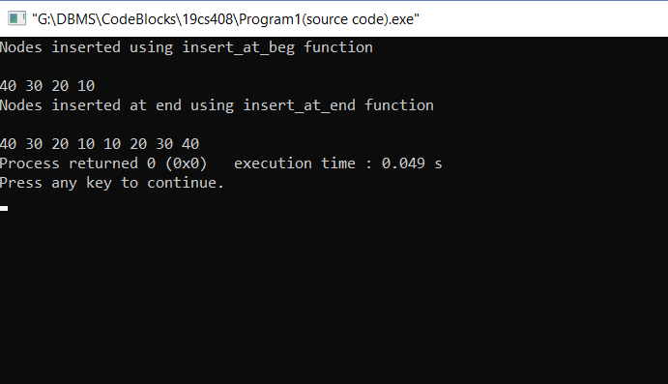

INPUT:

#include<iostream>

using namespace std;

class node

{

public:

int data;

node* npx;

};

node* XOR(node* a, node* b)

{

return (node*) ((uintptr_t) (a) ^ (uintptr_t) (b));

}

void insert_at_begin(node **first, int data)

{

node *new_node=new node();

new_node->data=data;

new_node->npx=*first;

if(*first!=NULL)

{

(*first)->npx = XOR(new_node , (*first)->npx);

}

*first=new_node;

}

void insert_at_end(node **first,int data)

{

node *prev=NULL;

node *curr=*first;

node *next=XOR(prev,curr->npx);

while(next)

{

prev=curr;

curr=next;

next=XOR(prev,curr->npx);

}

next=new node();

next->data=data;

next->npx=XOR(curr,NULL);

curr->npx=XOR(curr->npx,next);

}

void printList (node *first)

{

node *curr = first;

node *prev = NULL;

node *next;

while (curr != NULL)

{

cout<<curr->data<<" ";

next = XOR (prev, curr->npx);

prev = curr;

curr = next;

}

}

int main ()

{

node *first = NULL;

insert_at_begin(&first, 10);

insert_at_begin(&first, 20);

insert_at_begin(&first, 30);

insert_at_begin(&first, 40);

cout<<"Nodes inserted using insert_at_beg function\n"<<endl;

printList (first);

insert_at_end(&first, 10);

insert_at_end(&first, 20);

insert_at_end(&first, 30);

insert_at_end(&first, 40);

cout<<"\nNodes inserted at end using insert_at_end function\n"<<endl;

printList(first);

return (0);

}

2.

#include<iostream>

using namespace std;

class node

{

public:

int data;

node* next;

};

node *reverse(node *head,int k)

{

node* current=head;

node* next=NULL;

node* pre=NULL;

int count=0;

while(current!=NULL && count<k)

{

next=current->next;

current->next=pre;

pre=current;

current=next;

count++;

}

if(next!=NULL)

head->next=reverse(next,k);

return pre;

}

void push(node** head_ref,int new_data)

{

node* new_node= new node();

new_node->data=new_data;

new_node->next=(*head_ref);

(*head_ref)=new_node;

}

void printlist(node *node)

{

while(node!=NULL)

{

cout<< node->data <<" ";

node=node->next;

}

}

int main()

{

node* head=NULL;

push(&head,9);

push(&head,8);

push(&head,7);

push(&head,6);

push(&head,5);

push(&head,4);

push(&head,3);

push(&head,2);

push(&head,1);

cout<<"Given linked list\n"<<endl;

printlist(head);

head=reverse(head, 3);

cout<<"Reversed linked list\n"<<endl;

printlist(head);

return 0;

}

