create table Branch(branchname varchar2(15),

branchcity varchar2(15),

assest float,

primary key(branchname));

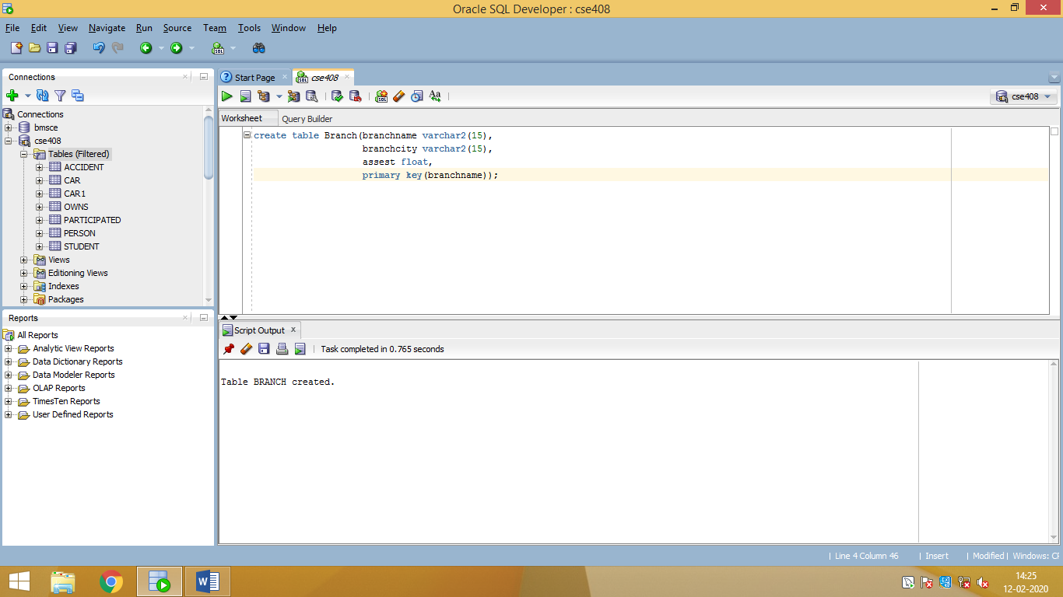

create table Accounts(Accno number(15),

branchname varchar2(15),

balance float(15),

primary key(Accno),

foreign key(branchname)references Branch(branchname));

create table Depositor(customer_name varchar2(15),

Accno number(15),

primary key(customer_name,Accno),

foreign key(Accno)references Accounts(Accno));

create table Customer(Customer_name varchar2(15),

cust_street varchar2(15),

cust_city varchar2(15),

primary key(Customer_name));

create table loan(loanno number(15),

branchname varchar(15),

amount float,

primary key(loanno),

foreign key(branchname)references Branch(branchname));

create table borrower(cust_name varchar2(15),

loanno number(15),

primary key(cust_name),

foreign key(cust_name)references Customer(Customer_name),

foreign key(loanno)references loan(loanno));

insert into Branch values('&branchname', '&branchcity', &assest);

select *from Branch;

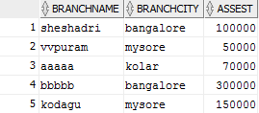

insert into Accounts values(&Accno,'&branchname',&balance);

select *from Accounts;

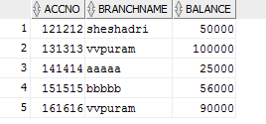

insert into Depositor values('&customer_name',&Accno);

select *from Depositor;

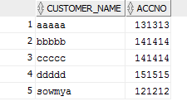

insert into Customer values('&Customer_name','&cust_street','&cust_city');

select *from Customer;

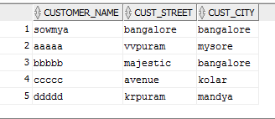

insert into loan values(&loanno,'&branchname',&amount);

select *from loan;

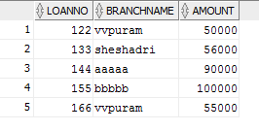

insert into borrower values('&cust_name',&loanno);

select *from borrower;

