CUSTOMER:

create table cust(cust_no number(10),

cname varchar2(15),

city varchar2(15),

primary key(cust_no));

create table Or_der(order_no number(10),

odate date,

cust_no number(10),

order_amount number(10),

primary key(order_no),

foreign key(cust_no)references cust(cust_no));

create table item(item_no number(10),

price float,

primary key(item_no));

create table order_item(order_no number(10),

item_no number(10),

qty number(10),

primary key(order_no,item_no),

foreign key(order_no)references Or_der(order_no),

foreign key(item_no)references item(item_no));

create table warehouse(warehouse_no number(10),

city varchar2(15),

primary key(warehouse_no));

create table shipment(order_no number(10),

warehouse_no number(10),

sdate date,

primary key(order_no,warehouse_no),

foreign key(order_no)references Or_der(order_no),

foreign key(warehouse_no)references warehouse(warehouse_no));

insert into cust values(&cust_no,'&cname','&city');

select * from cust;

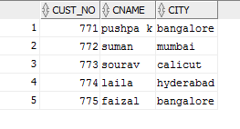

insert into Or_der values(&order_no,&odate,&cust_no,&order_amount );

select * from Or_der;

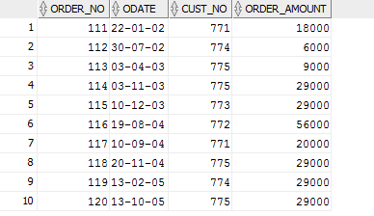

insert into item values(&item_no,&price);

select * from item;

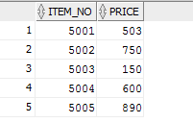

insert into order_item values(&order_no,&item_no,&qty);

select * from order_item;

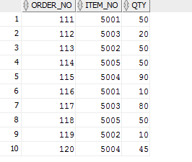

insert into warehouse values(&warehouse_no,'&city');

select * from warehouse;

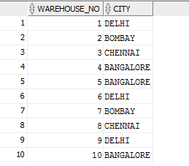

insert into shipment values(&order_no,&warehouse_no,'&sdate');

select * from shipment;

