**TIC_TAC_TOE**

**Features:**

* **Two-player game**: Supports two players taking turns.
* **Grid display**: Visually represents the 3x3 game board.
* **Win detection**: Automatically detects and announces the winner or if the game ends in a draw.
* **Replay option**: Allows players to restart the game without exiting.

**How to Play:**

1. Run the game.
2. Players take turns entering their moves by specifying the row and column numbers.
3. The game will update the board and check for a winner after each move.
4. The game ends when there is a winner or a draw.
5. Players can choose to play again or exit.

**Requirements:**

* Java Development Kit (JDK) installed.

**Screenshots of the Execution:**

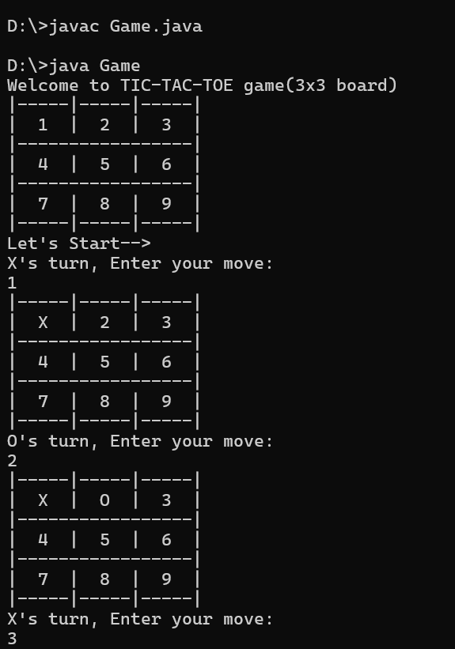

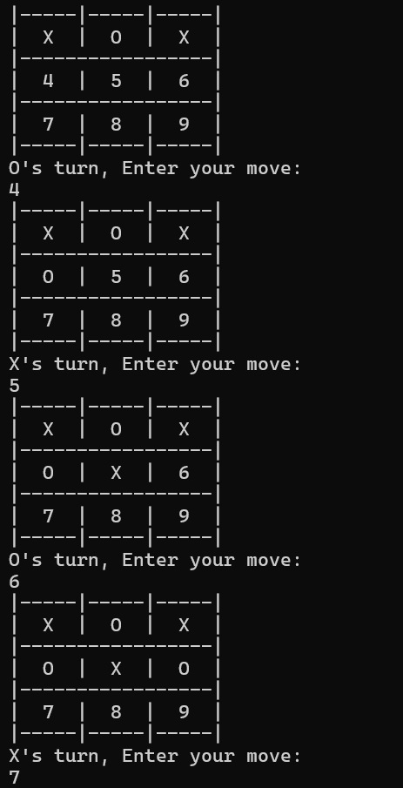

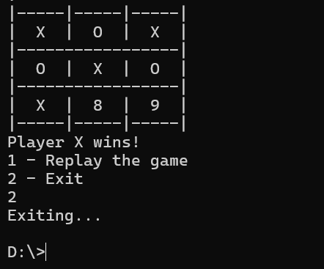

**Project Structure:**

* "Game.java" : Main class containing the game logic and user interaction.
* "gameboard" method : Method representing the game board and its operations.
* "play" & "turn" methods : Method representing a player and their moves.
* "winner" method :Method checks for the winner.
* "draw" method : Method checks if the game is draw.
* "mainaccess" method : Method access all the above methods implements the game logic in an order.