ClearSky Predictor: Software Development Life Cycle (SDLC)
Client Overview Document
This document details the engineering methodology and lifecycle stages used to develop the ClearSky Predictor platform. It highlights how we integrated complex Machine Learning pipelines alongside modern web development.

1. SDLC Methodology: Iterative Agile Framework
For the ClearSky Predictor, we utilize an Iterative Agile Development Methodology. This approach allows us to rapidly prototype machine learning models, gather continuous feedback, and incrementally enhance the user interface and AI capabilities without disrupting existing services.
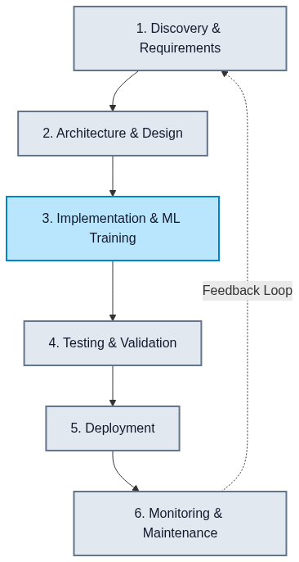

2. The 6 Phases of the ClearSky SDLC

Phase 1: Discovery & Requirements Gathering
- Goal: Define the exact predictive and visual capabilities required by end-users.
- Activities:
- Identifying necessary data sources (OpenWeatherMap for pollution metrics, Google Earth Engine for NDVI/vegetation data).
- Defining the core AI requirements: Using an LSTM for time-series forecasting and LLaMA-3 for the contextual chatbot.
- Establishing performance metrics (e.g., API response times under 500ms, model accuracy KPIs).

Phase 2: Architecture & System Design
- Goal: Blueprint the decoupled, microservice architecture to isolate heavy ML tasks from web traffic.
- Design Outcomes:
- Frontend Component: React & Vite for a highly responsive UI.
- Orchestration Layer: Node.js/Express backend to rate-limit and cache requests.
- ML Microservice Layer: Python/FastAPI environment dedicated strictly to data processing, inference, and satellite calculations.

Phase 3: Implementation & Parallel Execution
- Goal: Execute code development securely and efficiently across parallel engineering tracks.
- 1. Software Engineering Track: UI and React component development.
- 2. Data Science / ML Track: Training LSTM models and creating prompt-engineering pipelines for Chatbots.

Phase 4: Testing & Validation
- Goal: Ensure enterprise-grade reliability.
- Model Validation: Evaluating predictions using RMSE metric.
- Integration Testing: Testing Node-to-Python handoffs.
- UI/UX Testing: Ensuring layouts break cleanly on mobile devices.

Phase 5: Deployment & Release Management
- Goal: Deliver the application securely into production.
- Secrets Management: Secure injection of APIs.
- Containerization: Dockerizing all microservices.
- Gradual Rollout: Pushing to Staging before Production.

Phase 6: Continuous Monitoring & Maintenance
- Goal: Ensure long-term system health.
- Model Drift Monitoring: Retraining models if seasonal weather shifts negatively impact accuracy.
- Error Logging: Tracking latency and limit quotas.

3. Security & Compliance Highlights
To ensure trust, our SDLC strictly enforces:
- Strict Boundary Separation: End-users never communicate directly with ML models or databases.
- State-less AI Interaction: PII is stripped before sending location data to the LLM.

