library(readxl)

Homezilla_Dataset <- read_excel("C:/Users/Sowmya/Desktop/fall2018/IDS515/Homezilla/Homezilla Dataset.xlsx",

sheet = "62 Listing Properties")

View(Homezilla_Dataset)

listing_properties<-Homezilla_Dataset

> str(listing_properties)

Classes ‘tbl_df’, ‘tbl’ and 'data.frame': 62 obs. of 10 variables:

$ Web ID : chr "F1410261" "V1089633" "V1052961" "V1071997" ...

$ type : chr "house" "house" "house" "house" ...

$ subtype : chr "Single Family Detached" "Condo Apartment" "Single Family Detached" "Single Family Detached" ...

$ sqfoot : num 4115 990 4359 2769 1975 ...

$ bedrooms : num 3 2 3 5 3 6 2 2 1 2 ...

$ bathrooms : num 4 2 4 4 3 4 2 1 1 1 ...

$ half baths : num 0 0 0 0 0 0 0 0 0 0 ...

$ price : num 1050000 199900 1399000 2798000 598800 ...

$ status : chr "STACT" "STACT" "STINA" "STINA" ...

$ last update: chr "2014-07-09 155732" "2014-10-10 152509" "2014-09-15 133614" "2014-08-19 154230" ...

is.na(listing_properties)

colnames(listing_properties) <- c("Web_ID", "type", "subtype", "sqfoot", "bedrooms", "bathrooms",

"half_baths", "price", "status", "last_update")

library(readxl)

Homezilla_Dataset <- read_excel("C:/Users/Sowmya/Desktop/fall2018/IDS515/Homezilla/Homezilla Dataset.xlsx",

sheet = "Browsing Data")

browsing_data<-Homezilla_Dataset

**Data Cleaning:**

colnames(browsing_data) <- c("Web_ID", "Time_Viewed", "Timestamp", "Direction", "Photo_ID", "PhotoTag1", "PhotoTag2", "PhotoTag3", "PhotoTag4", "PhotoTag5", "PhotoTag6", "PhotoTag7", "PhotoTag8", "UserAgent","CustomerID")

#boxplot(browsing_data$Time_Viewed)

boxplot(browsing_data$Time_Viewed)

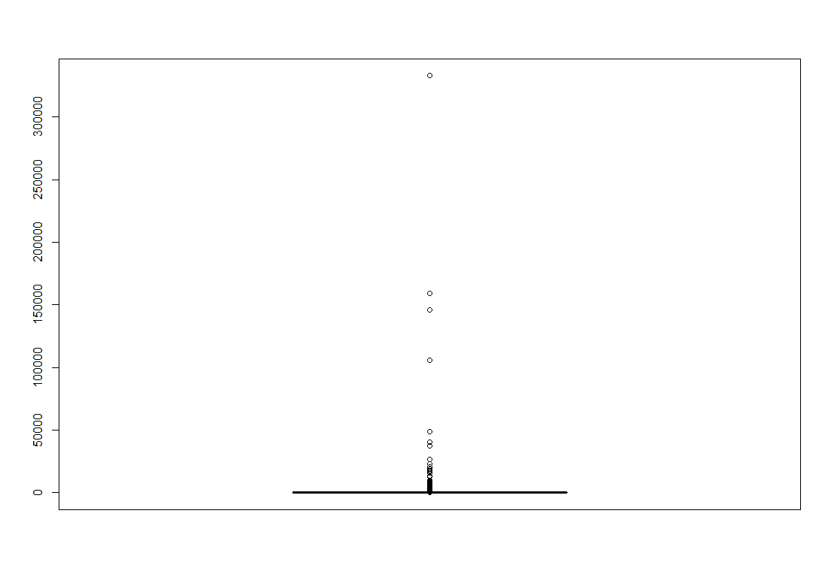

outliersBrowse = boxplot.stats(browsing_data$Time_Viewed, coef = 2)$out

browsing_data$Time_Viewed = ifelse(browsing_data$Time_Viewed %in% outliersBrowse, NA, browsing_data$Time_Viewed)

boxplot(browsing_data$Time_Viewed)

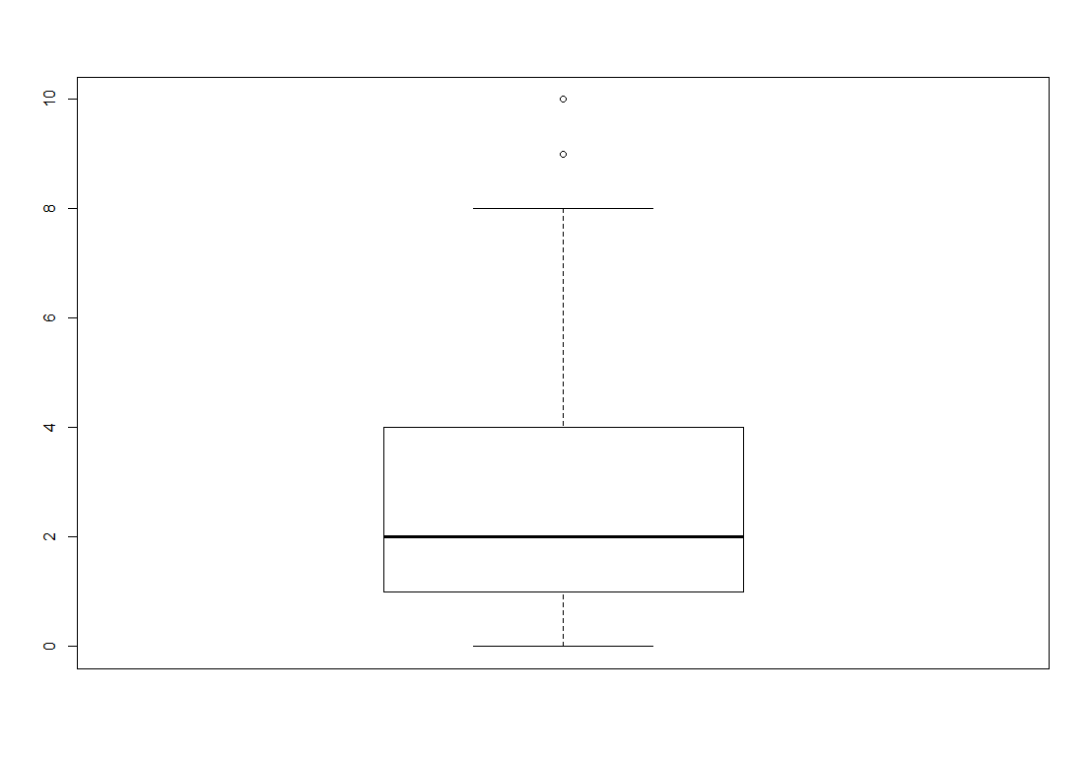

browsing_data$Direction <- as.factor(browsing_data$Direction)

browsing_data$Direction[is.na(browsing_data$Direction)] <- "First"

levels(browsing_data$Direction)

> levels(browsing_data$Direction)

[1] "First" "left" "right"

browsing_data$Time_Viewed[is.na(browsing_data$Time_Viewed)] = mean(browsing_data$Time_Viewed, na.rm=TRUE)

browsing_data$Time_Viewed <- as.factor(ifelse(browsing_data$Time_Viewed >=3, 1,0))

levels(browsing_data$Time_Viewed)

> levels(browsing_data$Time_Viewed)

[1] "0" "1"

browsing_data$PhotoTag3[is.na(browsing_data$PhotoTag3)] <- "Null"

browsing_data$PhotoTag3<- as.factor(browsing_data$PhotoTag3)

browsing_data$PhotoTag4[is.na(browsing_data$PhotoTag4)] <- "Null"

browsing_data$PhotoTag4<- as.factor(browsing_data$PhotoTag4)

browsing_data$PhotoTag5[is.na(browsing_data$PhotoTag5)] <- "Null"

browsing_data$PhotoTag5<- as.factor(browsing_data$PhotoTag5)

browsing_data$PhotoTag6[is.na(browsing_data$PhotoTag6)] <- "Null"

browsing_data$PhotoTag6<- as.factor(browsing_data$PhotoTag6)

browsing_data$PhotoTag7[is.na(browsing_data$PhotoTag7)] <- "Null"

browsing_data$PhotoTag7<- as.factor(browsing_data$PhotoTag7)

browsing_data$PhotoTag8[is.na(browsing_data$PhotoTag8)] <- "Null"

browsing_data$PhotoTag8<- as.factor(browsing_data$PhotoTag8)

**Filter and Join dataset:**

#filter data frame based on subtype

condo_webid<-as.data.frame(listing_properties[ listing_properties$subtype == "Condo Apartment", 1:3])

is.na(condo_webid)

condo_webid<-na.omit(condo_webid)

head(condo_webid)

townhouse<-as.data.frame(listing_properties[ listing_properties$subtype == "Townhouse", 1:3])

is.na(townhouse)

townhouse<-na.omit(townhouse)

head(townhouse)

single_family <- as.data.frame(listing_properties[

listing_properties$subtype == "Single Family Detached", 1:3 ])

is.na(single_family)

single_family<-na.omit(single_family)

head(single_family)

#join with browsing data set

head(browsing_data)

is.na(browsing_data$Web_ID) #no rows without webid

single_web<-merge(single_family, browsing_data, by="Web_ID")

head(single_web)

nrow(single_web)

condo_web<-merge(condo_webid, browsing_data, by="Web_ID")

head(condo_web)

nrow(condo_web)

townHouse_web<-merge(townhouse, browsing_data, by="Web_ID")

head(townHouse_web)

nrow(townHouse_web)

**Logistic regression**

#Model for condo apartment

myFormula<- Time_Viewed ~ Direction + PhotoTag2 + PhotoTag3 + PhotoTag4 + PhotoTag5 + PhotoTag6 + PhotoTag7

condo_regression<-glm(myFormula, data = condo_web, family = binomial(logit))

summary(condo_regression)

#modify based on NA

levels(condo_web$PhotoTag4)[levels(condo_web$PhotoTag4)=="machines-visible"] <- "Null"

levels(condo_web$PhotoTag6)[levels(condo_web$PhotoTag6)=="living-window"] <- "Null"

levels(condo_web$PhotoTag3)[levels(condo_web$PhotoTag3)=="tableview"] <- "Null"

levels(condo_web$PhotoTag5)[levels(condo_web$PhotoTag5)=="living-window"] <- "Null"

levels(condo_web$PhotoTag5)[levels(condo_web$PhotoTag5)=="machines-not-visible"] <- "Null"

levels(condo_web$PhotoTag6)[levels(condo_web$PhotoTag6)=="bath-sink"] <- "Null"

levels(condo_web$PhotoTag3)[levels(condo_web$PhotoTag3)=="bath-tub"] <- "Null"

levels(condo_web$PhotoTag3)[levels(condo_web$PhotoTag3)=="machines-visible"] <- "Null"

myFormula<- Time_Viewed ~ Direction + PhotoTag2 + PhotoTag2 + PhotoTag3

condo_regression<-glm(myFormula, data = condo_web, family = binomial(logit))

summary(condo_regression)

#Predict the factors affecting single_family house types

myFormula<- Time_Viewed ~ Direction + PhotoTag2 + PhotoTag3 + PhotoTag4 + PhotoTag5

single_regression<-glm(myFormula, data = single_web, family =binomial(logit))

summary(single_regression)

#Model for TownHouse

myFormula<- Time_Viewed ~ Direction + PhotoTag2 + PhotoTag3 + PhotoTag4

town_regression<-glm(myFormula, data = townHouse_web, family = binomial(logit))

summary(town_regression)

**Variable selection:**

library(Rcmdr)

finalCondo<-stepwise(condo_regression, direction = "forward", criterion = "BIC")

summary(finalCondo)

#Smaller the AIC better the model