**Found bugs or issues:**

**1.BUG**

|  |  |  |
| --- | --- | --- |
| **Steps to Reproduce** | **Expected Result** | **Actual Result** |
| Step 1: Open Segwise login page  Step 2: Observe the password input field  Step 3: Notice the “Forgot password?” link beside it | The Forgot Password link is above the Password input field. | The Forgot Password link should  be below the password field. |

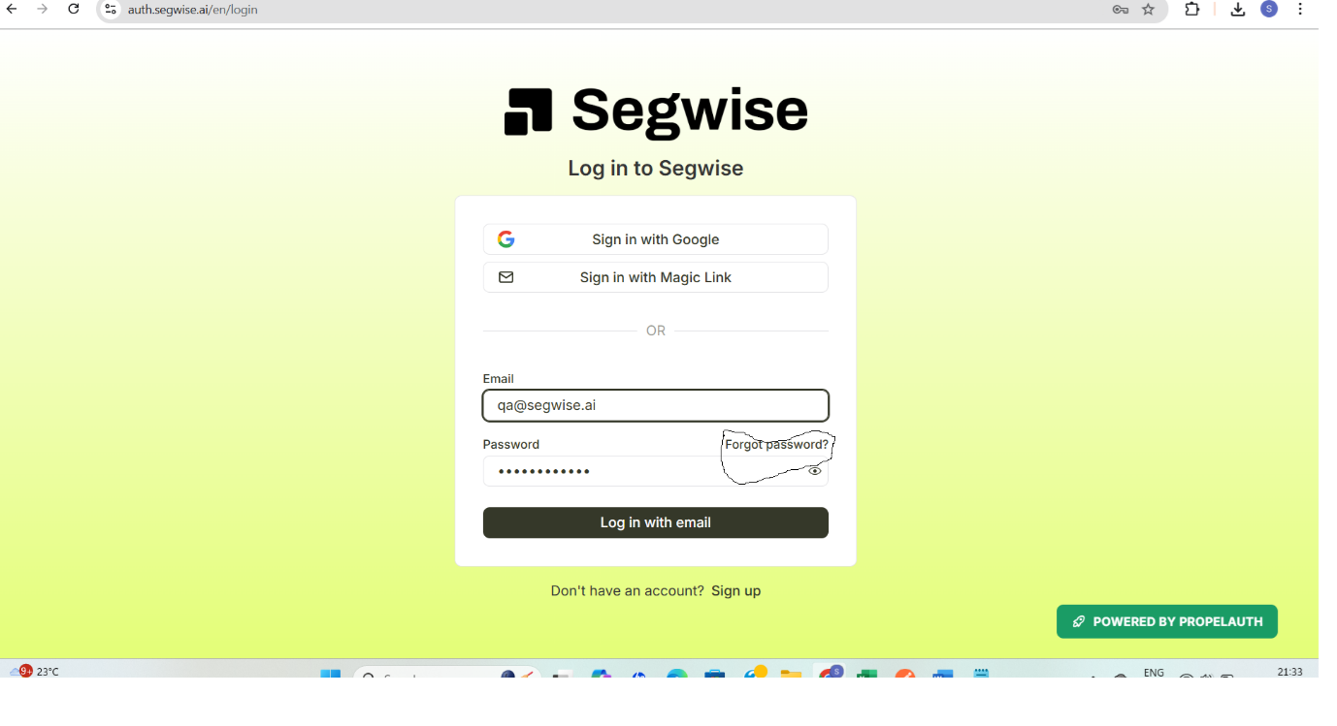

**2. BUG**

|  |  |  |
| --- | --- | --- |
| **Steps to Reproduce** | **Expected Result** | **Actual Result** |
| Step 1: Open Segwise login page  Step 2: Login using email: qa@segwise.ai  Password: segwise_test  Step 3: On Home Page click on the creative analytics.  Step 4: an empty folder can be created in Folder section. | Empty folder cannot be created. | Empty folder is getting created. |

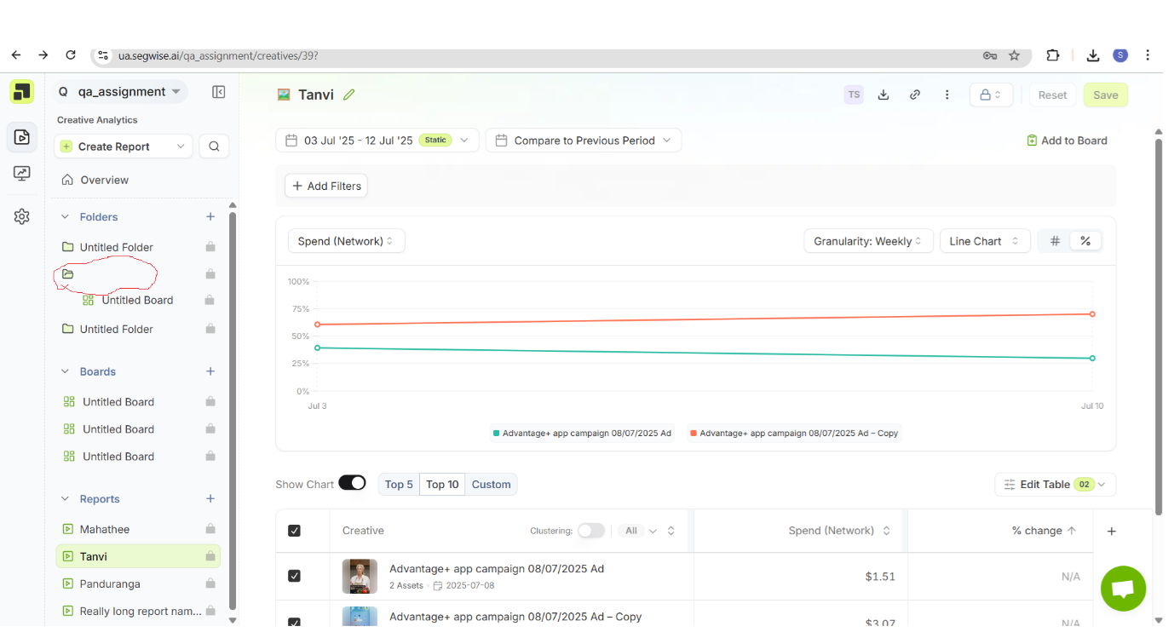

**3. BUG**

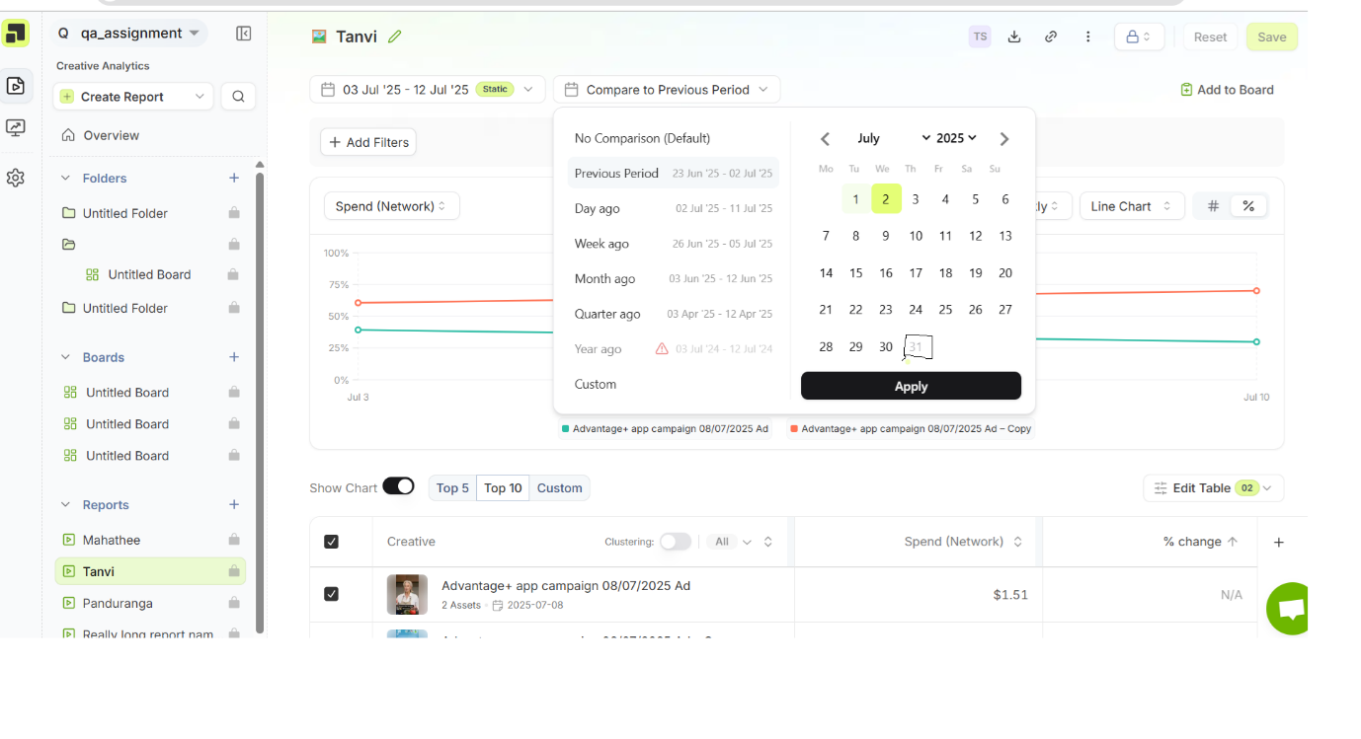

|  |  |  |
| --- | --- | --- |
| **Step to Reproduce** | **Excepted Result** | **Actual Result** |
| 1. Login to dashboard 2. Select the report. 3. Open date filter 4. Navigate to July 2025 | The July 31st gets enabled only after the 1st August 2pm IST. | The July 31st should be enabled after the current date is 1st August. |

**4.BUG**

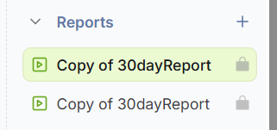

|  |  |  |
| --- | --- | --- |
| **Step to Reproduce** | **Excepted Result** | **Actual Result** |
| 1. Login to dashboard 2. Select the report. 3. Click on the duplicate button. 4. Again, click on the duplicate button. | In report section duplicate report should not be present. | Report name should not be created with the same name as it is created before. |

**Regression Checklist:**

|  |  |
| --- | --- |
| **Sl no** | **Test Case** |
| 1 | Login as a user click on the creative analytics tab.  Select the report and apply all the filter with AND operation and verify if all the filters are applied. |
| 2 | Login as a user click on the creative analytics tab.  Select the report and apply all the filter with OR operation and verify if all the filters are applied. |
| 3 | Verify the result for all the below charts.   * Line chart * Bar chart * Pie chart * Stacked Bar chart |
| 4 | Verify the result for all Granularity and networks. |
| 5. | Verify the creation of Create new report for  1.creative report  2. launch report  3. Tag report  4. custom report |