Cloud Security
- Cloud Computing Security: Cloud Security is an evolving sub-domain of computer security, network security, and, more broadly, information security.
- Cloud computing security is the set of control-based technologies and policies designed to adhere to regulatory compliance rules and protect information, data applications and infrastructure associated with cloud computing use.
- Goals of Security Services are Privacy, Authenticity, Integrity and Conﬁdentiality.
- “Security costs money, but it also costs in time, convenience, capabilities,…” said by Bruce Schneider
- The first Anti- Virus software for Cloud Computing is PANDA developed by PANDA Company.
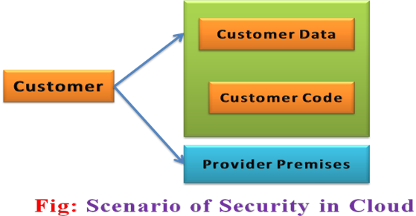
- Security concerns arising because both customer data and program (or) code are residing in provider premises.
- There are three important protection goals or pillars of Cloud Computing services are Conﬁdentiality, Integrity, Authenticity.
- Security is always a major concern in open system Cloud Architectures.
- Security is one of the most difficult task to implement in cloud computing i.e. different forms of attacks in the application side and in the hardware components.
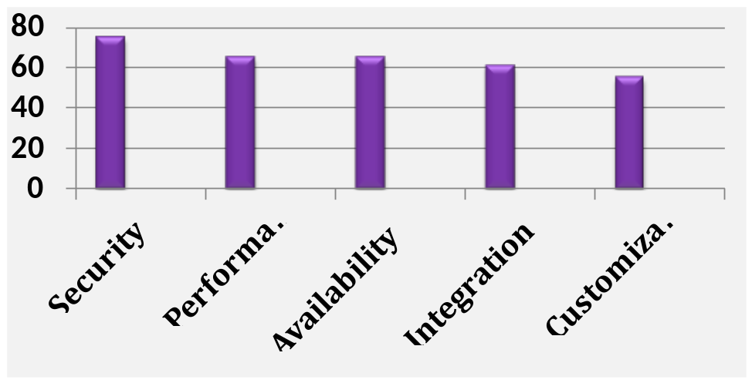

Research Challenges
Fig: Gartner Survey for Cloud Computing Challenges
- Cloud Security Requirements
  - Access Control
  - Authentication
  - Content screening
  - Proper use of IT Resources
  - User monitoring
  - Protection of web services
  - Protection of data base
  - Securing message
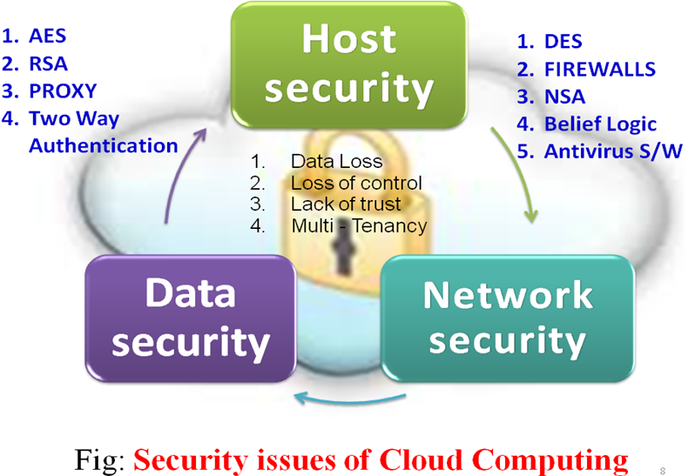

- Types of Cloud Securities are
  - Data Security
  - Network Security
  - Host Security
  - Cloud Security Services
  - Cloud Security Possible Solutions
1. Data Security: Data security refers to protective digital privacy measures that are applied to prevent unauthorized access to computers, databases and websites. Data security is also known as Information Security (IS) or Computer Security.
- The big challenge in traditional data centers and the cloud is the location of your data on someone else’s servers.
- The cloud provider declares bankruptcy and its servers are seized or it ceases operations.
- A third party with no relationship to you.
- The solution is to do two things you should be doing anyway:
  - Encrypt sensitive data in your database and in memory.
  - Decrypt it only in memory for the duration of the need for the data.
- Choose a second provider and use automated, regular backups.
- It consists of
    - Data Control
    - Encrypt Everything
    - Regulatory & Standards Compliance
a) Data Control: It can be managed with three ways
- When the cloud provider goes down: Regular “off-site” backups will protect. Having a second cloud provider through which you can launch a replacement infrastructure is even better.
- When a subpoena compels your cloud provider to turn over your data: If the subpoena is directed at you, obviously you have to turn over the data to the courts, regardless of what precautions you take, but these legal requirements apply whether your data is in the cloud or on your own internal IT infrastructure. Encrypting your data will protect you against this scenario.
- When your cloud provider fails to adequately protect their network: When you select a cloud provider, you absolutely must understand how they treat physical, network, and host security. Example: Amazon does not even disclose where their data centers are located; they simply claim that each data center is housed in a nondescript building with a military-grade perimeter. Even if you know that my database server is in the us-east-1a availability zone, you don’t know where the data center(s) behind that availability zone is located, or even which of the three East Coast availability zones us-east-1a represents. Amazon publishes its security standards and processes at http://aws.amazon.com
b) Encrypt Everything: In the cloud, your data is stored somewhere servers:
- Data lies within a virtual machine guest operating system, and you control the mechanisms for access to that data.
- Network traffic exchanging data between instances is not visible to other virtual hosts.
- For most cloud storage services, access to data is private by default.
- It can be done three ways
  - Encrypt your network traffic: A nice feature of the Amazon cloud is that virtual servers cannot sniff the traffic of other virtual servers. Encrypt all network traffic, not just web traffic.
  - Encrypt your backups: you should be encrypting it using some kind of strong cryptography, such as PGP. Files, folders->Temporary storage->encrypt->cloud storage system->secured
  - Encrypt your file systems: Its expensive to encrypt file systems - the EC2 Xen system zeros. The challenge with encrypted file systems on servers lies in how you manage the decryption password.
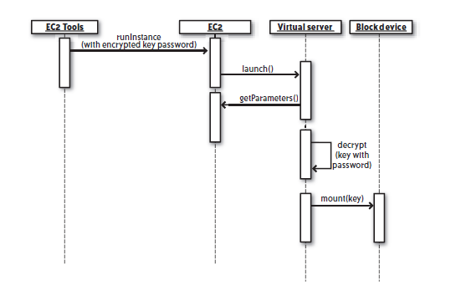
Fig: The Process of starting a Virtual Server with Encrypted File systems
c) Regulatory and Standards Compliance
- There are the following standards:
  - Directive 95/46/EC - EC Directive on Data Protection. A 1995 directive for European Union nations relating to the protection of private data and where it can be shared.
  - HIPAA - Health Insurance Portability and accountability Act. A comprehensive law relating to a number of health care issues. Of particular concern to technologists are the privacy and security regulations around the handling of health care data.
  - PCI or PCI DSS - Payment Card Industry Data Security standard. A standard that defines the information security processes and procedures to which an organization must adhere when handling credit card transactions.
  - SOX - Sarbanes-Oxley Act - Establishes legal requirements around the reporting of publicly held companies to their shareholders.
  - 21CFR11 - Title 21 CFR Part 11 of the Federal Code of Regulations. This standard specifies guidelines governing electronic signatures and the management of electronic records in the pharmaceutical and medical device manufacturing industry.
- Three kinds of issues in standards and regulations:
- “How” issues: how an application of a specific type should operate in order to protect certain concerns specific to its problem domain. Ex: HIPAA defines how you should handle personally identifying health care data.
- “Where” issues: One key impact of this particular directive is that the private data on EU citizens - Directive 95/46/EC.
- “What” issues: standards prescribing very specific components to your infrastructure. Ex: PCI DSS.
2) Network Security
- Network Security describes that the policies and procedures implemented by a Network Administrator to avoid and keep track of unauthorized access, exploitation, modification, or denial of the network and network resources.
- It define firewall like traffic rules governing what traffic can reach virtual server in that group.
- Firewall Rules are Firewall protects the perimeter one or more network segments and Firewall is a one of the security mechanism to protect the data (or) restrict from unwanted websites information.
- Examples of irregular traffics includes are Port scans, Denial-of-Security attacks and known vulnerability exploits attempt.
- It consists of
  - Firewall Rules
  - Network Intrusion Detection
a) Firewall Rules
- A Firewall protects the perimeter of one or more network segments.
- A main firewall protects the outermost perimeter, allowing in only HTTP, HTTPS. Within that network segment are border systems, such as load balancers, that route traffic into a DMZ protected by another firewall.
- Finally, within the DMZ (DeMiliterized Zone) are application servers that make database and other requests across a third firewall into protected systems on a highly sensitive internal network.
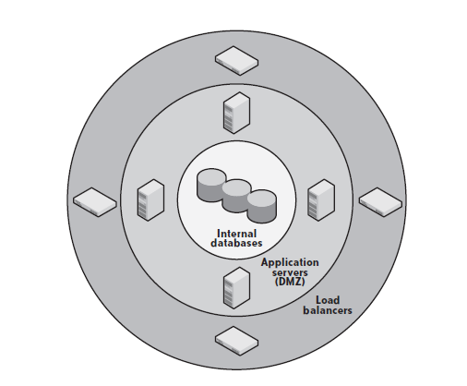
Fig: Firewalls are the primary tool in perimeter security
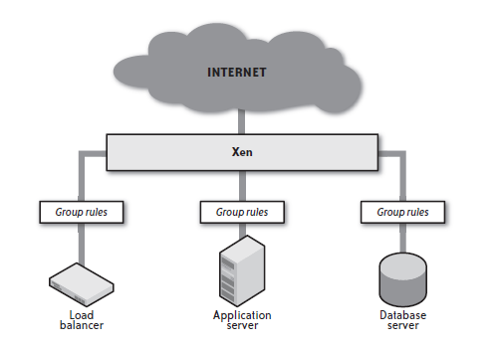
Fig: Security Group Ru b) Network Intrusion Detection System
i) purpose of a network intrusion detection system:
- NIDS typically alerts you to port scans as evidence of a precursor to a potential future attack.
- When the NIDS sees traffic that contains malicious payload, it can either block the traffic or send out an alert.
- ii) Implementing network intrusion detection in the cloud:
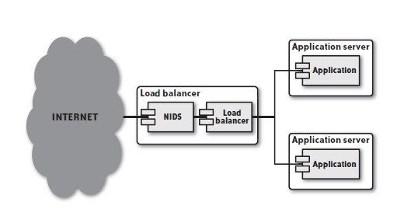
- The load balancer approach creates a single point of failure for your network intrusion detection system because, in general, the load balancer is the most exposed component in your infrastructure.
- Ex: NESSUS – Vulnerability scanner. Stable release 5.2.7.
3. Host Security
- The Host Based Security System (HBSS) is the official name given to the Department of Defense (DOD) and used within the DOD to monitor, detect, and counter attacks against the DOD computer networks and systems.
- Host Security describes how your server is setup for the task i.e. Preventing attacks, Minimizing the impact of an attack on system and Responding to attacks.
- It consists of
    - System Hardening
    - Antivirus Production
    - Host Intrusion Detection
    - Data Segmentation
    - Credential Management
a) System Hardening: Server hardening is the process of disabling or removing unnecessary services and eliminating unimportant user accounts.
- Tools: Bastille Linux
- Once you install Bastille Linux, you execute the interactive scripts that ask you questions about your server. It then proceeds to disable services and accounts.
- Hardened system meets the following criteria:
  - No network services are running except those necessary to support the server’s function.
  - No user accounts are enabled on the server except those necessary to support the services running on the server or to provide access for users who need it.
  - All configuration files for common server software are configured to the most secure settings.
  - All necessary services run under a non privileged role user account (e.g., run MySQL as the MYSQL user, not root).
b) Antivirus Protection: Some regulations and standards require the implementation of an antivirus (AV) system on your servers.
- Choose with Two critical features in your AV software:
- How wide is the protection it provides? In other words, what percentage of known exploits does it cover?
- What is the median delta between the time when a virus is released into the wild and the time your AV product of choice provides protection against it?
c) HIDS:
- Host intrusion detection system (HIDS) such as OSSEC monitors the state of your server for anything unusual.
- An HIDS is in some ways similar to an AV system, except it examines the system for all signs of compromise and notifies you when any core operating system or service file changes.
- The downside of an HIDS is that it requires CPU power to operate, resources on your server.
- Reference - http://www.ossec.net
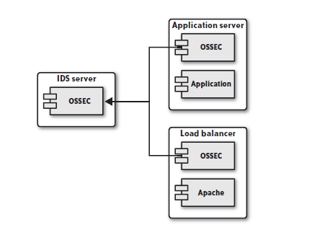
Fig: A HIDS infrastructure reporting to a Centralized Server
d) Data Segmentation:
- The segmentation of data based on differing levels of sensitivity is your first tool in minimizing the impact of a successful attack.
- Ex: An attacker who accesses your customer database has found some important information, but that attacker still lacks access to the credit card data.
e) Credential Management:
- The most secure approach to providing access to virtual servers is the dynamic delivery of public SSH(secured shell) keys to target servers.
- The best credential management system provides remote access to the server only for users who absolutely have an operational need to access the server and only for the time period for which they need that access.
- 4. Cloud Security Services: It is a service provider solution that provides cloud hosted offerings i.e. customers to federate to their web-based and SaaS applications through their provider, and lets service providers connect to their customers through a secure channel without requiring them to open their firewall ports.
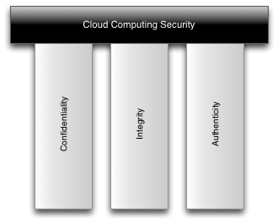
Fig: Pillars of Cloud Computing Security
- Confidentiality: The conﬁdentiality of a system is guaranteed providing it prevents unauthorized gathering of information, and to ensure that information cannot be accessed by subjects who do not have corresponding rights.
- Integrity: When dealing with millions of PBs of data, the utmost care must be taken to ensure that customer data is protected and preserved by adhering to the highest standards of data security and by engineering systems that ensure the integrity of the data
- Authenticity: The authenticity of a subject or object is deﬁned as its genuineness and credibility, these can be veriﬁed on the basis of its unique identity and characteristic features.
5. Cloud Security Possible Solutions
- There are many possible solutions for Cloud Security is
- Minimize Lack of Trust: Policy Language, Certification.
- Minimize Loss of Control : Monitoring, Utilizing different clouds, Access control management and Identity Management (IDM).
- Minimize Multi - Tenancy: Private cloud and Strong separation.
- Loss of Control: Take back control.
- Lack of trust: Increase trust (Mechanisms), Technology, Policy, regulation and Contracts (incentives): topic of a future talk.
Cloud Security Incidents
- These security incidents showed by the www.cloutage.com
- Data loss: Microsoft – 2009, T-Mobile, Lost data in the Mobile.
- Downtimes: Amazon S3 – 2008, no availability, Power supply
- Password cracking: Amazon EC2 – 2009,Cracked passwords.
- Botnets and malware
- Lack of trust
- Loss of control
Multi-tenancy
Techniques of the Cloud Security
- Key Algorithms : AES, Blowfish, RSA, DES,DH
- Encryption in Place : PGP, FileVault, Firmware
- Secure Transmission : SSL, VPN, SSH
- Firewalls: Packet-filtering-Firewall, Dual - Homed Gateway, Choke-gate firewall, and Screened-subnet firewall.
Cloud Security Risks
  - Privileged user access
  - Regulatory compliance
  - Data Location
  - Data Segregation
  - Data Recovery
  - Investigative Support
  - Long Term Viability
Cloud Security Threats
- Data Breaches
- Data Loss
- Insecure APIs
- Denial of Service
- Malicious Insiders
- Abuse of Cloud Services
- Insufficient Due Diligence
- Shared Technology
- Account or Service Traffic Hijacking.
Advantages of Cloud Security
- Data Consistency
- Replication
- High assurance and integrity.
- Safe Data.
- Greater Resiliency
- Fault Tolerance and Reliability
- On-Demand Security Controls
- Real-Time Detection of System Tampering
- Rapid Re-Constitution of Services
- Reduction of Assessment and Authorization Activities
- Greater Investment in Security Infrastructure
- Rapid Re-Constitution of Services
Redundancy / Disaster Recovery.
Cloud Security issues
- Data loss
- Downtimes
- Password cracking
- Botnets and malware
- Lack of trust
- Loss of control
- Multi-tenancy

Cloud Disaster Recovery
- Cloud Disaster Recovery: Cloud Disaster Recovery is a service that enables the backup and recovery of remote machines on a cloud-based platform.
- It is a component of a disaster recovery plan that involves maintaining copies of enterprise data in a cloud storage environment as a security measure.
- Cloud disaster recovery is primarily an infrastructure as a service (IaaS) solution that backs up designated system data on a remote offsite cloud server.
- Cloud Disaster Recovery is also known as cloud DR Blue Print or cloud DR or cloud DRP.
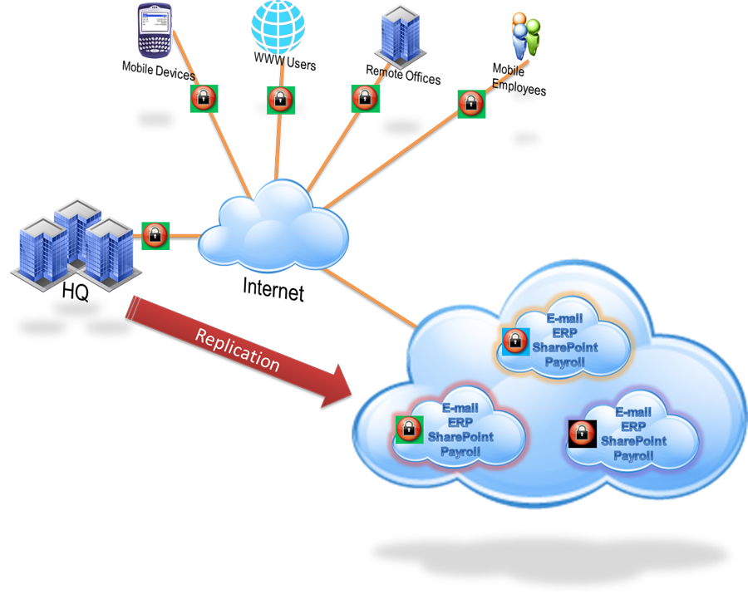
Fig: Cloud based Disaster Recovery is the most efficient and cost effective approach for data back up.
- It provides updated recovery point objective (RPO) and recovery time objective (RTO) in case of a disaster or system restore.
- A Cloud DRP vendor provisions users and storage space and continuously update designated systems with client software installed on each system, users have the ability to add, edit and delete systems and storage capacity, without having to consider the back-end supported infrastructure.
- A Cloud-based Disaster Recovery solution enables the user to scale up the entire cloud DRP solution from some-to-many, the user is normally billed on a monthly basis only for the storage and client software licenses.
- Most Cloud DR also provisions backup and recovery for critical server machines that host enterprise-level applications like MS-SQL, Oracle, etc.
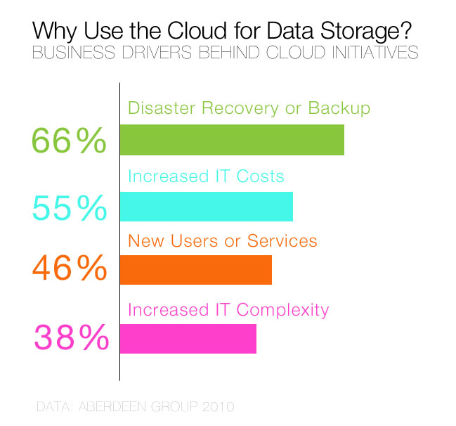
Fig: Why Use the Cloud Data Storage
- One of the major advantages of Cloud Computing is its disaster recovery approach, with this system, enterprises have a cost effective disaster recovery plan in place.
- Every organization requires a Business Continuity Plan (BCP) or Disaster Recovery Plan (DRP) which falls within cost constraints while achieving the target recovery requirements in terms of recovery time objective (RTO) and recovery point objective (RPO).
- The Cloud platform manages the Disaster Recovery servers and storage devices effectively and reduces the impact of failure at the disaster site.
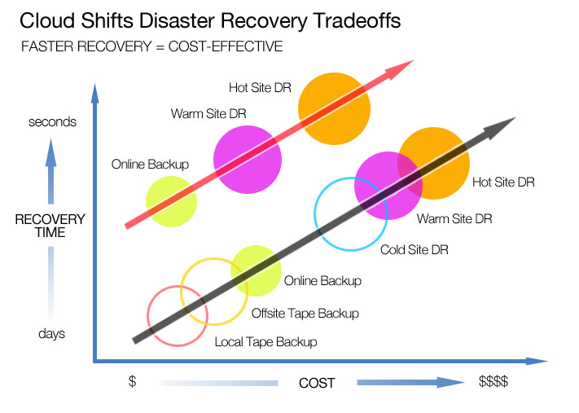
Fig: Types of Backup Sites
- By using Disaster Recovery as a service one can handle these disasters and can recover data fast with low cost, as in other techniques DR as a Service doesn’t need any initial payment to use it provides pay on use method.
- Problem - Too many small and medium-size businesses would simply go out of business in the case of the data center fire.
- Solution - Disaster Recovery Plan (survive from a fire)
- Disaster Recovery Process (Test Twice/Year)
- Expectation – Restore Cloud Infrastructure at cloud provider in minutes/Hours. Each company should document & Test regularly Disaster Recovery Plan.
- Disaster Recovery is a Recovery-as-a-Service (RaaS) offering that introduces native cloud-based disaster recovery capabilities for virtual environments.
- Disaster Recovery offers a cost-effective, simple, automated process for replication and recovering applications and data in a standby environment.
- Key features of the service include:
  - Self-service Disaster Recovery protection for VM
  - Recovery Point Objectives (RPO)
  - Recovery Time Objectives (RTO)
  - Automated and Flexible failover Testing.
Automated planned Migrations, and Recovery
- There are 6 causes of data loss due to disaster occurrence
  - Natural Disasters
  - Machine critical application failure
  - Network failure
  - Network intrusion
  - Hacking or Malicious code
  - System failure
- Serious Cloud Failures & Disasters
  - Google Doc’s Disaster in September
  - Action Replay for Google Docs
  - Microsoft’s Office 365 Cloud Disaster
  - Bad Weather Conditions can Result in Cloud Disaster - Amazon
  - Amazon Elastic Cloud Compute Outage
  - Drop Box Outage
  - Google App Engine outage
Cloud Disaster Recovery consists of:
  - Disaster Recovery Planning
  - Disasters in the Cloud
  - Disaster Management
  - Capacity Planning
  - Cloud Scale
1. Disaster Recovery Planning
- The possibility of some disaster occurring over time is reasonably nonzero.
- Identify an Acceptable Recovery State and develop processes and procedures to achieve the fast recovery state in the event of a disaster.
- Acceptable Recovery State - how much data you are willing to lose in the event of a disaster.
- The cost of surviving with zero downtime and zero data loss could have been having multiple data centers in different geographic locations that were constantly synchronized.
- It involves Two key Metrics.
  - Recovery Point Objective(RPO)
  - Recovery Time Objective(RTO)
(i) Recovery Point Objective(RPO)
- Recovery Point Objective(RPO) identifies how much data you are willing to lose in the event of disaster, specified in a number of hours or days of data.
- Weekly off-site backups will survive the loss of your data center with a week of data loss.
- Daily on-site backups will survive the loss of your production environment with a day of data loss.
- A NAS/SAN will survive the loss of any individual server, except for instances of data corruption with no data loss.
- A clustered DB will survive the loss of any individual data storage device or database node with no data loss.
(ii) Recovery Time Objective(RTO)
- Recovery Time Objective(RTO) identifies how much downtime is acceptable in the event of a disaster.
- The ability to assemble a replacement infrastructure for your disasters including the data restore time.
- Define a level 1 disaster - the loss of a single data center & level 2 disaster - the loss of multiple data centers.
In a traditional infrastructure, a rapid RTO is very expensive, depending on the nature of that agreement, it can nearly double the costs of your IT infrastructure.
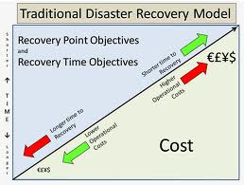
Fig: Disaster Recovery Technique
3
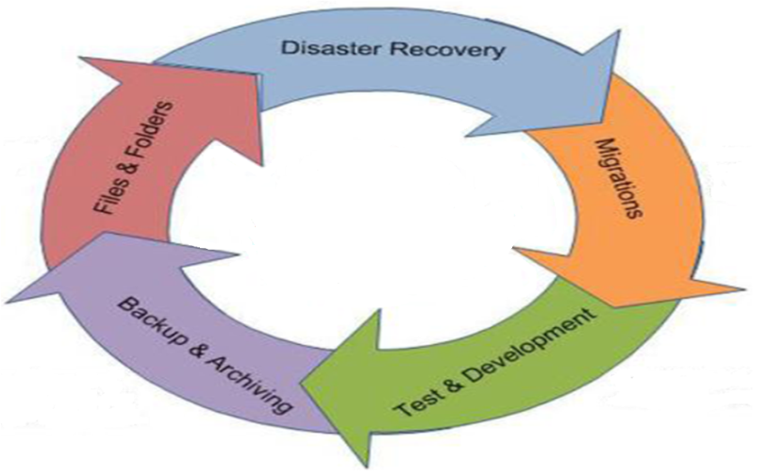
1 5
Fig: Disaster Recovery Process
- Traditional Disaster Recovery: Traditional disaster recovery was developed by share group which are divided into 6 types.
  - No offsite data
  - Data backup
  - Data backup with hot site
  - Electronic vault
  - Point in time copies
  - Transaction integrity
2. Disasters in the Cloud
- Cloud Disaster recovery allows businesses faster recovery of critical IT systems & data without incurring the expense of a second physical backup site.
- It consists of
- Backup and Data Retention
- Geographic Redundancy Issues in DRPlan
- Organizational Red
(a) Backup and Data Retention
Types of Data:
- Fixed data such as your OS and common utilities belong in your AMI.
- Transient data file caches and other data that can be lost completely without impacting the integrity of the system.
- Runtime configuration data necessary to make the system operate properly in a specific context.
- Persistent data it changes constantly and a Database Engine is the best tool for managing it.
- Ability to recover from a disaster is limited by the quality and frequency of your backups.
- You need to freeze the database only for an instant to create your snapshot.
- The process follows these steps:
1. Lock the database.
2. Sync the file system
3. Take a snapshot.
4. Unlock the database.
- The steps for creating the database dump are:
1. Execute the database dump.
2. When complete, encrypt the dump and break it into small, manageable chunks.
3. Move the dump over to S3.
(b) Geographic Redundancy
- For RTO, the key is redundancy in infrastructure.
- With a physical infrastructure, geographical redundancy is expensive, but in the cloud, it is relatively cheap.
- If you have a 2-hour RTO with a 24-hour RPO, geographical redundancy means that your second location can be operational within two hours of the complete loss of your primary location using data that is no older than 24 hours.
- E.g.: Amazon provides built-in geographic redundancy in the form of regions and availability zones.
- The issues need to consider for simultaneous operation include: - DNS Management (use round-robin DNS)
- Database Management (Master & Slave)
- Regulatory Issues (Amazon + GoGrid / Rackspace)
(c) Organizational Redundancy
- What will happen to the hardware assets that run cloud infrastructure if cloud provider simply disappears from the earth?
- Identify another cloud provider and establish a backup environment with that provider in the event your first provider fails.
Issues:
- Store your portable backups at your secondary cloud provider.
- Create machine images that can operate applications in the secondary provider’s virtualized environment.
- Keep the machine images up to date with respect to their counterparts with the primary provider.
- Not all cloud providers and MSPs support the same operation systems or file systems.
select a cloud provider that can support your needs.
3. Disaster Management
- When a disaster has happened and have the tools and processes in place to execute Recovery plan.
Issues:
  - Monitoring
  - Load balancer Recovery
  - Application Server Recovery
  - Database server Recovery
- Monitoring: You cannot replace a failing server or execute your disaster recovery plan if you don’t know that there has been a failure.
- Your monitoring systems cannot live in either your primary/ secondary cloud provider’s infrastructure.
- There exist a number of tools, such as enStratus and RightScale, that manage your infrastructure for you.
- The primary monitoring objective should be to figure out what is going to fail before it actually fails.
- Monitor for failure at three levels:
  - Through the provisioning API (for Amazon, the EC2 web services API).
  - Through your own instance state monitoring tools.
  - Through your application health monitoring tools.
b) Load Balancer Recovery: The downside of a failure in your cloud-based load balancer is minor.
- Its a matter of launching a new load balancer instance from the AMI and notifying it of the IP addresses of its application servers.
- Reduce any downtime by keeping a load balancer running in an alternative availability zone and then remapping your static IP address upon the failure of the main load balancer.
- Hardware load balancers without incurring the costs.
(C) Application Server Recovery: Operating multiple application servers in multiple availability zones, the system will survive the failure of any one instance—or even an entire availability zone.
- Recover the server & future failures don’t affect your infrastructure.
- The recovery of a failed application server is only slightly more complex than the recovery of a failed load balancer.
- Once the server is operational, you must notify the load balancer of the existence of the new server so that the new server enters the load-balancing rotation.
(d) Database Server Recovery: The hardest part of disaster recovery in the cloud.
- Disaster recovery algorithm has to identify where an uncorrupted copy of the database exists.
- Use a Clustered database that can survive the loss of an individual database server without the need to execute a complex recovery procedure.
- Solutions for all levels of database failure: Launch a replacement instance in the old instance’s availability zone and mount its old volume.
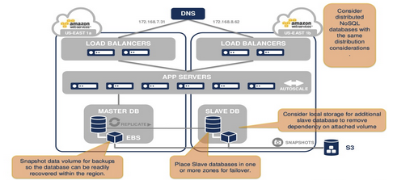
Fig: Disaster Management with Right Scale DR in Cloud
4. Capacity Planning
- Scaling a Cloud Infrastructure: The ability to automatically scale an infrastructure vertically and horizontally with little/no impact to the applications running in that infrastructure.
- The obvious benefit of cloud scaling is that you pay only for the resources you use.
- The downside of cloud scaling, has lazy system architects use to avoid capacity planning.
- Apply the full capabilities of the cloud to your IT infrastructure without falling prey to its dangers.
- These are two types
- Capacity Planning
- Cloud Scale
- Capacity Planning: Developing a strategy that guarantees your infrastructure can support the resource demands placed on it.
- The core concerns for scaling in the cloud is to knowing your expected usage patterns as they vary during the day, over the course of a week, during holidays, and across the seasonal variance of your business.
- Cloud Computing capacity and scalability mean that Disaster Recovery, once reserved for the rich and famous, is now accessible to everyone.
- These are two types
(a) Expected Demand b) The Impact of Load
(a) Expected Demand: Know what demands you expect to be placed on your application and have a well-quantified expectation that enables to plan out an infrastructure to support expected loads.
- Recognize when actual load is diverging in a meaningful way from expected load and understand the impact of changing application requirements on your infrastructure
- Eg: The expected traffic for an e-commerce site over the course of a typical day as well as projected peak volumes over the next 12 months.
(b) The Impact of Load: The ability to scale a web application / website is tied directly to understanding where the resource constraints lie and what impact the addition of various resources has on the application.
- It consists of
- Revisit Application Architecture & Database Architectures
- Use the fastest storage devices for database access
- Properly index your database
- Various Potential capacity constraints are as follows:
  - The bandwidth into the load balancer
  - The CPU and RAM of the load balancer
  - The load balancer spread load across the application servers
  - The bandwidth b/w the load balancer & the app’n servers
  - The CPU and RAM of the application server
5. Cloud Scale
- Delivering services at Cloud-scale requires a radically different approach to designing, building, deploying, and operating datacenters.
- When software applications are built as distributed systems, every aspect of the physical environment - from the server design to the building itself - creates an opportunity to drive systems integration for greater reliability, scalability, efficiency, and sustainability.
- Objectives:
- Make cloud systems scalable by design.
- Enable analysis of scalability of basic and composed services in the cloud.
- Ensure industrial relevance and uptake of the Cloud Scale results.
- The goal of Cloud Scale is to aid service providers in analyzing, predicting and resolving scalability issues, i.e., support scalable service engineering.
- Cloud Scale provides an engineering approach for building scalable cloud applications and services.
- Points of Scale: Depending on your application, the most likely initial stress points will be one of the following three components:
  - The CPU on your application server
  - The RAM on your application server
  - The disk I/O on your database server
Advantages
- Improved data protection
- Low Total Cost of Ownership (TCO)
- Ease of use
- Fast implementation
- Leverage existing IT
- Lower energy consumption
Agility and scalability

