UNIT-V
Cloud service models and Case studies
Cloud Service Models:
Software as a Service (SaaS)
Software as a service (SaaS) sometimes referred to as “software on demand,” is software that is deployed over the internet and/or is deployed to run behind a firewall on a local area network or personal computer. With SaaS, a provider licenses an application to customers either as a service on demand, through a subscription, in a “pay-as-you-go” model, or (increasingly) at no charge. This approach to application delivery is part of the utility computing model where all of the technology is in the "cloud" accessed over the Internet as a service.
Characteristics
- Network-based access to, and management of, commercially available software.
- Activities managed from central locations rather than at each customer's site, enabling customers to access applications remotely via the Web.
- Application delivery typically closer to a one-to-many model (single instance, multi-tenant architecture) than to a one-to-one model, including architecture, pricing, partnering, and management characteristics.
- Centralized feature updating, which obviates the need for end-users to download patches and upgrades.
- More feature requests from users, since there is frequently no marginal cost for requesting new features
- Faster new feature releases, since the entire community of users benefits
- Embodiment of recognized best practices, since the user community drives the software publisher to support best practice.
Configuration and customization
SaaS applications similarly support what is traditionally known as application configuration. In other words, like traditional enterprise software, a single customer can alter the set of configuration options (a.k.a. parameters) that affect its functionality and look-and-feel. Each customer may have its own settings (or: parameter values) for the configuration options. The application can be customized to the degree it was designed for based on a set of predefined configuration options.
Accelerated feature delivery
SaaS applications are often updated more frequently than traditional software, in many cases on a weekly or monthly basis. This is enabled by several factors:
- The application is hosted centrally, so an update is decided and executed by the provider, not by customers.
- The application only has a single configuration, making development testing faster.
- The application vendor does not have to expend resources updating and maintaining backdated versions of the software, because there is only a single version.
- The application vendor has access to all customer data, expediting design and regression testing.
- The solution provider has access to user behavior within the application (usually via web analytics), making it easier to identify areas worthy of improvement.
Accelerated feature delivery is further enabled by agile software development methodologies. Such methodologies, which have evolved in the mid-1990s, provide a set of software development tools and practices to support frequent software releases.
Open integration protocols
Because SaaS applications cannot access a company's internal systems (databases or internal services), they predominantly offer integration protocols and application programming interfaces (APIs) that operate over a wide area network. Typically, these are protocols based on HTTP, REST, and SOAP.
The ubiquity of SaaS applications and other Internet services and the standardization of their API technology has spawned development of mashups, which are lightweight applications that combine data, presentation and functionality from multiple services, creating a compound service. Mashups further differentiate SaaS applications from on-premises software as the latter cannot be easily integrated outside a company's firewall.
Collaborative (and "social") functionality
Inspired by the success of online social networks and other so-called web 2.0 functionality, many SaaS applications offer features that let their users collaborate and share information.
For example, many project management applications delivered in the SaaS model offer—in addition to traditional project planning functionality—collaboration features letting users comment on tasks and plans and share documents within and outside an organization. Several other SaaS applications let users vote on and offer new feature ideas.
Although some collaboration-related functionality is also integrated into on-premises software, (implicit or explicit) collaboration between users or different customers is only possible with centrally hosted software.
OpenSaas
OpenSaaS refers to software as a service (SaaS) based on open source code. Similar to SaaS applications, Open SaaS is a web-based application that is hosted, supported and maintained by a service provider. While the roadmap for Open SaaS applications is defined by its community of users, upgrades and product enhancements are managed by a central provider. The term was coined in 2011 by Dries Buytaert, creator of the Drupal content management framework.
Examples
Salesforce.com
Arguably the quintessential Software as a Service application, Salesforce remains at the vanguard of the cloud computing revolution it helped create. The customer relations management solution enables businesses to collect all information on customers, prospects and leads within a single online platform, enabling authorized employees to access critical data on any connected device at any time. Salesforce credits its tools for boosting customer sales an average of 37 percent as well as driving increased client loyalty and satisfaction.
Microsoft Office 365
Signature Microsoft productivity applications such as Word, Excel and PowerPoint are longtime staples of the workplace, but the cloud-based Microsoft Office 365 dramatically expands the Office suite’s parameters. Users now may create, edit and share content from any PC, Mac, iOS, Android or Windows device in real-time, connect with colleagues and customers across a range of tools from email to video conferencing and leverage a range of collaborative technologies supporting secure interactions both inside and outside of the organization.
Box
This online workspace enables professionals to collaborate with anyone, anywhere. Users can securely share large files via traditional link or custom URL, safeguarding data and documents via permissions and password protection. Box supports more than 120 file types, and users may preview content prior to downloading. All content sharing, editing, discussion and approval is confined to one centralized file, and users receive real-time notifications when edits are made. Box also automates tasks such as employee onboarding and contract approvals, reducing repetition and abbreviating review cycles.
Google Apps
Google long ago expanded beyond its search and advertising roots to offer businesses a comprehensive suite of productivity tools. Google Apps includes custom professional email (complete with spam protection), shared calendars and video meetings alongside Google Drive. A cloud-based document storage solution, Google Drive enables staffers to access files from any device and share them instantly with colleagues, in the process eliminating email attachments as well as the hassles of merging different versions.
Amazon Web Services
Amazon, too, has evolved beyond its core e-commerce platform to support the on-demand delivery of cloud-based IT resources and applications, bolstered by pay-as-you-go pricing options. Amazon Web Services currently encompasses more than 70 services in all, including computing, storage, networking, database, analytics, deployment, management and tools for the Internet of Things.
Concur
Business travel can pose headaches for on-the-go employees and finance departments alike. Concur streamlines the process by automating travel and expense management. Its web-based and mobile solutions enable staffers to book travel plans according to their own needs and preferences, while also making sure all bookings fall within company spending limits. Concur additionally reconciles expenses after travel is completed and delivers electronic airline, hotel and auto rental receipts directly into digital expense reports. This negates the need to collect, track and submit paper receipts.
Zendesk
This cloud-based customer service and support ticketing platform enables representatives to more efficiently tackle inbound client requests across any communications channel — email, web, social media, phone or chat. Features include Automatic Answers (a machine learning-powered tool for interpreting and solving customer questions and requests), Zopim (a real-time chat service) and Zendesk Voice (a cloud-based, built-in phone support solution). According to Zendesk, its business users experience positive ratings for more than 86 percent of their customer interactions.
DocuSign
Electronic signature technology and transaction management services platform DocuSign supports the exchange of digital contracts and other e-signed documents. Users may access, sign and send business documents from their office, their hotel room or anywhere else their job leads, guaranteeing approvals and agreements are executed in a matter of minutes, not days. DocuSign e-signatures are legally binding for most business and personal transactions in virtually every nation across the globe. The app supports more than 85 million users in 188 Filing
Dropbox
Keep your documents and files at your fingertips across all your devices using Dropbox. Anything added to Dropbox storage automatically shows up across all your desktop and mobile devices, enabling professionals to begin a project on their work PC, make edits on their smartphone during the evening commute home, and add the finishing touches from their home tablet. Then users can invite teammates to access any Dropbox folder or send them specific files and images accessible through password-protected links; there’s even a remote wipe option in case of emergency.
Slack
A real-time messaging, archiving and search solution, Slack is redefining business communication. Users may organize team conversations in open channels dedicated to specific topics or projects or limit more sensitive interactions to private, invite-only participants. Colleagues also may interact one-on-one using private, secure direct messages. Slack also enables users to share files, documents, spreadsheets and PDFs, complete with options for adding comments and highlighting for future reference; moreover, all messages, notifications and files are automatically indexed and archived.
Applications
1. Microsoft Office 365
2. Salesforce.com
3. Box
4. Google Apps
5. Amazon Web Services
6. Concur
7. Zendesk
8. LinkedIn
9. DocuSign
10. Dropbox
11. Twitter
12. Slack
13. Adobe Creative Crowd
14. GoDaddy
15. GoToMeeting
16. JIRA (Atlassian)
17. Facebook
18. FedEx US
19. Workday
20. Outlook Web Access – 2010
21. Google Analytics
22. NetSuite
23. GitHub
24. Google Apps Admin
Platform as a Service (PaaS)
In the modern business environment, there is a growing emphasis on customer-friendly web applications and services. Many businesses today wish to provide a greater level of customer care and support to their clientele using web-developed applications and solutions. But all too often they find the costs of developing and deploying these apps prohibitive.
In recent years, several service providers have sprouted up to mitigate those costs and offer affordable application development. The most prominent among the services offered by these providers is the Platform-as-a-Service (PaaS) model, which provides businesses with an independently maintained platform upon which their web applications can be built, refined and deployed.
There are two prominent types of PaaS:
- Public PaaS is delivered by a services provider for building applications. Examples include Salesforce Heroku, AWS Elastic Beanstalk, Microsoft Azure, and Engine Yard.
- Enterprise PaaS is delivered by central IT within an organization to developers and possibly partners and business customers. Enterprise PaaS sits on top of public IaaS, on-premise bare metal, and on-premise virtual machines. Some technology analysts make a distinction between the actual service that central IT is delivering (PaaS) and the software used to deliver that service. For example, Gartner uses the term “cloud-enabled application platform” or CEAP. Examples include Apprenda, VMware- and EMC-owned Pivotal, and Red Hat OpenShift.
Characteristics
Runtime Framework: This is the “software stack” aspect of PaaS, and perhaps the aspect that comes first to mind for most people. The PaaS runtime framework executes end-user code according to policies set by the application owner and cloud provider. PaaS runtime frameworks come in many flavors, some based on traditional application runtimes, others based on 4GL and visual programming concepts, and some with pluggable support for multiple application runtimes.
Abstraction: Platform-oriented cloud platforms are distinguished by the higher level of abstraction they provide. With IaaS, the focus is on delivering to users “raw” access to physical or virtual infrastructure. In contrast, with PaaS, the focus is on the applications that the cloud must support. Whereas an IaaS cloud gives the user a bunch of virtual machines that must be configured and to which application components must be deployed, a PaaS cloud provides the user a way to deploy her applications into a seemingly limitless pool of computing resources, eliminating the complexity of deployment and infrastructure configuration.
Automation: A PaaS environment is a bit like a swan on a pond — graceful and elegant above the water, and paddling its little legs off below the water. The aforementioned abstraction provides the elegant user experience “above the water,” while high levels of automation provide the “paddling” beneath the surface. PaaS environments automate the process of deploying applications to infrastructure, configuring application components, provisioning and configuring supporting technology like load balancers and databases, and managing system change based on policies set by the user.
While IaaS is known for its ability to shift capital costs to operational costs through outsourcing, only PaaS is able to slash costs across the development, deployment and management aspects of the application lifecycle.
Cloud Services: PaaS offerings provide developers and architects with services and APIs that help simplify the job of delivering elastically scalable, highly available cloud applications. These cloud services provide a wide variety of capabilities, and in many instances are key differentiators among competing PaaS offerings.
Examples of cloud services include services and APIs for distributed caching, queuing and messaging, workload management, file and data storage, user identity, analytics, and more. By providing built-in cloud services, platform offerings eliminate the need to integrate many disparate components and decrease time-to-market for applications on the platform.
Examples
PaaS software provides a stable online platform, independent of on-site computing resources, allowing businesses to save large amounts of money by streamlining the structure of their web applications. As with all business decisions, however, choosing a PaaS vendor that meets the needs of your business in terms of freedom, costs, and risk exposure is paramount to ensuring the successful and cost-effective development of web applications and their accessibility to your customer base.
Apprenda
Apprenda’s enterprise Platform as a Service (PaaS) for Java and .NET delivers significant cost savings and massive improvements in productivity by freeing app development teams from internal infrastructure and IT. Apprenda modernizes existing applications for the cloud and lets developers build cloud native applications faster.
Applications on Apprenda inherit cloud characteristics such as scalability, multi-tenancy, elasticity, high availability, SaaS enablement, and more.
Pivotal CF
Pivotal is a big data and application enterprise PaaS vendor that is owned by VMware, EMC, and others. Pivotal CFis a proprietary enterprise PaaS based on Cloud Foundry.
Red Hat Openshift
Red Hat OpenShift is an open-source enterprise PaaS (CEAP) that is not based on Cloud Foundry, the more prominent open-source option. Red Hat has its own public PaaS version of OpenShift. Red Hat has added OpenShift on top of its Red Hat Enterprise Linux (RHEL), JBoss, and OpenStack stack.
Applications

Build New Cloud-Native Applications With Paas
Platform as a Service (PaaS) is driving the shift from cloud-based infrastructure to cloud-based innovation. The ability to design new applications specifically for the cloud with PaaS provides the means to increase your speed of innovation and improve business outcomes.

Reduce Costs, Improve Security And Minimize Footprint
PaaS relieves your IT staff from the burden of infrastructure and software management, patching and troubleshooting. The system software and “plug-in” services are provided and maintained by the cloud provider.

Enjoy The Most Robust, Integrated Paas In The Industry
Azure PaaS offers services that span web and mobile application development, data services, integration and security. Azure PaaS provides scale-out capabilities and backup data replication services. Applications built with Azure PaaS can interact with Microsoft Azure Active Directory for robust identity management.

Use Azure For Modern Mobile Applications
Smartphones and tablets account for more than 80% of all computing devices purchased today. Consequently, mobile applications are a critical aspect of digital transformation and competitive differentiation.
Azure offers a highly scalable, globally available mobile application development platform that brings a rich set of capabilities to mobile developers. Developers tap into a single code-base for all devices and build apps on a unified platform with a rich portfolio of services.

Accelerate Your Application Development With Acts
From strategy through design and execution of the most critical cloud application projects, ACTS utilizes its business outcome methodology and technical acumen to accelerate and improve application development for clients.
Infrastructure as a Service (IaaS)
Infrastructure as a Service (IaaS) is the most straightforward of the four models for delivering cloud services. IaaS is the virtual delivery of computing resources in the form of hardware, networking, and storage services. It may also include the delivery of operating systems and virtualization technology to manage the resources. Rather than buying and installing the required resources in their own data center, companies rent these resources as needed.
Many companies with a hybrid environment are likely to include IaaS in some form because IaaS is a highly practical solution for companies with various IT resource challenges. Whether a company needs additional resources to support a temporary development project, an on-going dedicated development testing environment, or disaster recovery, paying for infrastructure services on a per-use basis can be highly cost-effective.
Characteristics
Dynamic Scaling
Some level of uncertainty always exists when planning for IT resources. One of the major benefits of IaaS for companies faced with this type of uncertainty is the fact that resources can be automatically scaled up or down based on the requirements of the application.
This important characteristic of IaaS is called dynamic scaling — if customers wind up needing more resources than expected, they can get them immediately (probably up to a given limit). A provider or creator of IaaS typically optimizes the environment so that the hardware, the operating system, and automation can support a huge number of workloads.
Service Levels
Consumers acquire IaaS services in different ways. Many consumers rent capacity based on an on-demand model with no contract. In other situations, the consumer signs a contract for a specific amount of storage or compute. A typical IaaS contract has some level of service guarantee. At the low end, a provider might simply state that the company will do its best to provide good service. If the consumers are willing to pay a premium price, they might get a mirrored service so that there are almost no change-of-service interruptions.

A typical service-level agreement states what the provider has agreed to deliver in terms of availability and response to demand. The service level might, for example, specify that the resources will be available 99.999% of the time and that more resources will be provided dynamically if greater than 80% of any given resource is being used.
The Rental Model
When companies use IaaS, it’s often said that the servers, storage, or other IT infrastructure components are rented for a fee based on the quantity of resources used and how long they’re in use. Although this is true, there are some important differences between this rental arrangement and the traditional rental models you may be familiar with.
For example, when you purchase server and storage resources using IaaS services, you gain immediate virtual access to the resources you need. You aren’t, however, renting the actual physical servers or other infrastructure. Don’t expect a big truck to pull up to your office and deliver the servers you need to complete your project. The physical components stay put in the infrastructure service provider’s data center. This concept of renting is an essential element of cloud computing, and it provides the foundation for the cost and scalability benefits of the various cloud models.
Within a private IaaS model, renting takes on a different focus. Although you might not charge each user to access a resource, in the charge-back model, you can allocate usage fees to an individual department based on usage over a week, month, or year. Because of the flexibility of the IaaS model, you can charge more of the budget to heavy users.
Licensing
The use of public IaaS has led to innovation in licensing and payment models for software you want to run in these cloud environments. Note that this licensing is for the software you want to run in your cloud environment, not the license between you and the cloud provider. For example, some IaaS and software providers have created a “bring your own license” (BYOL) plan so you have a way to use your software license in both traditional and cloud environments.
Another option is called “pay as you go” (PAYG), which generally integrates the software licenses with the on-demand infrastructure services. For example, say that you’re running Microsoft Windows Server and using the PAYG route. If you’re paying ten cents an hour for cloud access, a few cents of that fee might be going to Microsoft.
Metering And Costs
Clearly, you derive a potential economic benefit by controlling the amount of resources you demand and pay for so that you have just the right match with your requirements. To ensure that users are charged for the resources they request and use, IaaS providers need a consistent and predictable way to measure usage. This process is called metering.

Ideally, the IaaS provider will have a transparent process for identifying charges incurred by the user. With multiple users accessing resources from the same environment, the IaaS provider needs an accurate method for measuring the physical use of resources to make sure each customer is charged the right amount.

IaaS providers often use the metering process to charge users based on the instance of computing consumed. An instance is defined as the CPU power and the memory and storage space consumed in an hour. When an instance is initiated, hourly charges begin to accumulate until the instance is terminated. The charge for a very small instance may be as little as two cents an hour; the hourly fee could increase to $2.60 for a large resource-intensive instance running Windows.

Metering to assess the charges for the IaaS services you request begins when the instance is initiated and ends when the instance is terminated. At this point, the virtual machine provisioned for you is removed, and you no longer receive charges. Until this point, the charges apply whether the resources are fully used or are laying idle.

In addition to the basic per-instance charge, your IaaS provider may include charges such as the following (keep in mind that charges can change daily):

Storage: A per-gigabyte (GB) charge for the persistent storage of data of approximately $0.00015 an hour or $0.10 a month.

Data transfer: A per-GB charge for data transfers of approximately $0.15. This fee may drop to $0.05 per GB if you move large amounts of data during the billing month. Some providers offer free inbound data transfers or free transfers between separate instances on the same provider.

Optional services: Charges for services such as reserved IP addresses, virtual private network (VPN), advanced monitoring capabilities, or support services.

Because of the variety of costs, many cloud providers offer cost calculators so organizations can estimate their monthly IaaS costs. Here are the typical billing options:

Pay as you go: Users are billed for resources used based on instance pricing.

Reserved pricing: Users are billed an upfront fee, depending on the instance type, and then billed at a discounted hourly usage rate. For some companies, this provides the best rates.

Self-Service Provisioning
You can’t discuss the key characteristics of IaaS without understanding the imperative of self-service. The banking ATM service is a great example of the business value of self service. Without the availability of the self-service ATM, banks would be required to use costly resources to manage activities of all their customers — even for the most repetitive tasks. With an ATM, repetitive tasks can be handled easily with a self-service interface. The customer makes a direct request to perform routine transactions that conform to predefined business rules.
Examples
Infrastructure as a service, or IaaS, is managed computing infrastructure that is offered on demand such that computing can be quickly scaled up and down. This is the basis for cloud computing. Infrastructure as a service typically includes technologies for using many compute instances to provide a single service. It is often charged on a utility model whereby customers pay for what they use. This can be compared with the traditional upfront capital investment required to build data centers and install your own computing equipment. The following are illustrative examples of infrastructure as a service.
Computing
Computing instances that can be used to run websites, software as a service, automation and analysis. Instances are often virtual machines that typically support attached storage and networking. Data centers are fully managed by the provider.
Firewalls
Firewalls for computing instances. For example, a firm might use a firewall to restrict access to a compute instance such that only its corporate IP addresses can connect.
Auto Scaling
The ability to automatically start and stop instances in response to current demand. For example, a website that automatically adds instances when cpu utilization passes 66% for more than two minutes on an instance.
Load Balancers
Load balancers to distribute work to instances. For example, software as a service that uses load balancers to distribute traffic to instances. This can be combined with auto scaling to provide a target cpu to user ratio such as a minimum of 1 cpu for every 50 users.
Monitoring
Cloud infrastructure services may provide monitoring tools that allow automated responses to situations such as a server that appears to be down.
Batch Jobs
Platforms for scheduling and managing batch jobs. For example, an ecommerce company might perform inventory management tasks as a daily batch job.
Data Storage
Computing instances may have attached storage. It is also common to use a cloud storage service that may be more scalable, sharable and resilient than local storage.
Databases
Databases including cloud-based SQL and NoSQL databases.
Infrastructure Management
User interfaces and APIs for managing computing infrastructure. For example, an API that allows you to back up an instance image automatically.
Identity & Access Management
Tools for managing authentication and authorization.
Keys Management
Tools for managing encryption keys.
Content Delivery Network
A service that delivers content and media to users from a data center that is physically close to them. For example, an ecommerce website that delivers its images and web pages from dozens of regional data centers near popular centers to reduce page load times.
Messaging
Messaging platforms such as a service for delivering transactional and marketing emails.
Integration
Integration tools such as publish and subscribe notifications. For example, an ecommerce site might notify all instances when a new product is added to its product database.
Applications
Enabling add-on services – in addition to providing day-to-day computing resources, IaaS allows users to layer a wide-range of services on top of the infrastructure. That might include computing-as-a-service, disaster recovery-as-a-service, analytics or BI-as-a-service, and more.
Big data – Managing, storing and analyzing big data like structured data (i.e., databases) and unstructured data (i.e., social media, images, web, emails, Internet of Things (IoT) sensors) requires a significant amount of processing power. IaaS is a perfect environment to manage big data because it can handle large workloads and can integrate with business intelligence tools. This delivers business insights that can help users predict trends, improve relationships with customers and create new products and services.
Disaster recovery – With a robust and scalable infrastructure layer, organizations can consolidate their disparate disaster recovery systems into one virtualized environment for disaster recovery. This diversifying of the backup systems gives businesses peace of mind knowing that their data is secure.
Testing and development – The computing and networking power behind IaaS make it a perfect place to run and manage testing and development cycles. With SLAs in place from providers and a high-level of security, enterprises can trust IaaS to run business-critical projects and get to market faster with a higher scalability of computing resources.
Networking services – Because the network continues to grow in complexity, many are turning to IaaS service providers to deliver networking-as-a-service support. This may be for a short-term big data project, or to support ongoing initiatives, freeing up internal IT staff for other priorities.

Case Studies:
SaaS: Salesforce.com
Telecommunications Company
B2B & B2C Salesforce Implementation
What’s the problem?
The client sought to digitalise their end to end processes across both their B2B and B3C businesses
• Our client has chosen Salesforce as their primary business support tool for customer facing staff in their call centres, stores, partner organisations and sales teams
• There are a number of Salesforce projects at the client with a key unifying theme of improving customer centricity, speed to value and productivity through digitisation
What we did…
PwC created a transformational roadmap to maximise their Salesforce investment, ensure security, and meet organisational compliance
• Strong business engagement by the architecture team with the business to ensure that the solution removed key pain points for the organisation and took advantage of the capabilities included with Salesforce Sales and Service Cloud licenses
• Integration and security approach determined by the Architecture team for the existing marketing automation and data warehouse solutions
• Facilitation of workshops to determine the enhanced Sales Pipeline and Opportunity management process including contract management
• Design of a new complaints and compensation management solution utilising service Cloud Email to Case and SLA management functionality
• Formal engagement with the client’s architecture council, security and privacy teams to ensure compliance of the solution to organisational policies, directives and guidelines
How did it do?
The solution delivered an improved uptake of Salesforce, resulting in better data quality and improved business insights
• Improved communications between sales, legal and customer onboarding teams
• Better sales pipeline information being entered in the system and improved communications between Sales, Legal and customer onboarding teams
• Reduction in complexity for the complaint management team allowing them to focus on resolving the customer’s issue through improved automation and less re-keying
• The solution was delivered to meet the client’s security standards and ensure
structural separation was preserved
• De-risk contract management process by better understanding the contractual
obligations across a portfolio of customers
Facebook.com
State Bicycle Co.
When it comes to social media, it’s best to think visual. After all, Facebook posts with pictures get 5.5 times more likes compared to their text-only brethren. Making the most of the public’s penchant for pictures is Arizona-based bicycle manufacturer State Bicycle Co., who create beautiful visual content for their followers to ogle.

Keen to grow their Facebook audience and boost online sales at statebicycle.com, the company came up with a number of ways to reach out to cycling lovers. One of the most popular is their weekly photo challenge, where State Bicycle Co. reward the follower who submits the best snap on a given theme (e.g. the winner of the “most beat-up bike” theme landed themselves a brand new ride).

State Bicycle Co. also offer unique discount codes on ‘Facebook Fridays’ and encourage followers to like posts to reveal sneak previews of new products.

These efforts have been richly rewarded. Since 2013 State Bicycle Co. has grown its followers from 4,500 to 480,000. Today, 12 per cent of State Bicycle Co.’s website traffic comes from Facebook, at a fifth of the cost per click of other platforms. Best of all? State Bicycle Co. attribute $500,000 in annual sales to coupon codes and traffic from Facebook.
Think visual. Get creative. Tease your new products.
PaaS:
Google App Engine

Zembly
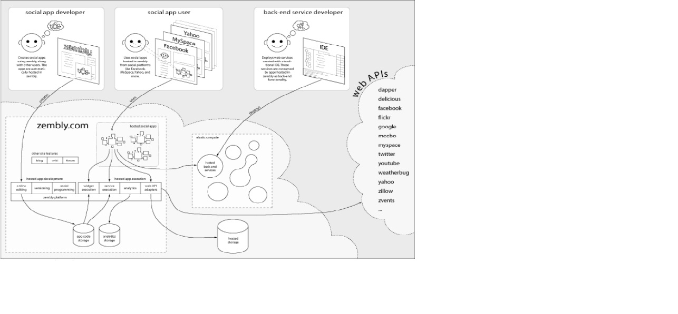
What is “zembly”?
•“zembly” is the place to create social applications, together
>“zembly” allows users to easily create and host social applications of all shapes and sizes, targeting the most popular social platforms on the web
•Think of “zembly” like Wikipedia for social applications
>a wiki for live, editable code that is more than just about trivial widgets, but rather about full-fledged social applications that can tap into the social graph and reach millions of users.
Three Major Things you create in Zembly
• Services
> Contain business logic
> Take parameters
> Can be used by widgets and applications
• Widgets
> Relatively independent web components having certain features
> Contain (X)HTML files, CSS files, Java Scripts
• Applications
> Full featured Social Applications
> Facebook apps, Meebo apps, iPhone apps
Steps for Creating a Service
•Write business logic in JavaScript
>Using IDE-like JavaScript editor: code completion, syntax checking, format, code snippet, change history
•Set up parameters
•Find and use other services
•Handle error conditions
>You can use built-in validation
•Test the service
•Publish the service
>Version control

MS-Azure

Cloud-based Metering and Smart Analytics solution
Microsoft Azure (IaaS And PaaS), Verizon Wireless Network, MVC, Azure Tables, Azure Service Bus Queue
Saviant is one of those few Azure Cloud experts who have pushed the envelop to adopt Azure’s cutting-edge IoT solutions to deliver client a Multi-tenant, cloud-based solution that communicates with Verizon Wireless Network and backed by strong data analytical engine. Experts at Saviant implemented a fast and secured data processing using Service Bus, Worker Role and Azure Tables. This helped create a high performance Azure Architecture to process data from 500,000 meters every day with accounts to a mere 5% of the implemented system’s capacity.
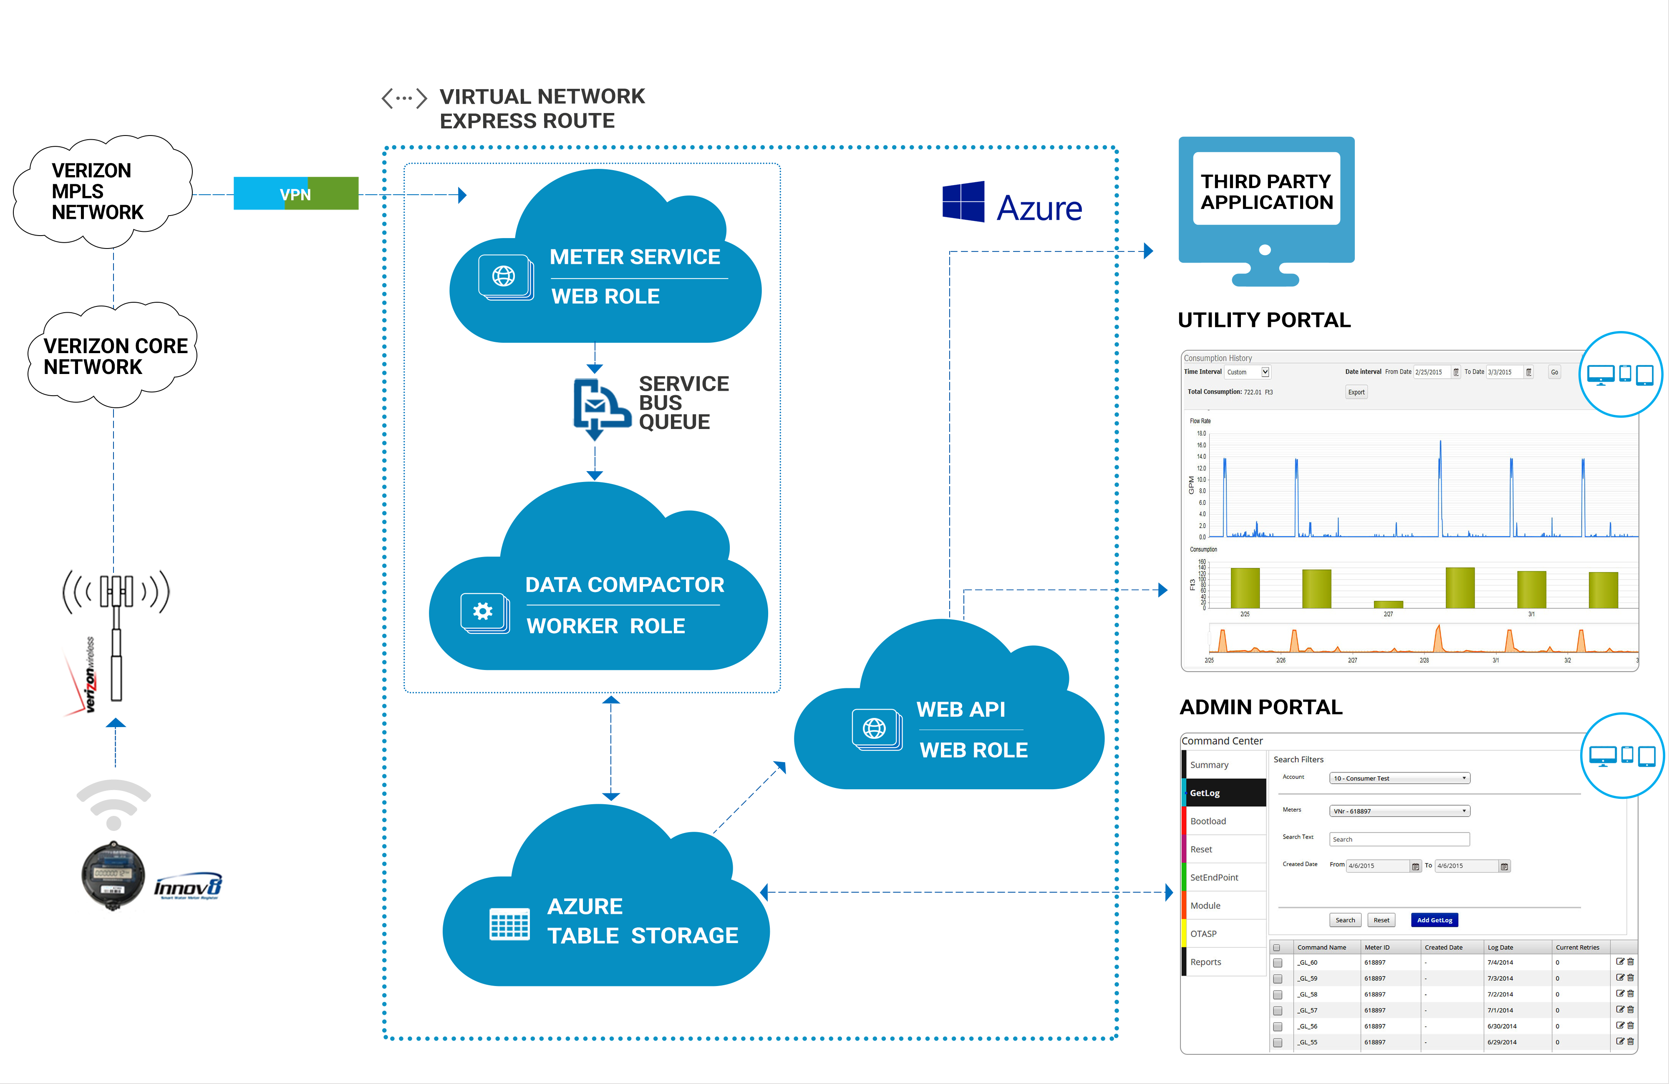
The IoT based Smart Water Metering architecture provide real-time access to users and water department about water consumption at real time. The system generates alerts for over consumption of water resource; billing; leakage detection anomalies; real-time consumption data as few of the 22 alerts in total which the system is designed to generate. The system features two-way communication between Cloud Service and CDMA based water meters with communication time locked at 200-300 millisecond. The VN Server and Azure Storage serves as the meter data management system (MDMS) for the VN system.
IBM Bluemix
“Word-of-mobile” marketing startup unlocks the power of human relationships with Bluemix.
“The IBM Bluemix offering has transformed an idea into a growing company. Without it, we would not have our business! The Bluemix and IBM MobileFirst teams have transformed Gamifo's vision into reality, jointly delivering 10 times the value in a fraction of the cost to our customers.”

– Dr. Ethan Hadar, chief executive officer, Gamifo

The need:
Gamifo Ltd. provides marketing services and a digital marketing platform for retail customers. When the startup was just an idea, Gamifo needed the right development platform in order to build a mobile app capable of running campaigns, providing relationship analysis of consumers’ social networks, detecting qualified leads, and generating consumer traffic for retailers.
The IBM Cloud solution:
Gamifo turned to IBM Bluemix to build and support its TaPrize app and other solutions, benefiting from the broad set of tools and capabilities available on Bluemix, including full application-lifecycle management, centralized logging, and system health management. Within the first few weeks of the app’s launch, 20 retail companies joined the Gamifo platform, with hundreds predicted to join by the end of the 2015 calendar year.
Industry:
Computer services
IaaS:
Amazon EC2
The Kellogg Company Case Study
About The Kellogg Company
The Kellogg Company was founded in 1898 when founder W. K. Kellogg and his brother, Dr. John Harvey Kellogg, accidentally flaked wheat berry—a mistake that would result in the recipe for Kellogg’s Corn Flakes. The company, which is headquartered in Battle Creek, Michigan, now operates in 180 countries, providing ready-to-eat cereals and other food products. Its 2013 reported net sales totaled $14.8 billion. Kellogg’s brands include Froot Loops, Frosted Flakes, Special K, Rice Krispies, Pop Tarts, Eggo Waffles, Nutri-Grain Bars, and of course, Kellogg’s Corn Flakes.
The Challenge
Margins are tight in the ready-to-eat cereal industry. For a company like Kellogg, approximately a third of its annual revenue is spent on promotional costs or trade spend: every dollar spent on coupons and special offers, promotions for special pricing, sponsorships, even the location each brand occupies on the grocery-store shelf. “Any improvements we make to trade spend go straight to our bottom line,” says Stover McIlwain, Senior Director of IT Infrastructure Engineering at Kellogg. “If we improve trade spend by just 1 percent, that’s $50 million dollars.”
The company keeps a close eye on its trade spend, analyzing large volumes of data and running complex simulations to predict which promotional activities will be the most effective. Kellogg had been using a traditional relational database on premises for data analysis and modeling, but by 2013, that solution was no longer keeping up with the pace of demand. Each day, Kellogg needed to run dozens of complex data simulations on things like TV ad spend, digital marketing, coupon campaigns and other promotions, sales commissions, display and shelving costs—but its system only had the capacity to run just one simulation a day. “Margins are very tight in our industry, and even slight changes in trade spend can swing market share,” McIlwain says. “Revenue growth is flat in some of our categories, so we need to be very agile to stay competitive. We needed to eliminate waste and invest more in the trade spend that drives faster time to market and greater revenue.” It was clear that Kellogg needed to move away from its traditional on-premises infrastructure.
Why Amazon Web Services
Kellogg needed a solution that could accommodate terabytes of data, scale according to infrastructure needs, and stay within its budget. The company became interested in an SAP solution called Accelerated Trade Promotion Planning, which is powered by SAP HANA, SAP’s in-memory database technology platform. Amazon Web Services (AWS) offered a fully SAP-certified HANA environment on a public cloud platform. Because SAP works on the AWS Cloud, the company knew it could achieve the speed, performance, and agility it required without making a significant investment in physical hardware. Kellogg decided to start immediately with test and development environments for its US operations.
The company is now running the SAP Accelerated Trade Promotion Management (TPM) solution, powered by SAP HANA and leveraging multiple AWS instance types for both the SAP application and HANA database layers. These Amazon Elastic Compute Cloud (Amazon EC2) instances process 16 TB of sales data weekly from promotions in the US, modeling dozens of data simulations a day.
The company also uses Amazon Virtual Private Cloud (Amazon VPC), which is connected directly to the Kellogg data centers to allow access to SAP TPM directly for employees who are on the company network. Amazon Simple Storage Service (Amazon S3) is used for data backups, including HANA, and Amazon Elastic Block Store (Amazon EBS) provisioned IOPS (P-IOPS) volumes for storage. The company logs events using AWS Identity and Access Management (AWS IAM).
Kellogg uses Amazon CloudWatch for monitoring, which helps the company allocate costs to each department based on their individual infrastructure use. “CloudWatch helps our people make better decisions around the capacity they need, so that they can avoid waste,” McIlwain says. “We were never able to do that with our on-premises infrastructure. AWS breaks down usage and cost to such a granular level that we can identify which costs come from which department, like a toll model.” Costs and benefits of this IT service can now be aligned so that Kellogg can assess the true return on investment.
For high availability, Kellogg leverages multiple AWS Availability Zones (AZs) without the additional cost of maintaining a separate datacenter.
The Benefits
Kellogg estimates that it will save close to a million dollars in software, hardware, and maintenance over the next 5 years, just by using AWS in its test and development environments. “Using AWS saves us more than $900,000 and lets us run dozens of data simulations a day so we can reduce trade spend. It’s a win-win, and a pretty compelling business case for moving to the cloud,” McIlwain says.
By using AWS, the company is also able to be more agile. Instead of having to wait 30 days to make changes to its trade spend analysis system, the company can spin up instances immediately to perform the necessary data simulations (or calculations). “The speed and agility that using AWS gives us lets us develop and deliver business services much more quickly than before, so that we can keep one step ahead of the market. Our staff can deploy instances 90 percent faster than with our previous on-premises solution,” McIlwain says. “The AWS Cloud drives a lot of business benefits for Kellogg.”

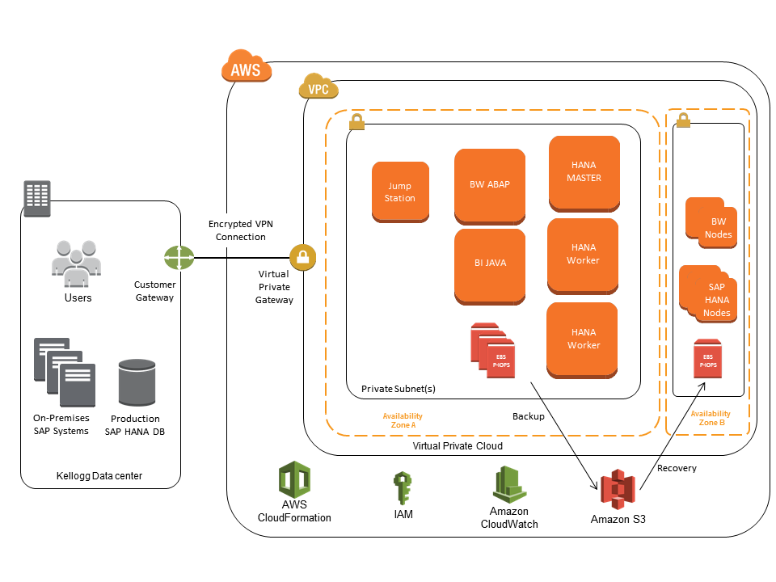
Figure 1. Kellogg SAP HANA Deployment Architecture on AWS

Kellogg engineers liked the accessibility and familiarity of the AWS platform, which enabled them to easily apply their existing knowledge and infrastructure skills to the AWS Cloud. In addition, by using AWS, the IT team’s internal customers can now self-fund IT projects—saving the IT team from having to budget for projects from other departments and driving more efficient use of resources. “AWS allows me to do the unprecedented: bill Sales directly for the infrastructure they’re using, instead of the hosting costs being lost in the overall Infrastructure annual budget,” McIlwain says.
Kellogg is pleased that AWS supports the option to leverage existing HANA licenses that the company previously purchased from SAP; it allows the team to quickly provision instances and avoid having to repeatedly install and configure the software.

The company uses AWS Support, Business Level, and training, as well; one engineer already has successfully achieved the AWS Certified Architect certification. “The engineering support included training and documentation,” McIlwain says. “It exceeded expectations and became a key differentiator and added benefit in working with AWS.”

Kellogg is using AWS for its US operations, and plans to expand worldwide in 2014 — which should increase the amount of data being processed from 16 TB to 50 TB. “By using AWS, we have happier customers and we work faster, cheaper, and better,” McIlwain says.
Amazon S3
Amazon.com Case Study
About Amazon.com
Amazon.com is the world’s largest online retailer. In 2011, Amazon.com switched from tape backup to using Amazon Simple Storage Service (Amazon S3) for backing up the majority of its Oracle databases. This strategy reduces complexity and capital expenditures, provides faster backup and restore performance, eliminates tape capacity planning for backup and archive, and frees up administrative staff for higher value operations. The company was able to replace their backup tape infrastructure with cloud-based Amazon S3 storage, eliminate backup software, and experienced a 12X performance improvement, reducing restore time from around 15 hours to 2.5 hours in select scenarios.
The Challenge
As Amazon.com grows larger, the sizes of their Oracle databases continue to grow, and so does the sheer number of databases they maintain. This has caused growing pains related to backing up legacy Oracle databases to tape and led to the consideration of alternate strategies including the use of Cloud services of Amazon Web Services (AWS), a subsidiary of Amazon.com. Some of the business challenges Amazon.com faced included:

Utilization and capacity planning is complex, and time and capital expense budget are at a premium. Significant capital expenditures were required over the years for tape hardware, data center space for this hardware, and enterprise licensing fees for tape software. During that time, managing tape infrastructure required highly skilled staff to spend time with setup, certification and engineering archive planning instead of on higher value projects. And at the end of every fiscal year, projecting future capacity requirements required time consuming audits, forecasting, and budgeting.
The cost of backup software required to support multiple tape devices sneaks up on you. Tape robots provide basic read/write capability, but in order to fully utilize them, you must invest in proprietary tape backup software. For Amazon.com, the cost of the software had been high, and added significantly to overall backup costs. The cost of this software was an ongoing budgeting pain point, but one that was difficult to address as long as backups needed to be written to tape devices.
Maintaining reliable backups and being fast and efficient when retrieving data requires a lot of time and effort with tape. When data needs to be durably stored on tape, multiple copies are required. When everything is working correctly, and there is minimal contention for tape resources, the tape robots and backup software can easily find the required data. However, if there is a hardware failure, human intervention is necessary to restore from tape. Contention for tape drives resulting from multiple users’ tape requests slows down restore processes even more. This adds to the recovery time objective (RTO) and makes achieving it more challenging compared to backing up to Cloud storage.
Why Amazon Web Services
Amazon.com initiated the evaluation of Amazon S3 for economic and performance improvements related to data backup. As part of that evaluation, they considered security, availability, and performance aspects of Amazon S3 backups. Amazon.com also executed a cost-benefit analysis to ensure that a migration to Amazon S3 would be financially worthwhile. That cost benefit analysis included the following elements:

Performance advantage and cost competitiveness. It was important that the overall costs of the backups did not increase. At the same time, Amazon.com required faster backup and recovery performance. The time and effort required for backup and for recovery operations proved to be a significant improvement over tape, with restoring from Amazon S3 running from two to twelve times faster than a similar restore from tape. Amazon.com required any new backup medium to provide improved performance while maintaining or reducing overall costs. Backing up to on-premises disk based storage would have improved performance, but missed on cost competitiveness. Amazon S3 Cloud based storage met both criteria.
Greater durability and availability. Amazon S3 is designed to provide 99.999999999% durability and 99.99% availability of objects over a given year. Amazon.com compared these figures with those observed from their tape infrastructure, and determined that Amazon S3 offered significant improvement.
Less operational friction. Amazon.com DBAs had to evaluate whether Amazon S3 backups would be viable for their database backups. They determined that using Amazon S3 for backups was easy to implement because it worked seamlessly with Oracle RMAN.
Strong data security. Amazon.com found that AWS met all of their requirements for physical security, security accreditations, and security processes, protecting data in flight, data at rest, and utilizing suitable encryption standards.
The Benefits
With the migration to Amazon S3 well along the way to completion, Amazon.com has realized several benefits, including:

Elimination of complex and time-consuming tape capacity planning. Amazon.com is growing larger and more dynamic each year, both organically and as a result of acquisitions. AWS has enabled Amazon.com to keep pace with this rapid expansion, and to do so seamlessly. Historically, Amazon.com business groups have had to write annual backup plans, quantifying the amount of tape storage that they plan to use for the year and the frequency with which they will use the tape resources. These plans are then used to charge each organization for their tape usage, spreading the cost among many teams. With Amazon S3, teams simply pay for what they use, and are billed for their usage as they go. There are virtually no upper limits as to how much data can be stored in Amazon S3, and so there are no worries about running out of resources. For teams adopting Amazon S3 backups, the need for formal planning has been all but eliminated.
Reduced capital expenditures. Amazon.com no longer needs to acquire tape robots, tape drives, tape inventory, data center space, networking gear, enterprise backup software, or predict future tape consumption. This eliminates the burden of budgeting for capital equipment well in advance as well as the capital expense.
Immediate availability of data for restoring – no need to locate or retrieve physical tapes. Whenever a DBA needs to restore data from tape, they face delays. The tape backup software needs to read the tape catalog to find the correct files to restore, locate the correct tape, mount the tape, and read the data from it. In almost all cases the data is spread across multiple tapes, resulting in further delays. This, combined with contention for tape drives resulting from multiple users’ tape requests, slows the process down even more. This is especially severe during critical events such as a data center outage, when many databases must be restored simultaneously and as soon as possible. None of these problems occur with Amazon S3. Data restores can begin immediately, with no waiting or tape queuing – and that means the database can be recovered much faster.
Backing up a database to Amazon S3 can be two to twelve times faster than with tape drives. As one example, in a benchmark test a DBA was able to restore 3.8 terabytes in 2.5 hours over gigabit Ethernet. This amounts to 25 gigabytes per minute, or 422MB per second. In addition, since Amazon.com uses RMAN data compression, the effective restore rate was 3.37 gigabytes per second. This 2.5 hours compares to, conservatively, 10-15 hours that would be required to restore from tape.
Easy implementation of Oracle RMAN backups to Amazon S3. The DBAs found it easy to start backing up their databases to Amazon S3. Directing Oracle RMAN backups to Amazon S3 requires only a configuration of the Oracle Secure Backup Cloud (SBC) module. The effort required to configure the Oracle SBC module amounted to an hour or less per database. After this one-time setup, the database backups were transparently redirected to Amazon S3.
Durable data storage provided by Amazon S3, which is designed for 11 nines durability. On occasion, Amazon.com has experienced hardware failures with tape infrastructure – tapes that break, tape drives that fail, and robotic components that fail. Sometimes this happens when a DBA is trying to restore a database, and dramatically increases the mean time to recover (MTTR). With the durability and availability of Amazon S3, these issues are no longer a concern.
Freeing up valuable human resources. With tape infrastructure, Amazon.com had to seek out engineers who were experienced with very large tape backup installations – a specialized, vendor-specific skill set that is difficult to find. They also needed to hire data center technicians and dedicate them to problem-solving and troubleshooting hardware issues – replacing drives, shuffling tapes around, shipping and tracking tapes, and so on. Amazon S3 allowed them to free up these specialists from day-to-day operations so that they can work on more valuable, business-critical engineering tasks.
Elimination of physical tape transport to off-site location. Any company that has been storing Oracle backup data offsite should take a hard look at the costs involved in transporting, securing and storing their tapes offsite – these costs can be reduced or possibly eliminated by storing the data in Amazon S3.
As the world’s largest online retailer, Amazon.com continuously innovates in order to provide improved customer experience and offer products at the lowest possible prices. One such innovation has been to replace tape with Amazon S3 storage for database backups. This innovation is one that can be easily replicated by other organizations that back up their Oracle databases to tape.
Netflix
Netflix: A Case of Transformation for the Digital Future
Origins: DVD-by-Mail Business Model
The classic management textbook theories would have predicted that Netflix should have now failed. Indeed in January 2007, JP Morgan Scurities downgraded the Netflix stock citing high competition and most wondered how Netflix might create a ‘second act’ beyond DVD Distribution. After all, it started in 1997 as a mail-order DVD-by-Mail business with monthly subscription fees so that consumers could avoid late fees. During the first decade, it had built impressive logistics chain with over 50 regional warehouses to distribute the DVDs to its customers. By February 2007, it had distributed its billionth DVD. That success and that kind of growth should have trapped the company to define its business model with core competency in logistics and distribution.

Netflix Classic Red Envelope (circa 2005)
But Netflix’s different in the sense that it had recognized the power of data and analytics. It had developed a superior recommendation engine, Cinematch to better predict the pattern of request of DVD titles by subscribers. It even organized open contest — Netflix Prize — to win $1 million prize to anyone who could improve on its algorithms. It was a data-driven company before data and analytics were in vogue.

By 2009, it had over 100,000 DVD titles and 10 million customers. It could have continued on its trajectory. But, it didn’t. Netflix innovation focused on two dimensions: logistics and analytics.

Blockbuster and other video rental physical stores didn’t recognize possible disruption from a mail-order subscription company like Netflix. Blockbuster even turned down an opportunity to acquire Netflix in 2000.

Netflix 1.0 was about disruption of physical stores.
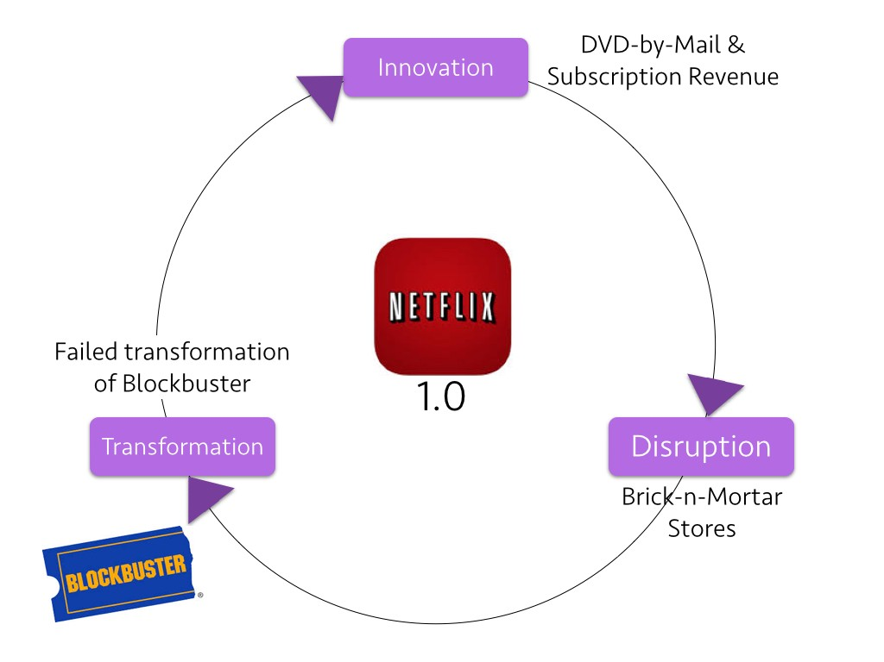

Innovation — Disruption — Transformation Cycle for the DVD-By-Mail Era
Netflix 2.0 — Video Streaming
Since starting its video streaming services in 2007, Netflix has successfully grown its business. By the end of 2016, it had nearly 94 million members globally — expected to reach 100 million mark during the frst half of 2017. Netflix video streaming consumes 37% of downstream internet bandwidth during primetime hours in the USA — far ahead of YouTube, Amazon and Facebook.

Netflix has become the defacto primetime entertainment on the web. It can be streamed on computers, mobile phones, tablets, smart televisions and video game consoles.

What’s the main message from the Netflix story till 2016? It is a rare company that could abandon its traditional successful business model — DVD-by-Mail distribution — and embrace a new business model with video streaming and become a leader. Past success is not guarantee of future success. Transformational leadership is about “preserving the core while creating the new” and Reed Hastings at Netflix has shown that perfectly thus far.

Cloud Plus Data and Analytics
Digital business transformation of Netflix can be seen through two lenses: (1) technology and (2) data & analytics.

Through the technology lens, you see how Netflix worked with Amazon to develop a world-class back-end infrastructure.

Working with Amazon Web Services, Netflix could quickly deploy thousands of servers and terabytes of storage within short time. This video highlights their working relationship with Amazon.

AWS delivers cloud services for Netflix
Many companies might have shied away from depending so much on a competitor — Amazon has its own video-on-demand service. Netflix decided to bet on the cloud by working with a leading company, namely Amazon. By selecting the second-best to Amazon, Netflix would have simply compromised on its ability to deliver best quality service to its customers.

Through the information lens, you see how Netflix has collected the most detailed data possible to be the best at knowing their customers on an individual basis. Really understanding customer preferences and continually sharpen the recommendation engine.

Today, everything that Netflix provides to each customer is a recommendation. The core DNA of Netflix is Personalization — which builds on its data-rich recommendation engine.

Personalization in the homepage consists of groups of videos arranged in horizontal rows. Each row has a title that conveys the meaningful connection between the videos in that group. Personalization is how Netflix selects the rows, the items for each row and the order. And that varies for every individual. And that is done by machines and at scale and speed.

Furthermore, Netflix has been able to add more useful data to make its recommendation even more powerful based on its strategic relationship with Facebook. Specifically, it has been able to add preferences of friends on the social network to refine the recommendations.

Netflix — facebook Link
So, everything Netflix offers to an individual is personal but supported by powerful data and analytics.

The layout — including the rows and columns — are personalized by Netflix
Netflix has been able to take its information advantage with big data and analytics one step further. Their bet on licensing House of Cards was not a blind bet but based on the analysis of their data. Kevin Spacey remarked, “Netflix was the only company that said, ‘We believe in you. We’ve run our data, and it tells us our audience would watch this series.” Other studios were handicapped because they did not have the required data and analytics capability. They continue to rely on outmoded models of pilot shows and sampling to decide the likelihood of success.

Netflix had data and analytics to mitigate risks
Netflix has futher leveraged this information capability to produce its own hit shows such as Orange is the New Black and Marco Polo.

So, where is Netflix headed? It is a master at capitalizing on technology developments and taking advantage of information driven advantage to continually refine its business model.

Internet TV is replacing linear TV. This means that Apps are replacing channels and Netflix is a leading app.

Television is no longer the only screen. This means that Netflix will be on any screen and optimized for any size.

TV guides are standard and customers want personalized recommendations. That means, Netflix will offer unique suggestions that for every user. And will continually experiment and learn to improve the recomemndations.

Netflix has data that suggests there is different viewing behavior depending on the day of the week, the time of day, the device, and sometimes even the location. They have not yet implemented contextual recommendations but could well do that in the near future.

The innovation — disruption — transformation journey for Netflix 2.0 shows mastery of different competencies than what we saw with DVD-by-Mail business model.
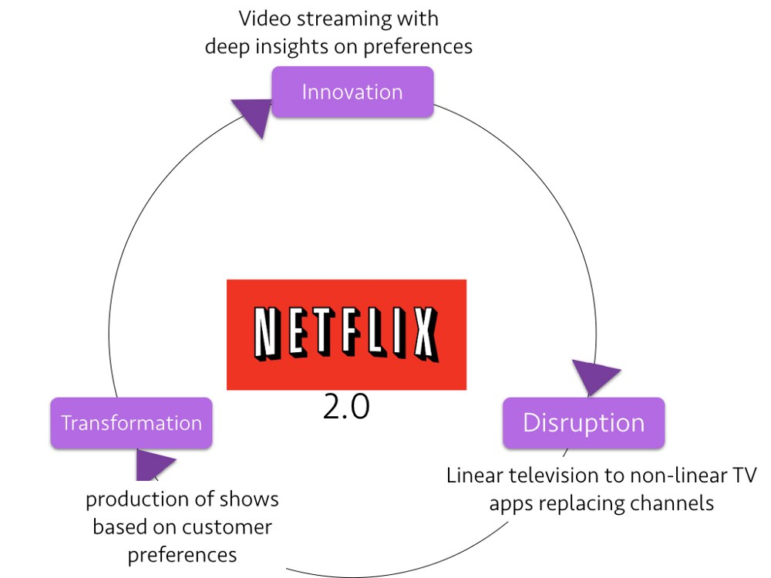

The stock performance of Netflix has been impressive relative to the two benchmark indices — Nasdaq and S&P 500.

Netflix Illustrates The Digital Matrix in Action
Embraced Streaming as Experimentation at the Edge in 2007. In 2007, few traditional media companies focused on video-streaming and it was at that time Netflix began experimenting with this technology. Although he demonstrated video-streaming in 2007 (as alternative to downloading of movies), Reed Hastings at Netflix believed that it wasn’t yet ready for primetime. He commented that: “The market is microscopic…DVD is going to be a very big market for a very long time.” Writing in the 2008 annual report, he noted: “In 2009, we will maintain our focus on improving our core services as well as gaining even greater traction with streaming.” At the end of 2011, Reed Hastings wrote in the CEO Letter: “ Our core strategy is to grow our streaming subscription business domestically and globally. We are continuously improving the customer experience, with a focus on expanding our streaming content, enhancing our user interface and extending our streaming service to even more Internet-connected devices….and that the DVD portion of our domestic service will be a fading differentiator to our streaming success.”

2. Co-create with Amazon Web Services—part of potential formidable competitor, Amazon. In a 2010 blogpost, Amazon highlighted four reasons why they chose Amazon Cloud as Netflix’s computing platform: 1. We needed to re-architect, which allowed us to question everything, including whether to keep building out our own data center solution. (they decided to work with an extenal entity). 2. Letting Amazon focus on data center infrastructure allows our engineers to focus on building and improving our business (focus on areas of customer service improvement than control all parts of the technology stack). 3. We’re not very good at predicting customer growth or device engagement (that means Netflix technology costs will always be more than it would be with Amazon) and 4. We think cloud computing is the future (and their cloud competencies were limited to research and experimentation and not full scale global deployment). Writing in the 2012 CEO Letter, Reed Hastings noted: “While the retail side of Amazon may compete with us, we do not believe that Amazon will use the AWS operation in such a manner as to gain competitive advantage against our service.”
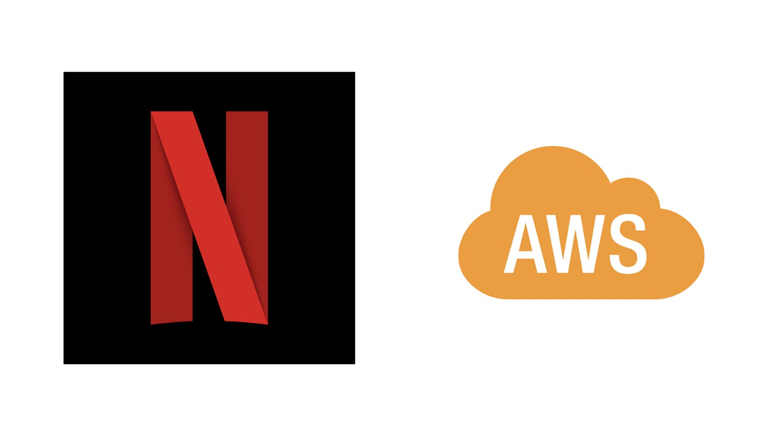
Netflix relies on AWS — a part of Amazon
3. Differentiate at the nexus of humans and powerful machines. The main difference between Netflix and traditional media company is that Netflix puts algorithms and data at the core of its engine. Its bet on House of Cards is a case in point as described by Wired. “While networks traditionally order a show based on whether it likes a pilot, Netflix ordered two full seasons (26 episodes) of House of Cards without seeing a single scene. It reportedly bid more than $100 million to secure first rights to the show, outbidding HBO and AMC because it is utterly convinced the show will be a big hit.” At the same time, humans play important complimentary roles and Netflix well knows the limitations of algorithms. Product development, service enhancements, betting on original shows and every major strategic decisions are taken by smart humans working with detailed data and powerful algorithms. Time permitting, take a look at the type of jobs posted on Netflix Careers and think about how it might compare against the type of jobs at a traditional media company. Netflix culture is also key to attract and retain the top tech talent that otherwise could be lured by any of the digital giants such as Google or Apple or Facebook or many of the start-ups.

