Memory Hierarchy
- The memory unit is an essential component in any digital computer since it is needed for storing programs and data
- Not all accumulated information is needed by the CPU at the same time
- Therefore, it is more economical to use low-cost storage devices to serve as a backup for storing the information that is not currently used by CPU
- The memory unit that directly communicate with CPU is called the main memory
- Devices that provide backup storage are called auxiliary memory
- The memory hierarchy system consists of all storage devices employed in a computer system from the slow by high-capacity auxiliary memory to a relatively faster main memory, to an even smaller and faster cache memory
- The main memory occupies a central position by being able to communicate directly with the CPU and with auxiliary memory devices through an I/O processor
- A special very-high-speed memory called cache is used to increase the speed of processing by making current programs and data available to the CPU at a rapid rate
- CPU logic is usually faster than main memory access time, with the result that processing speed is limited primarily by the speed of main memory
- The cache is used for storing segments of programs currently being executed in the CPU and temporary data frequently needed in the present calculations
- The typical access time ratio between cache and main memory is about 1to7 . Auxiliary memory access time is usually 1000 times that of main memory.
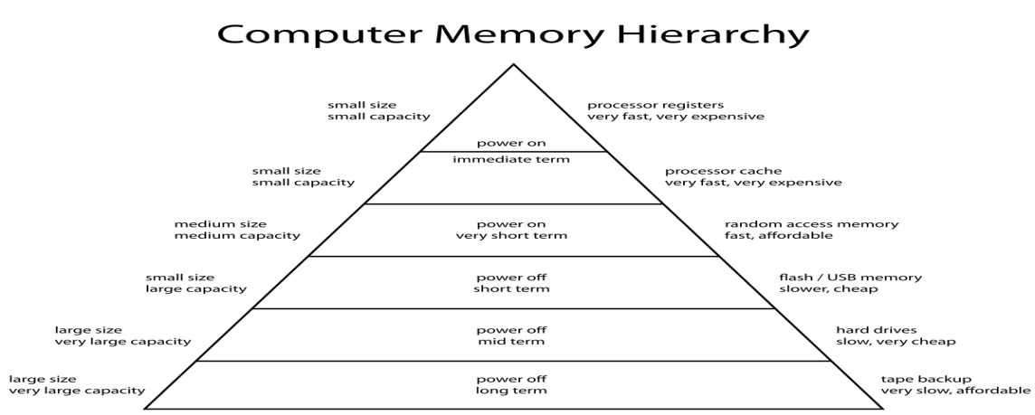
Main Memory
- Most of the main memory in a general purpose computer is made up of RAM integrated circuits chips, but a portion of the memory may be constructed with ROM chips
- RAM– Random Access memory
- Integrated RAM are available in two possible operating modes, Static and Dynamic
- ROM– Read Only memory

Random-Access Memory (RAM)
Static RAM (SRAM)
- Each cell stores bit with a six-transistor circuit.
- Retains value indefinitely, as long as it is kept powered.
- Relatively insensitive to disturbances such as electrical noise.
- Faster and more expensive than DRAM.

Dynamic RAM (DRAM)
- Each cell stores bit with a capacitor and transistor.
- Value must be refreshed every 10-100 ms.
- Sensitive to disturbances.
- Slower and cheaper than SRAM.

ROM
- ROM is used for storing programs that are PERMENTLY resident in the computer and for tables of constants that do not change in value once the production of the computer is completed
- The ROM portion of main memory is needed for storing an initial program called bootstrap loader, witch is to start the computer software operating when power is turned off

- A RAM chip is better suited for communication with the CPU if it has one or more control inputs that select the chip when needed
  - The Block diagram of a RAM chip is shown next slide, the capacity of the memory is 128 words of 8 bits (one byte) per word.
ROM
Memory Address Map
- Memory Address Map is a pictorial representation of assigned address space for each chip in the system.
- To demonstrate an example, assume that a computer system needs 512 bytes of RAM and 512 bytes of ROM.
- The RAM have 128 byte and need seven address lines, where the ROM have 512 bytes and need 9 address lines.
- The hexadecimal address assigns a range of hexadecimal equivalent address for each chip
- Line 8 and 9 represent four distinct binary combination to specify which RAM we chose
- When line 10 is 0, CPU selects a RAM. And when it’s 1, it selects the ROM

Cache memory
- If the active portions of the program and data are placed in a fast small memory, the average memory access time can be reduced, Thus reducing the total execution time of the program
- Such a fast small memory is referred to as cache memory .The cache is the fastest component in the memory hierarchy and approaches the speed of CPU component
- When CPU needs to access memory, the cache is examined ,If the word is found in the cache, it is read from the fast memory .If the word addressed by the CPU is not found in the cache, the main memory is accessed to read the word
- The performance of cache memory is frequently measured in terms of a quantity called hit ratio .When the CPU refers to memory and finds the word in cache, it is said to produce a hit
Otherwise, it is a miss .Hit ratio = hit / (hit+miss)
- The basic characteristic of cache memory is its fast access time, Therefore, very little or no time must be wasted when searching the words in the cache
- The transformation of data from main memory to cache memory is referred to as a mapping process, there are three types of mapping: Associative mapping ,Direct mapping ,Set-associative mapping .To help understand the mapping procedure, we have the following example:
Associative mapping
- The fastest and most flexible cache organization uses an associative memory
- The associative memory stores both the address and data of the memory word
- This permits any location in cache to store ant word from main memory
- The address value of 15 bits is shown as a five-digit octal number and its corresponding 12-bit word is shown as a four-digit octal number
- A CPU address of 15 bits is places in the argument register and the associative memory us searched for a matching address If the address is found, the corresponding 12-bits data is read and sent to the CPU . If not, the main memory is accessed for the word ,If the cache is full, an address-data pair must be displaced to make room for a pair that is needed and not presently in the cache
Direct Mapping
Associative memory is expensive compared to RAM .In general case, there are 2^k words in cache memory and 2^n words in main memory (in our case, k=9, n=15) .The n bit memory address is divided into two fields: k-bits for the index and n-k bits for the tag field .

Set-Associative Mapping
The disadvantage of direct mapping is that two words with the same index in their address but with different tag values cannot reside in cache memory at the same time .Set-Associative Mapping is an improvement over the direct-mapping in that each word of cache can store two or more word of memory under the same index address. In the slide, each index address refers to two data words and their associated tags.Each tag requires six bits and each data word has 12 bits, so the word length is 2*(6+12) = 36 bits
Virtual Memory
The address used by a programmer will be called a virtual address or logical address.An address in main memory is called a physical address.

The term page refers to groups of address space of the same size .For example: if auxiliary memory contains 1024K and main memory contains 32K and page size equals to 1K, then auxiliary memory has 1024 pages and main memory has 32 pages .Only part of the program needs to be in memory for execution .Logical address space can therefore be much larger than physical address space .Allows for more efficient process creation.
Demand Paging
In stead of loading whole program into memory, demand paging is an alternative strategy to initially load pages only as they are needed.Lazy Swapper: Pages are only loaded when they are demanded during program execution .Transfer of a page memory to continuous disk space.

When a process is to be swapped in, the pager guesses which pages will be used before the process is swapped out again.Instead of swapping in a whole process, the pager brings only those necessary pages into memory.Valid-Invalid Bit -With each page table entry a valid–invalid bit is associated (v=> in-memory , i =>not-in-memory) .Initially valid–invalid bit is set to i on all entries .During address translation, if valid–invalid bit in page table entry is i => page fault .
Page Fault
Performance of Demand Paging
Page Replacement
What if there is no free frame? Page replacement –find some page in memory, but not really in use, swap it out .In this case, same page may be brought into memory several times

Peripheral devices
I/O operations are accomplished through external devices that provide a means of exchanging data between external environment and computer. An external device attaches to the computer by a link to an I/O module. An external device linked to an I/O module is called peripheral device or peripheral. The figure below shows attachment of external devices through I/O module.External Devices can be categorized as
1. Human readable: suitable for communicating with computer user. For example - video display terminals and printers.
2. Machine readable: suitable for communicating with equipment. For example - sensor, actuators used in robotics application.
3. Communication: suitable for communicating with remote devices. They may be human readable device such as terminal and machine readable device such as another computer
input-output interface
Transfer information between internal storage and external peripherals. Resolves the difference between CPU and peripherals
- Signal value changes
- Transfer rate mapping
- Data code format mapping
- Control operating modes (not to disturb each other)
- Interfaces supervise and synchronize transfers
- Lies between processor bus and peripheral device (or its controller)
I/O bus consists of Data lines ,Control lines, Address lines. Each peripheral is associated with its interface unit.1.Decode address and control received 2.Interrupts for the device 3. Provide signals for device 4.Synchronize and supervise data flow

Each interface has own address. Processor places address on address lines.Corresponding peripheral responds while others are deactivated.Same time processor provides function code on control lines.Interface executes function on peripheral.4 main command types Control commands, status, output data, input data.3 ways to communicate with I/O and memory.Use two separate buses Uses separate I/O processor,Memory communicate with both IOP and CPU via memory bus,IOP has separate set of data, address and control lines with peripheral interfaces,Use common bus but separate control lines,Common bus and control lines.
Uses common bus for data transfer
Isolated I/O- 1.Uses separate Memory or I/O R/W lines 2. Separate I/O instruction set 3. Own address spaces for memory and I/O 4.Complex but high flexible
Memory mapped I/O- 1. Uses same address space with memory 2.Only one set of R/W signals 3.Interface registers considered as a part of memory system 4.Reduces memory address space available 5.Same instruction set
Example of I/O Interface (I/O port)
The four registers communicate directly with the I/O device attached to the interface. The I/O data to and from the device can be transferred into either port A or port B. Port A may be defined as an input port and port B may be defined as an output port. The output device such as magnetic disk transfers data in both directions. So bidirectional data bus is used. CPU gives control information to control register. The bits in the status register are used for status conditions. It is also used for recording errors that may occur during the data transfer. The bus buffers use the bidirectional data bus to communicate with the CPU. A timing and control circuit is used to detect the address assigned to the bus buffers.
CS | RS1 | RS0 | Register selected
0 | X | X | None: data bus in high impedance
1 | 0 | 0 | Port A register
1 | 0 | 1 | Port B register
1 | 1 | 0 | Control register
1 | 1 | 1 | Status register
Interface communicate with CPU though data bus .CS and RS determine interface address .Set of 4 registers directly communicate with the device.I/O data can transfer port A or B .Interface can use bidirectional lines when it is connected to.Input only (Character reader).Output only (Printer).Both (but not at the same time) (Hard disk). Issue commands – write command word to control register. Receive status – reading from status register. Data transfer – via port A and B registers. Function code of I/O bus not used.
Asynchronous Data Transfer
Internal operations in a computer are synchronize with internal clock pulse generator Applied to all registers. All data transfer among registers happen at the same time with the occurrence of the clock pulse But the CPU and I/O interfaces are independent. They run on their own clocks.If I/O shares common clock with CPU two units said to be synchronize.Otherwise asynchronous
Requires control signals to indicate time at which transmission occurs.Main methods of indicate data transfer time. Strobe - Giving a signal by one unit to indicate transfer time. Handshaking - Transfer on agreement.Data transfer with a control signal indicating the presence of data.Data receiver sends an acknowledge receipt of data.Timing diagrams are commonly used to show the relationship between control signals.Sequence of control signals depends whether transfer initiated by source or destination.
Strobe Control
Uses a control line to time each transfer. Strobe is activated either by source or destination.Strobe says when there is valid data on data bus.Generally strobes activated by clock signals.CPU is always in control of the transfer (i.e. strobe is always from CPU).This method is mainly applicable in memory R/W operations..Most of I/O operations use handshaking
Source initiated data transfer
- Source places data on the bus
- Have a brief delay to settle data on the bus
- Source activate the strobe pulse
- Then destination reads data to internal register (Often uses falling edge)
- Source removes data after brief delay (Not necessary)
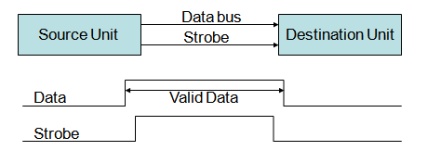
Destination initiated data transfer
- Initiated by destination
- Destination activates strobe
- Source places data on the bus
- Keeps data until accept them by destination
- Reads data to a register (Generally at falling edge of the strobe)
- Destination disable strobe
- Source removes data after predetermined time
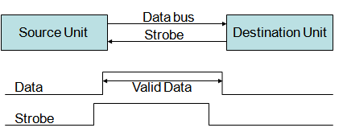
Handshaking
- Strobe disadvantage
  - In source initiation - Source doesn’t know whether destination got the data
  - In destination initiation – Destination doesn’t know whether source has placed the data on the bus
- Handshaking introduce a reply method to solve this problem. 1st control line
- Same direction as the data flow
- Use by the source
- Indicates whether it has valid data
- 2nd control line From destination to source
- Uses by the destination
- Indicates whether it can accept data
- Sequence of control used depends on the unit initiate transfer
- In a fault at one end timeout uses to detect the error
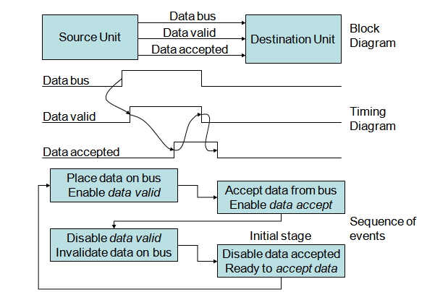

Destination Initiated Transfer
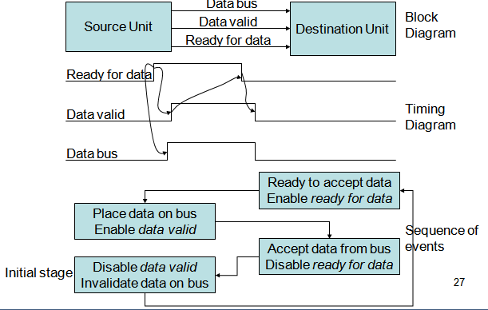
Modes of Transfer
- CPU merely execute instruction and accept data temporally from I/O devices
- Ultimate source and destination is memory
  - Receiving data from input devices stores in memory
  - Sending data to output devices from memory
- I/O handling modes
  - Programmed I/O
  - Interrupt-initiated I/O
  - Direct Memory Access (DMA)
Programmed I/O
- I/O instructions are executed according to a program in CPU
- I/O instruction transfers from and to CPU registers
- A memory load instruction used to load it memory
- Another instruction used to verify data and count the number of words transferred
- Constant I/O monitoring is required by CPU
- CPU stays in a program loop until I/O unit indicate data ready
- This waste CPU time
- I/O device and Interface use handshaking for data transfer
- Once data available on Data Register Interface sets flag bit (F) indicating data availability
- Interface do not reset data accepted line until CPU reads data and clear the flag
- CPU needs 3 instruction for each byte transfer
- Read the status register
- Check the flag bit
- Read data register when data available
- Transfer can be done in blocks for efficiency
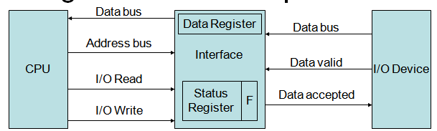
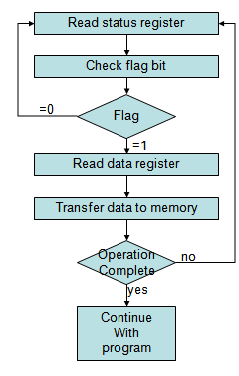
Interrupt Initiated I/O
- Instead of continues monitoring at CPU interface inform when data ready
- Uses interrupts
- CPU deviated from current program and take care of data transfer
  - Save return address from program counter to stack
  - Then control branches to service routing
    - Non vectored interrupts
    - Vectored interrupts
- After completing I/O transfer it returns back to previous program
- In addition to h/w computer should have s/w routings to control interface and transfer data
- Ex: Control commands – activate peripheral, check data state, stop tape, print character, issue interrupt
- I/O control software is fairly complex
- Standard I/O routing provided by the manufacturer and included with OS
- I/O routings available as OS procedures; do not need to go to assembly level details
Priority Interrupts
- Generally I/O data transfer is initiated by CPU
- But device must be ready first
- Device readiness for data transfer can be identify by the interrupt signal
- How CPU responds to the interrupt request
  - Push return address to the memory stack
  - Branch to the interrupt service routing
- Priority Interrupt system
  - Deals with simultaneous interrupts and determine which one to serve first (critical situation / fast I/O)
  - Determine in which conditions allow interrupting while executing another interrupt service routing
Polling
- Priority identification mechanism in software
- For all interrupts has a common branch address
- Then polls the interrupt devices in sequence
- The order at which it polls determine the priority
  - Higher priority device is tested first.
  - If its interrupt signal is on serves the device
  - Then test for the next device
  - Proceed on until last device
- Disadvantage: When there are multiple interrupts polling time might exceed time available to service the I/O device
- Solution: Hardware priority interrupts unit
Hardware Priority Interrupt Units
- Accepts interrupts from many sources
- Determine which one has higher priority
- Issue interrupt accordingly to the CPU
- Further each interrupt source has its own interrupt vector to access its own service routing directly
- No polling required
- 2 major establishments of hardware priority function
  - Serial Connection (Daisy-chain)
  - Parallel Connection
- Serial connection of all interrupt devices
- Higher priority one places first
- Interrupt request line is common (wired logic)
- CPU responds interrupt via Interrupt Acknowledge line
- If Device 1 has pending interrupt disable P1 and place its own Interrupt vector. Otherwise pass it to the next device via P0
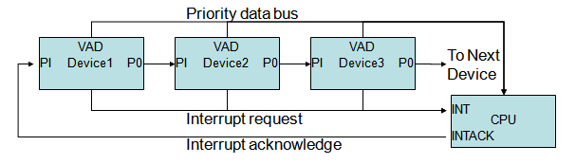
DMA (Direct Memory Access)
- CPU limits the data transfer speed for fast I/O devices
- DMA removes CPU and allow peripherals to handle memory bus
- During the transfer CPU does not have the control over the bus
- CPU idling the bus can be done through the control signals “Bus Request” & “Bus Grant”
  - DMA controller enables BR,
  - then CPU finishes current operation and puts its address and data buses in high impedance
  - CPU sets BG line
  - DMA transfers data and resets BR for the CPU to use the memory bus
- DMA data transfer can either happen as
  - Burst transfer or
  - Cycle stealing
- Interfaces with CPU and I/O devices
- Further DMA controller has
  - Address Register – used for direct communication with memory
  - Set of Address Lines – used for direct communication with memory
  - Word Count Register – specifies the number of words to be transferred
  - Control register – Specifies the mode of transfer
- Data transfer is done directly between device and memory under DMA control
- RD/WR signals are bidirectional
  - When BG is set DMA can use them for memory RD/WR
  - Otherwise CPU uses it DS and RS to write and read from DMA
- DMA uses Req and Ack signals with handshaking to communicate with external peripheral devices
- CPU treat all DMA registers as I/O interface registers and can be read and write under program control
- DMA is initialized by CPU
- Then DMA continues transfer an entire block of data between memory and peripheral
- CPU sends following information on DMA initialization
- Starting address for memory read or write
- Word count the number of words to be transferred
- Control to specify mode of transfer
- Control to start transfer
- CPU communicates with DMA after transfer initialization only if
- It receives an interrupt
- It wants to know how many words have been transferred
- CPU communicates with DMA through address and data bus as with any other interface unit
- DMA has its own address by which DS & RS activates
- CPU initialize DMA through data bus
- DMA can start data transfer between memory and peripheral device as it gets the control command
DMA Transfer
- Peripheral device sends DMA request
- DMA controller activates BR
- CPU finishes current bus cycle and grant the bus by activating BG
- DMA puts current address to the address bus and activate RD or WR accordingly
- And acknowledges peripheral
- Then peripheral puts data to (or reads data from) the bus
- Thus peripheral directly read or write memory
- For each word transferred DMA increment address and decrement word count register
- If word count is not zero DMA checks request line coming from peripheral
  - If active (fast devices) initiate the second transfer immediately
  - Otherwise disable BR
- If word count is zero
  - DMA stop transfer, disable BR and inform CPU the termination of data transfer
- Zero value in word count indicates successful data transfer
- DMA can have even more than one channel
- DMA commonly used in devices like magnetic disks and screen display

- 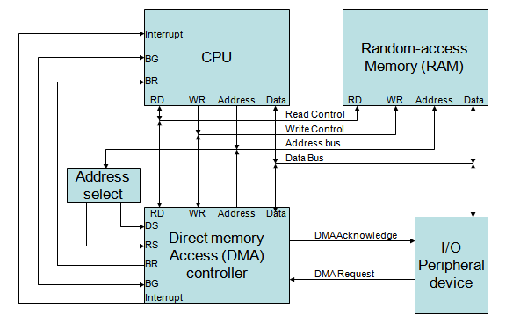

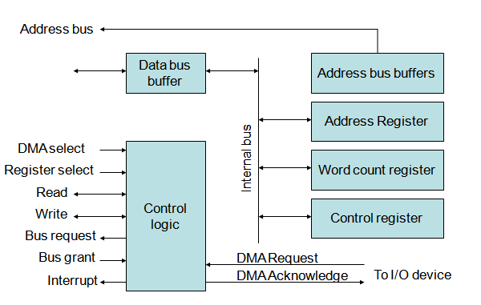

IOP
- Instead of each interface communicating with the CPU
- One or more external processors assigned to communicate directly with I/O devices
- IOP has both direct memory access and I/O communication capabilities
- IOP releases the CPU from the housekeeping the chores involved in I/O transfer
- Processors handling serial communication with remote terminal are called Data Communication Processors (DCP)
- IOP is similar to CPU except its handles only I/O processing
- Unlike DMA controller totally setup by the CPU, IOP can fetch and executes its own instructions
- Additionally IOP can perform other tasks like arithmetic, logic, branching and code translation
- Memory at the centre can communicate with both processors via DMA
- CPU responsible for data processing and computational tasks
- IOP transfers data between peripheral devices and memory
- CPU is usually assigned the task of initiating the I/O program, there after IOP operates independently
- IOP take care of data format difference and structure mapping between memory and various I/O devices
- Communication between CPU and IOP is similar to programmed I/O
- Communication between Memory and IOP is done as DMA
- IOP can be independent or slave processors depending on the sophistication of the system
- Instructions for IOP generally refers as commands

