UNIT-V
GRAPHS
5.1. Graph Basic Concepts
A graph is a pictorial representation of a set of objects where some pairs of objects are connected by links. The interconnected objects are represented by points termed as vertices, and the links that connect the vertices are called edges.
Formally, a graph is a pair of sets (V, E), where V is the set of vertices and Eis the set of edges, connecting the pairs of vertices. Take a look at the following graph −
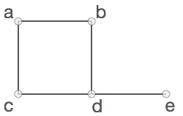
In the above graph,
V = {a, b, c, d, e}
E = {ab, ac, bd, cd, de}

Graph Data Structure
Mathematical graphs can be represented in data structure. We can represent a graph using an array of vertices and a two-dimensional array of edges. Before we proceed further, let's familiarize ourselves with some important terms −
- Vertex − Each node of the graph is represented as a vertex. In the following example, the labeled circle represents vertices. Thus, A to G are vertices. We can represent them using an array as shown in the following image. Here A can be identified by index 0. B can be identified using index 1 and so on.
- Edge − Edge represents a path between two vertices or a line between two vertices. In the following example, the lines from A to B, B to C, and so on represents edges. We can use a two-dimensional array to represent an array as shown in the following image. Here AB can be represented as 1 at row 0, column 1, BC as 1 at row 1, column 2 and so on, keeping other combinations as 0.
- Adjacency − Two node or vertices are adjacent if they are connected to each other through an edge. In the following example, B is adjacent to A, C is adjacent to B, and so on.
- Path − Path represents a sequence of edges between the two vertices. In the following example, ABCD represents a path from A to D.
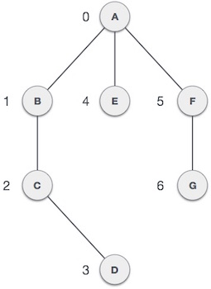
5.2. Operations on Graphs
The basic operations provided by a graph data structure G usually include:^{[1]}
- adjacent(G, x, y): tests whether there is an edge from the vertex x to the vertex y;
- neighbors(G, x): lists all vertices y such that there is an edge from the vertex x to the vertex y;
- add_vertex(G, x): adds the vertex x, if it is not there;
- remove_vertex(G, x): removes the vertex x, if it is there;
- add_edge(G, x, y): adds the edge from the vertex x to the vertex y, if it is not there;
- remove_edge(G, x, y): removes the edge from the vertex x to the vertex y, if it is there;
- get_vertex_value(G, x): returns the value associated with the vertex x;
- set_vertex_value(G, x, v): sets the value associated with the vertex x to v.
4.3 Graph Storage Structures
Graph is a data structure that consists of following two components:
1. A finite set of vertices also called as nodes.
2. A finite set of ordered pair of the form (u, v) called as edge. The pair is ordered because (u, v) is not same as (v, u) in case of a directed graph(di-graph). The pair of the form (u, v) indicates that there is an edge from vertex u to vertex v. The edges may contain weight/value/cost.
Graphs are used to represent many real-life applications: Graphs are used to represent networks. The networks may include paths in a city or telephone network or circuit network. Graphs are also used in social networks like linkedIn, Facebook. For example, in Facebook, each person is represented with a vertex(or node). Each node is a structure and contains information like person id, name, gender and locale.
Following is an example of an undirected graph with 5 vertices.
Following two are the most commonly used representations of a graph.
1. AdjacencyMatrix
2. AdjacencyList
There are other representations also like, Incidence Matrix and Incidence List. The choice of the graph representation is situation specific. It totally depends on the type of operations to be performed and ease of use.
AdjacencyMatrix:
Adjacency Matrix is a 2D array of size V x V where V is the number of vertices in a graph. Let the 2D array be adj[][], a slot adj[i][j] = 1 indicates that there is an edge from vertex i to vertex j. Adjacency matrix for undirected graph is always symmetric. Adjacency Matrix is also used to represent weighted graphs. If adj[i][j] = w, then there is an edge from vertex i to vertex j with weight w.
The adjacency matrix for the above example graph is:
Pros: Representation is easier to implement and follow. Removing an edge takes O(1) time. Queries like whether there is an edge from vertex ‘u’ to vertex ‘v’ are efficient and can be done O(1).
Cons: Consumes more space O(V^2). Even if the graph is sparse(contains less number of edges), it consumes the same space. Adding a vertex is O(V^2) time.
AdjacencyList:
An array of linked lists is used. Size of the array is equal to the number of vertices. Let the array be array[]. An entry array[i] represents the linked list of vertices adjacent to the ith vertex. This representation can also be used to represent a weighted graph. The weights of edges can be stored in nodes of linked lists. Following is adjacency list representation of the above graph.
5.4 Graph Algorithms
Graph traversal means visiting every vertex and edge exactly once in a well-defined order. While using certain graph algorithms, you must ensure that each vertex of the graph is visited exactly once. The order in which the vertices are visited are important and may depend upon the algorithm or question that you are solving.
During a traversal, it is important that you track which vertices have been visited. The most common way of tracking vertices is to mark them.
Breadth First Search (BFS)
There are many ways to traverse graphs. BFS is the most commonly used approach.
BFS is a traversing algorithm where you should start traversing from a selected node (source or starting node) and traverse the graph layerwise thus exploring the neighbour nodes (nodes which are directly connected to source node). You must then move towards the next-level neighbour nodes.
As the name BFS suggests, you are required to traverse the graph breadthwise as follows:
- First move horizontally and visit all the nodes of the current layer
- Move to the next layer
Consider the following diagram. 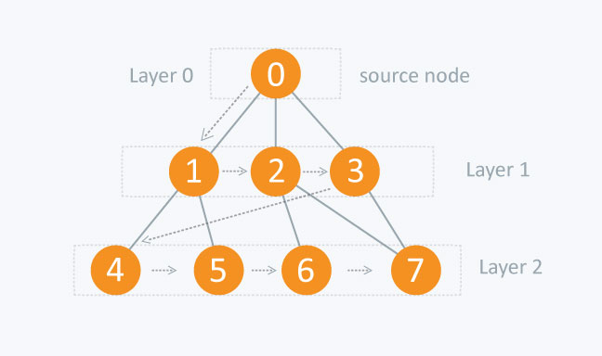
The distance between the nodes in layer 1 is comparitively lesser than the distance between the nodes in layer 2. Therefore, in BFS, you must traverse all the nodes in layer 1 before you move to the nodes in layer 2.
Traversing child nodes
A graph can contain cycles, which may bring you to the same node again while traversing the graph. To avoid processing of same node again, use a boolean array which marks the node after it is processed. While visiting the nodes in the layer of a graph, store them in a manner such that you can traverse the corresponding child nodes in a similar order.
In the earlier diagram, start traversing from 0 and visit its child nodes 1, 2, and 3. Store them in the order in which they are visited. This will allow you to visit the child nodes of 1 first (i.e. 4 and 5), then of 2 (i.e. 6 and 7), and then of 3 (i.e. 7) etc.
To make this process easy, use a queue to store the node and mark it as 'visited' until all its neighbours (vertices that are directly connected to it) are marked. The queue follows the First In First Out (FIFO) queuing method, and therefore, the neigbors of the node will be visited in the order in which they were inserted in the node i.e. the node that was inserted first will be visited first, and so on.
Pseudocode
BFS (G, s) //Where G is the graph and s is the source node
let Q be queue.
Q.enqueue( s ) //Inserting s in queue until all its neighbour vertices are marked.

mark s as visited.
while ( Q is not empty)
//Removing that vertex from queue,whose neighbour will be visited now
v = Q.dequeue( )

//processing all the neighbours of v
for all neighbours w of v in Graph G
if w is not visited
Q.enqueue( w ) //Stores w in Q to further visit its neighbour
mark w as visited.
Traversing process 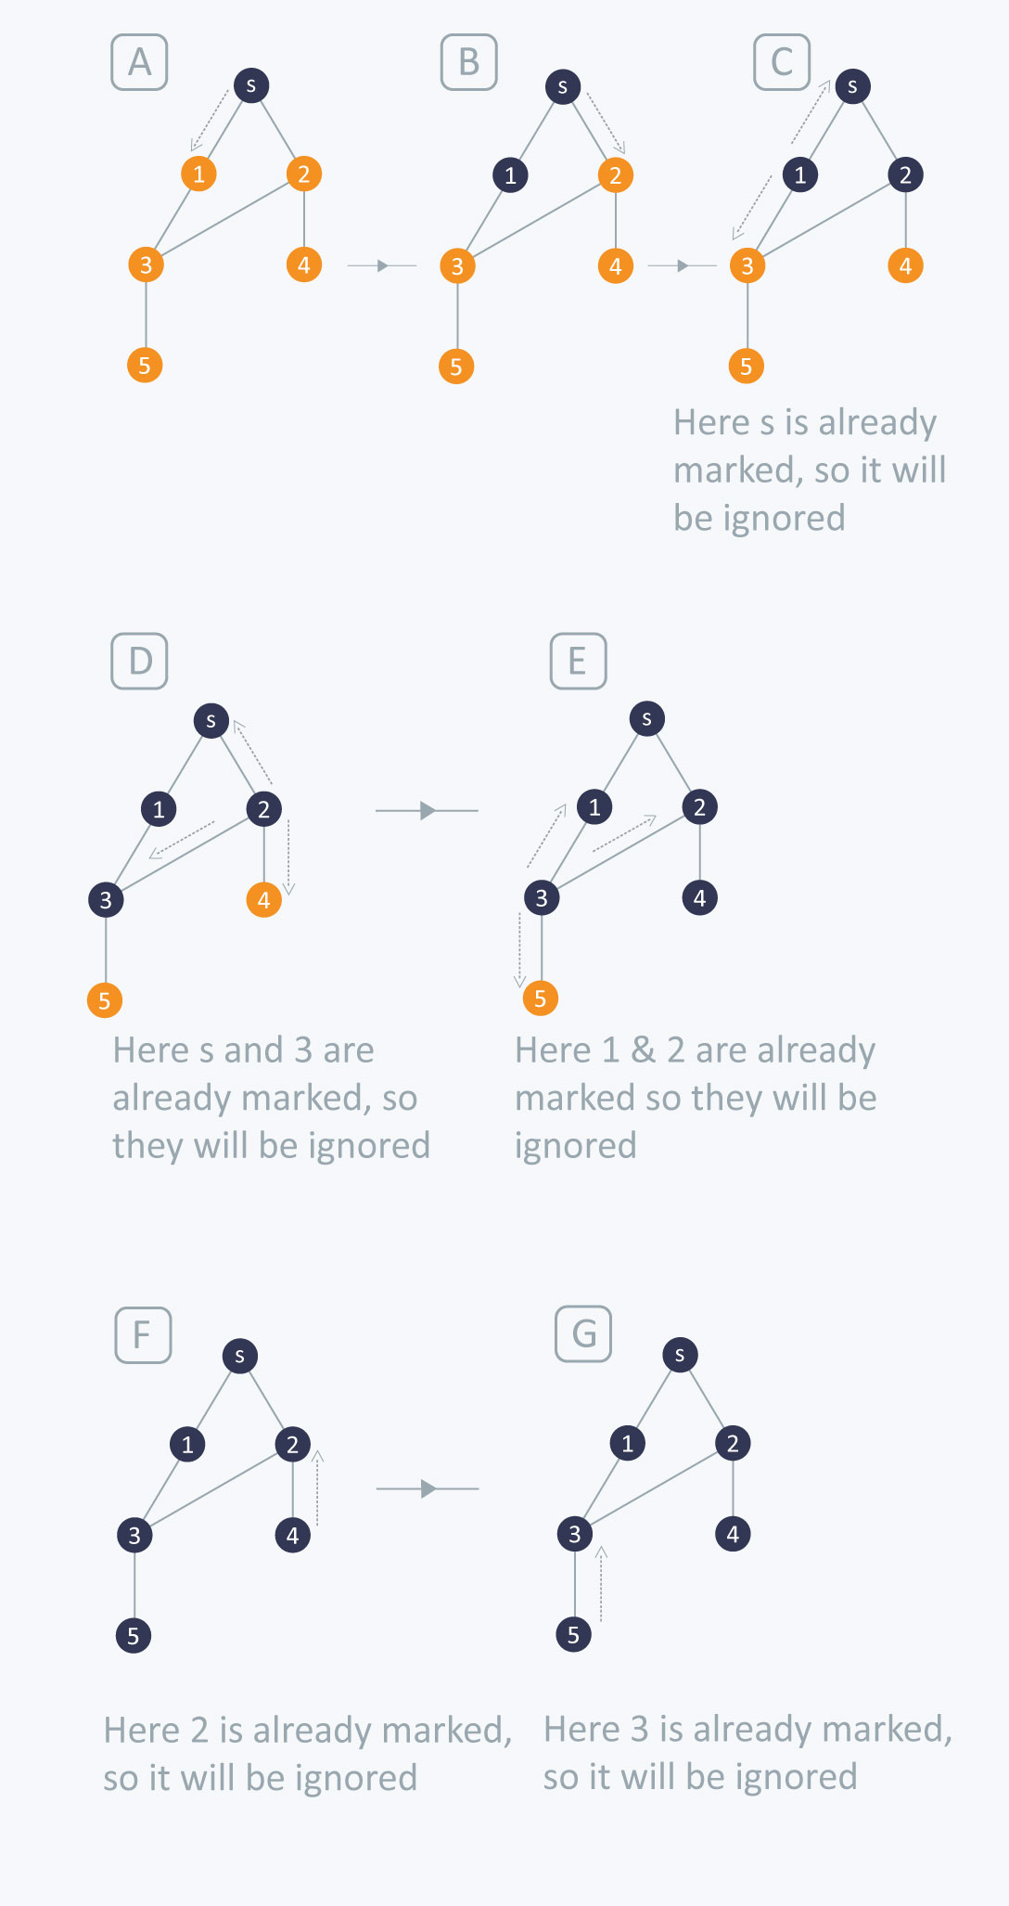
The traversing will start from the source node and push s in queue. s will be marked as 'visited'.
First iteration
- s will be popped from the queue
- Neighbors of s i.e. 1 and 2 will be traversed
- 1 and 2, which have not been traversed earlier, are traversed. They will be:
  - Pushed in the queue
  - 1 and 2 will be marked as visited
Second iteration
- 1 is popped from the queue
- Neighbors of 1 i.e. s and 3 are traversed
- s is ignored because it is marked as 'visited'
- 3, which has not been traversed earlier, is traversed. It is:
  - Pushed in the queue
  - Marked as visited
Third iteration
- 2 is popped from the queue
- Neighbors of 2 i.e. s, 3, and 4 are traversed
- 3 and s are ignored because they are marked as 'visited'
- 4, which has not been traversed earlier, is traversed. It is:
  - Pushed in the queue
  - Marked as visited
Fourth iteration
- 3 is popped from the queue
- Neighbors of 3 i.e. 1, 2, and 5 are traversed
- 1 and 2 are ignored because they are marked as 'visited'
- 5, which has not been traversed earlier, is traversed. It is:
  - Pushed in the queue
  - Marked as visited
Fifth iteration
- 4 will be popped from the queue
- Neighbors of 4 i.e. 2 is traversed
- 2 is ignored because it is already marked as 'visited'
Sixth iteration
- 5 is popped from the queue
- Neighbors of 5 i.e. 3 is traversed
- 3 is ignored because it is already marked as 'visited'
The queue is empty and it comes out of the loop. All the nodes have been traversed by using BFS.
If all the edges in a graph are of the same weight, then BFS can also be used to find the minimum distance between the nodes in a graph.
Example
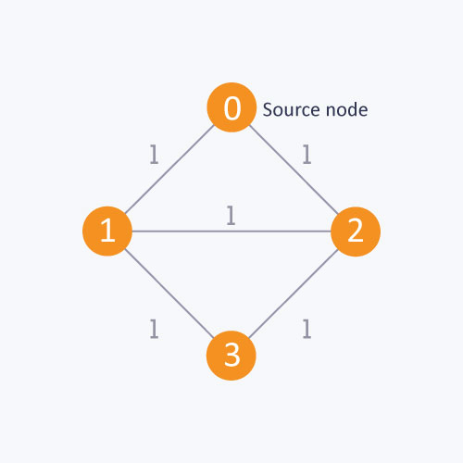
As in this diagram, start from the source node, to find the distance between the source node and node 1. If you do not follow the BFS algorithm, you can go from the source node to node 2 and then to node 1. This approach will calculate the distance between the source node and node 1 as 2, whereas, the minimum distance is actually 1. The minimum distance can be calculated correctly by using the BFS algorithm.
Complexity
The time complexity of BFS is O(V + E), where V is the number of nodes and E is the number of edges.
Applications
1. How to determine the level of each node in the given tree?
As you know in BFS, you traverse level wise. You can also use BFS to determine the level of each node.
Implementation
vector <int> v[10] ; //Vector for maintaining adjacency list explained above
int level[10]; //To determine the level of each node
bool vis[10]; //Mark the node if visited
void bfs(int s) {
queue <int> q;
q.push(s);
level[ s ] = 0 ; //Setting the level of the source node as 0
vis[ s ] = true;
while(!q.empty())
{
int p = q.front();
q.pop();
for(int i = 0;i < v[ p ].size() ; i++)
{
if(vis[ v[ p ][ i ] ] == false)
{
//Setting the level of each node with an increment in the level of parent node
level[ v[ p ][ i ] ] = level[ p ]+1;
q.push(v[ p ][ i ]);
vis[ v[ p ][ i ] ] = true;
}
}
}
}
This code is similar to the BFS code with only the following difference:
level[ v[ p ][ i ] ] = level[ p ]+1;
In this code, while you visit each node, the level of that node is set with an increment in the level of its parent node. This is how the level of each node is determined.
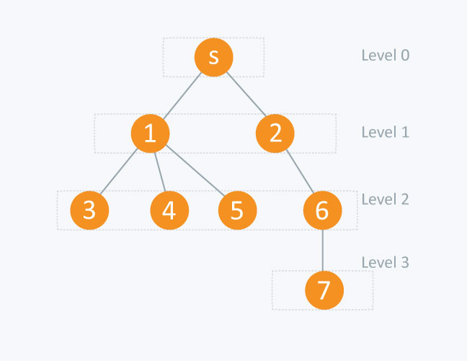
node level [node]

s (source node) 0
1 1
2 1
3 2
4 2
5 2
6 2
7 3
2. BFS
This type of BFS is used to find the shortest distance between two nodes in a graph provided that the edges in the graph have the weights 0 or 1. If you apply the BFS explained earlier in this article, you will get an incorrect result for the optimal distance between 2 nodes.
In this approach, a boolean array is not used to mark the node because the condition of the optimal distance will be checked when you visit each node. A double-ended queue is used to store the node. In 0-1 BFS, if the weight of the edge = 0, then the node is pushed to the front of the dequeue. If the weight of the edge = 1, then the node is pushed to the back of the dequeue.
Implementation
Here, edges[ v ] [ i ] is an adjacency list that exists in the form of pairs i.e. edges[ v ][ i ].first will contain the node to which v is connected and edges[ v ][ i ].second will contain the distance between v and edges[ v ][ i ].first.
Q is a double-ended queue. The distance is an array where, distance[ v ] will contain the distance from the start node to v node. Initially the distance defined from the source node to each node is infinity.
void bfs (int start)
{
deque <int > Q; //Double-ended queue
Q.push_back( start);
distance[ start ] = 0;
while( !Q.empty ())
{
int v = Q.front( );
Q.pop_front();
for( int i = 0 ; i < edges[v].size(); i++)
{

/* if distance of neighbour of v from start node is greater than sum of distance of v from start node and edge weight between v and its neighbour (distance between v and its neighbour of v) ,then change it */

if(distance[ edges[ v ][ i ].first ] > distance[ v ] + edges[ v ][ i ].second )
{

distance[ edges[ v ][ i ].first ] = distance[ v ] + edges[ v ][ i ].second;

/*if edge weight between v and its neighbour is 0 then push it to front of
double ended queue else push it to back*/

if(edges[ v ][ i ].second == 0)
{
Q.push_front( edges[ v ][ i ].first);
}
else
{
Q.push_back( edges[ v ][ i ].first);

}
}
}
}
}
Let’s understand this code with the following graph:
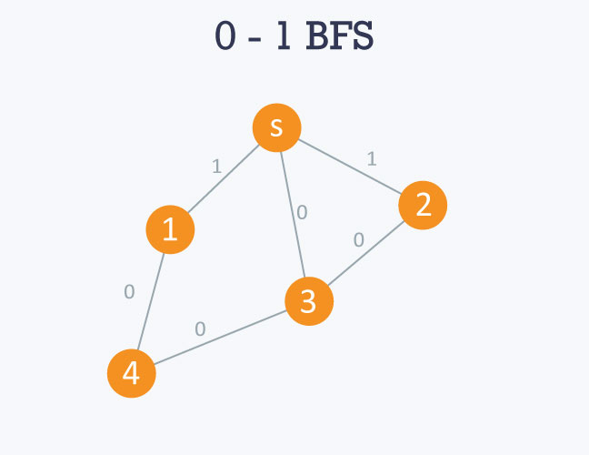
The adjacency list of the graph will be as follows:
Here 's' is considered to be 0 or source node.
0 -> 1 -> 3 -> 2
edges[ 0 ][ 0 ].first = 1 , edges[ 0 ][ 0 ].second = 1
edges[ 0 ][ 1 ].first = 3 , edges[ 0 ][ 1 ].second = 0
edges[ 0 ][ 2 ].first = 2 , edges[ 0 ][ 2 ].second = 1
1 -> 0 -> 4
edges[ 1 ][ 0 ].first = 0 , edges[ 1 ][ 0 ].second = 1
edges[ 1 ][ 1 ].first = 4 , edges[ 1 ][ 1 ].second = 0
2 -> 0 -> 3
edges[ 2 ][ 0 ].first = 0 , edges[ 2 ][ 0 ].second = 0
edges[ 2 ][ 1 ].first = 3 , edges[ 2 ][ 1 ].second = 0
3 -> 0 -> 2 -> 4
edges[ 3 ][ 0 ].first = 0 , edges[ 3 ][ 0 ].second = 0
edges[ 3 ][ 2 ].first = 2 , edges[ 3 ][ 2 ].second = 0
edges[ 3 ][ 3 ].first = 4 , edges[ 3 ][ 3 ].second = 0
4 -> 1 -> 3
edges[ 4 ][ 0 ].first = 1 , edges[ 4 ][ 0 ].second = 0
edges[ 4 ][ 1 ].first = 3 , edges[ 4 ][ 1 ].second = 0
If you use the BFS algorithm, the result will be incorrect because it will show you the optimal distance between s and node 1 and s and node 2 as 1 respectively. This is because it visits the children of s and calculates the distance between s and its children, which is 1. The actual optimal distance is 0 in both cases.
Processing
Starting from the source node, i.e 0, it will move towards 1, 2, and 3. Since the edge weight between 0 and 1 and 0 and 2 is 1 respectively, 1 and 2 will be pushed to the back of the queue. However, since the edge weight between 0 and 3 is 0, 3 will pushed to the front of the queue. The distance will be maintained in distance array accordingly.
3 will then be popped from the queue and the same process will be applied to its neighbours, and so on.
5.5. Graph ADT
The graph abstract data type (ADT) is defined as follows:
- Graph() creates a new, empty graph.
- addVertex(vert) adds an instance of Vertex to the graph.
- addEdge(fromVert, toVert) Adds a new, directed edge to the graph that connects two vertices.
- addEdge(fromVert, toVert, weight) Adds a new, weighted, directed edge to the graph that connects two vertices.
- getVertex(vertKey) finds the vertex in the graph named vertKey.
- getVertices() returns the list of all vertices in the graph.
- in returns True for a statement of the form vertex in graph, if the given vertex is in the graph, False otherwise.
Beginning with the formal definition for a graph there are several ways we can implement the graph ADT in Python. We will see that there are trade-offs in using different representations to implement the ADT described above. There are two well-known implementations of a graph, the adjacency matrix and the adjacency list.
Depth First Search (DFS)
The DFS algorithm is a recursive algorithm that uses the idea of backtracking. It involves exhaustive searches of all the nodes by going ahead, if possible, else by backtracking.
Here, the word backtrack means that when you are moving forward and there are no more nodes along the current path, you move backwards on the same path to find nodes to traverse. All the nodes will be visited on the current path till all the unvisited nodes have been traversed after which the next path will be selected.
This recursive nature of DFS can be implemented using stacks. The basic idea is as follows:
Pick a starting node and push all its adjacent nodes into a stack.
Pop a node from stack to select the next node to visit and push all its adjacent nodes into a stack.
Repeat this process until the stack is empty. However, ensure that the nodes that are visited are marked. This will prevent you from visiting the same node more than once. If you do not mark the nodes that are visited and you visit the same node more than once, you may end up in an infinite loop.
Pseudocode
DFS-iterative (G, s): //Where G is graph and s is source vertex
let S be stack
S.push( s ) //Inserting s in stack
mark s as visited.
while ( S is not empty):
//Pop a vertex from stack to visit next
v = S.top( )
S.pop( )
//Push all the neighbours of v in stack that are not visited
for all neighbours w of v in Graph G:
if w is not visited :
S.push( w )
mark w as visited

DFS-recursive(G, s):
mark s as visited
for all neighbours w of s in Graph G:
if w is not visited:
DFS-recursive(G, w)
The following image shows how DFS works.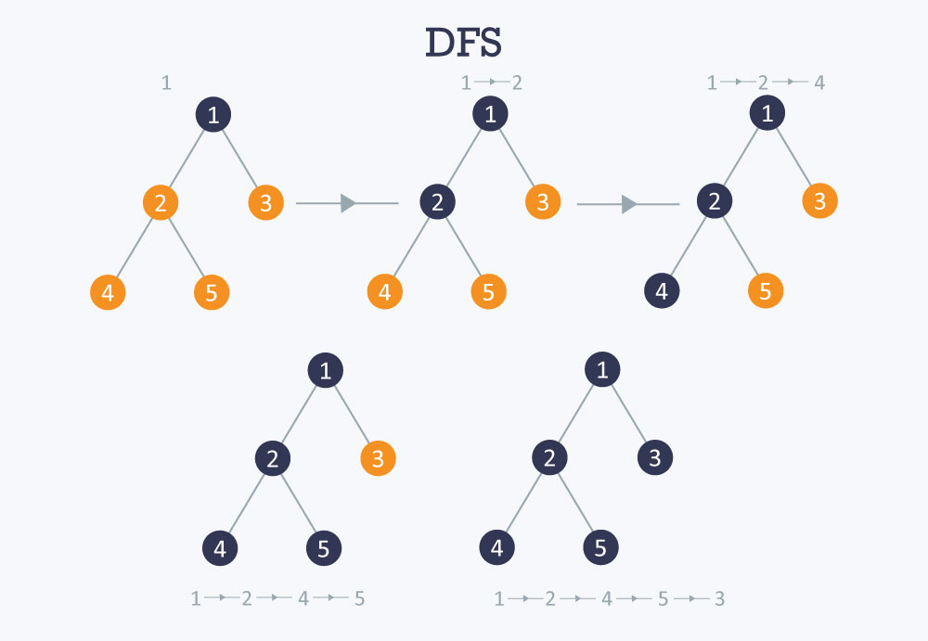
Time complexity O(V+E), when implemented using an adjacency list.
Applications
How to find connected components using DFS?
A graph is said to be disconnected if it is not connected, i.e. if two nodes exist in the graph such that there is no edge in between those nodes. In an undirected graph, a connected component is a set of vertices in a graph that are linked to each other by paths.
Consider the example given in the diagram. Graph G is a disconnected graph and has the following 3 connected components.
- First connected component is 1 -> 2 -> 3 as they are linked to each other
- Second connected component 4 -> 5
- Third connected component is vertex 6
In DFS, if we start from a start node it will mark all the nodes connected to the start node as visited. Therefore, if we choose any node in a connected component and run DFS on that node it will mark the whole connected component as visited.
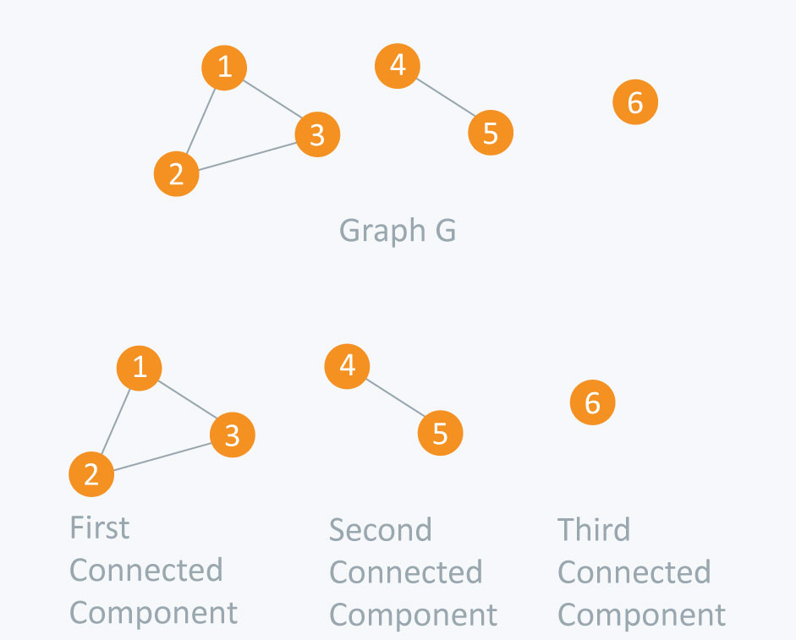
Input File
6
4
1 2
2 3
1 3
4 5
Code
#include <iostream>
#include <vector>
using namespace std;

vector <int> adj[10];
bool visited[10];

void dfs(int s) {
visited[s] = true;
for(int i = 0;i < adj[s].size();++i) {
if(visited[adj[s][i]] == false)
dfs(adj[s][i]);
}
}

void initialize() {
for(int i = 0;i < 10;++i)
visited[i] = false;
}

int main() {
int nodes, edges, x, y, connectedComponents = 0;
cin >> nodes; //Number of nodes
cin >> edges; //Number of edges
for(int i = 0;i < edges;++i) {
cin >> x >> y;
//Undirected Graph
adj[x].push_back(y); //Edge from vertex x to vertex y
adj[y].push_back(x); //Edge from vertex y to vertex x
}

initialize(); //Initialize all nodes as not visited

for(int i = 1;i <= nodes;++i) {
if(visited[i] == false) {
dfs(i);
connectedComponents++;
}
}
cout << "Number of connected components: " << connectedComponents << endl;
return 0;
}
Output
Number of connected components: 3
Time complexity O(V+E), when implemented using the adjacency list.
5.6. Dijkstra’s Algorithm
Given a graph and a source vertex in the graph, find shortest paths from source to all vertices in the given graph.

Dijkstra’s algorithm is very similar to Prim’s algorithm for minimum spanning tree. Like Prim’s MST, we generate a SPT (shortest path tree) with given source as root. We maintain two sets, one set contains vertices included in shortest path tree, other set includes vertices not yet included in shortest path tree. At every step of the algorithm, we find a vertex which is in the other set (set of not yet included) and has a minimum distance from the source.
Below are the detailed steps used in Dijkstra’s algorithm to find the shortest path from a single source vertex to all other vertices in the given graph.
Algorithm
1) Create a set sptSet (shortest path tree set) that keeps track of vertices included in shortest path tree, i.e., whose minimum distance from source is calculated and finalized. Initially, this set is empty.
2) Assign a distance value to all vertices in the input graph. Initialize all distance values as INFINITE. Assign distance value as 0 for the source vertex so that it is picked first.
3) While sptSet doesn’t include all vertices
….a) Pick a vertex u which is not there in sptSet and has minimum distance value.
….b) Include u to sptSet.
….c) Update distance value of all adjacent vertices of u. To update the distance values, iterate through all adjacent vertices. For every adjacent vertex v, if sum of distance value of u (from source) and weight of edge u-v, is less than the distance value of v, then update the distance value of v.

Let us understand with the following example:
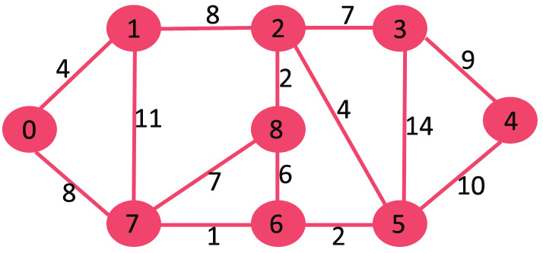

The set sptSet is initially empty and distances assigned to vertices are {0, INF, INF, INF, INF, INF, INF, INF} where INF indicates infinite. Now pick the vertex with minimum distance value. The vertex 0 is picked, include it in sptSet. So sptSet becomes {0}. After including 0 to sptSet, update distance values of its adjacent vertices. Adjacent vertices of 0 are 1 and 7. The distance values of 1 and 7 are updated as 4 and 8. Following subgraph shows vertices and their distance values, only the vertices with finite distance values are shown. The vertices included in SPT are shown in green colour.

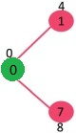
Pick the vertex with minimum distance value and not already included in SPT (not in sptSET). The vertex 1 is picked and added to sptSet. So sptSet now becomes {0, 1}. Update the distance values of adjacent vertices of 1. The distance value of vertex 2 becomes 12.
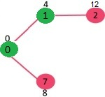
Pick the vertex with minimum distance value and not already included in SPT (not in sptSET). Vertex 7 is picked. So sptSet now becomes {0, 1, 7}. Update the distance values of adjacent vertices of 7. The distance value of vertex 6 and 8 becomes finite (15 and 9 respectively).
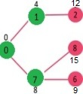
Pick the vertex with minimum distance value and not already included in SPT (not in sptSET). Vertex 6 is picked. So sptSet now becomes {0, 1, 7, 6}. Update the distance values of adjacent vertices of 6. The distance value of vertex 5 and 8 are updated.
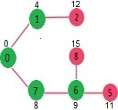
We repeat the above steps until sptSet doesn’t include all vertices of given graph. Finally, we get the following Shortest Path Tree (SPT).
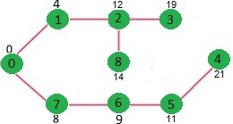
5.7. Topological Sorting
Topological sort: an ordering of the vertices in a directed acyclic graph, such that:
If there is a path from u to v, then v appears after u in the ordering.
Types of graphs:
The graphs should be directed: otherwise for any edge (u,v)
there would be a path from u to v and also from v to u,
and hence they cannot be ordered.
The graphs should be acyclic: otherwise for any two vertices u and v on a cycle
u would precede v and v would precede u.
The ordering may not be unique:
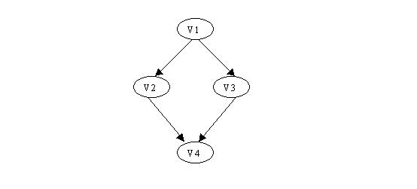
V1, V2, V3, V4 and V1, V3, V2, V4 are legal orderings
Degree of a vertex U: the number of edges (U,V) - outgoing edges
Indegree of a vertex U: the number of edges (V,U) - incoming edges
The algorithm for topological sort uses "indegrees" of vertices.
- Algorithm
  - Compute the indegrees of all vertices
  - Find a vertex U with indegree 0 and print it (store it in the ordering)
If there is no such vertex then there is a cycle and the vertices cannot be ordered. Stop.
  - Remove U and all its edges (U,V) from the graph.
  - Update the indegrees of the remaining vertices.
  - Repeat steps 2 through 4 while there are vertices to be processed.
- Example
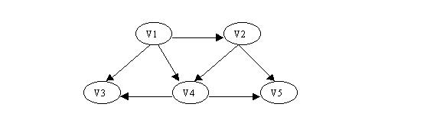
  - Compute the indegrees:
V1: 0
V2: 1
V3: 2
V4: 2
V5: 2
  - Find a vertex with indegree 0: V1
  - Output V1 , remove V1 and update the indegrees:
Sorted: V1
Remove edges: (V1,V2) , (V1, V3) and (V1,V4)
Updated indegrees:
V2: 0
V3: 1
V4: 1
V5: 2
The process is depicted in the following table:
 | Indegree
Sorted à |  | V1 | V1,V2 | V1,V2,V4 | V1,V2,V4,V3 | V1,V2,V4,V3,V5
V1 | 0
V2 | 1 | 0
V3 | 2 | 1 | 1 | 0
V4 | 2 | 1 | 0
V5 | 2 | 2 | 1 | 0 | 0
One possible sorting: V1, V2, V4, V3, V5
Another sorting: V1, V2, V4, V5, V3
Complexity of this algorithm: O(|V|²), |V| - the number of vertices.
To find a vertex of indegree 0 we scan all the vertices - |V| operations.
We do this for all vertices: |V|²
- Improved algorithm
After the initial scanning to find a vertex of degree 0, we need to scan only those vertices whose updated indegrees have become equal to zero.
  - Store all vertices with indegree 0 in a queue
  - get a vertex U and place it in the sorted sequence (array or another queue).
  - For all edges (U,V) update the indegree of V, and put V in the queue if the updated indegree is 0.
  - Perform steps 2 and 3 while the queue is not empty.
- Complexity
The number of operations is O(|E| + |V|), where |V| - number of vertices, |E| - number of edges.
How many operations are needed to compute the indegrees?
Depends on the representation:
Adjacency lists: O(|E|)
Matrix: O(|V|²)
Note that if the graph is complete |E| = O(|V|²)
5.8. Kruskals and Prims Algorithm
Below are the steps for finding MST using Kruskal’s algorithm
1. Sort all the edges in non-decreasing order of their weight.

2. Pick the smallest edge. Check if it forms a cycle with the spanning tree
formed so far. If cycle is not formed, include this edge. Else, discard it.

3. Repeat step#2 until there are (V-1) edges in the spanning tree.
The step#2 uses Union-Find algorithm to detect cycle. So we recommend to read following post as a prerequisite.
Union-Find Algorithm | Set 1 (Detect Cycle in a Graph)
Union-Find Algorithm | Set 2 (Union By Rank and Path Compression)
The algorithm is a Greedy Algorithm. The Greedy Choice is to pick the smallest weight edge that does not cause a cycle in the MST constructed so far. Let us understand it with an example: Consider the below input graph.
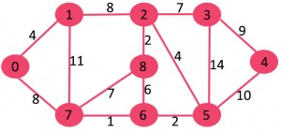
The graph contains 9 vertices and 14 edges. So, the minimum spanning tree formed will be having (9 – 1) = 8 edges.
After sorting:
Weight Src Dest
1 7 6
2 8 2
2 6 5
4 0 1
4 2 5
6 8 6
7 2 3
7 7 8
8 0 7
8 1 2
9 3 4
10 5 4
11 1 7
14 3 5
Now pick all edges one by one from sorted list of edges
1. Pick edge 7-6: No cycle is formed, include it.
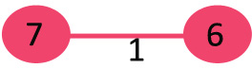

2. Pick edge 8-2: No cycle is formed, include it.
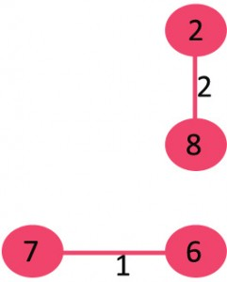

3. Pick edge 6-5: No cycle is formed, include it.
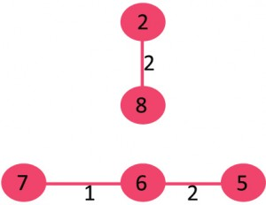

4. Pick edge 0-1: No cycle is formed, include it.
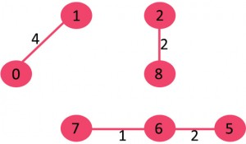

5. Pick edge 2-5: No cycle is formed, include it.
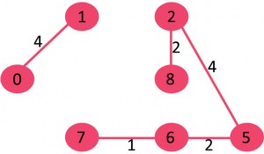

6. Pick edge 8-6: Since including this edge results in cycle, discard it.

7. Pick edge 2-3: No cycle is formed, include it.
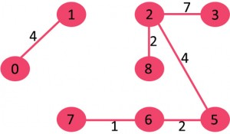

8. Pick edge 7-8: Since including this edge results in cycle, discard it.

9. Pick edge 0-7: No cycle is formed, include it.
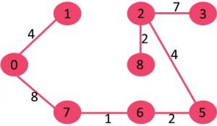

10. Pick edge 1-2: Since including this edge results in cycle, discard it.

11. Pick edge 3-4: No cycle is formed, include it.
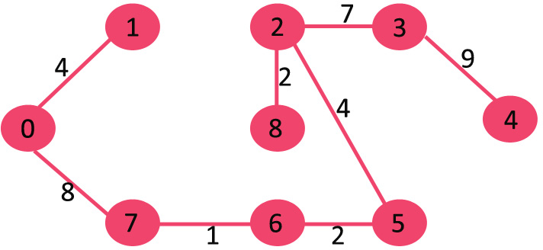
Since the number of edges included equals (V – 1), the algorithm stops here.
Prim’s Algorithm
The idea behind Prim’s algorithm is simple, a spanning tree means all vertices must be connected. So the two disjoint subsets (discussed above) of vertices must be connected to make a Spanning Tree. And they must be connected with the minimum weight edge to make it a Minimum Spanning Tree.

Algorithm
1) Create a set mstSet that keeps track of vertices already included in MST.
2) Assign a key value to all vertices in the input graph. Initialize all key values as INFINITE.
Assign key value as 0 for the first vertex so that it is picked first.
3) While mstSet doesn’t include all vertices
….a) Pick a vertex u which is not there in mstSet and has minimum key value.
….b) Include u to mstSet.
….c) Update key value of all adjacent vertices of u. To update the key values, iterate through all adjacent vertices. For every adjacent vertex v, if weight of edge u-v is less than the previous key value of v, update the key value as weight of u-v

The idea of using key values is to pick the minimum weight edge from cut. The key values are used only for vertices which are not yet included in MST, the key value for these vertices indicate the minimum weight edges connecting them to the set of vertices included in MST.

Let us understand with the following example:
The set mstSet is initially empty and keys assigned to vertices are {0, INF, INF, INF, INF, INF, INF, INF} where INF indicates infinite. Now pick the vertex with minimum key value. The vertex 0 is picked, include it in mstSet. SomstSet becomes {0}. After including to mstSet, update key values of adjacent vertices. Adjacent vertices of 0 are 1 and 7. The key values of 1 and 7 are updated as 4 and 8. Following subgraph shows vertices and their key values, only the vertices with finite key values are shown. The vertices included in MST are shown in green color.
Pick the vertex with minimum key value and not already included in MST (not in mstSET). The vertex 1 is picked and added to mstSet. So mstSet now becomes {0, 1}. Update the key values of adjacent vertices of 1. The key value of vertex 2 becomes 8.
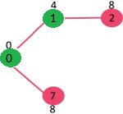
Pick the vertex with minimum key value and not already included in MST (not in mstSET). We can either pick vertex 7 or vertex 2, let vertex 7 is picked. So mstSet now becomes {0, 1, 7}. Update the key values of adjacent vertices of 7. The key value of vertex 6 and 8 becomes finite (7 and 1 respectively).
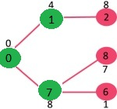
Pick the vertex with minimum key value and not already included in MST (not in mstSET). Vertex 6 is picked. So mstSet now becomes {0, 1, 7, 6}. Update the key values of adjacent vertices of 6. The key value of vertex 5 and 8 are updated.
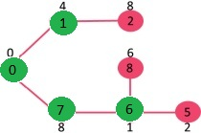
We repeat the above steps until mstSet includes all vertices of given graph. Finally, we get the following graph.
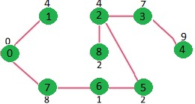

5.9. Euler’s and Hamiltonian Circuits
Certain graph problems deal with finding a path between two vertices such that each edge is traversed exactly once, or finding a path between two vertices while visiting each vertex exactly once. These paths are better known as Euler path and Hamiltonian path.
The Euler path problem was first proposed in the 1700’s.

Euler paths and circuits :
- An Euler path is a path that uses every edge of a graph exactly once.
- An Euler circuit is a circuit that uses every edge of a graph exactly once.
- An Euler path starts and ends at different vertices.
- An Euler circuit starts and ends at the same vertex.

The Konigsberg bridge problem’s graphical representation :
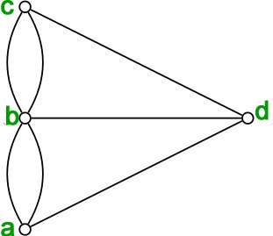
There are simple criteria for determining whether a multigraph has a Euler path or a Euler circuit. For any multigraph to have a Euler circuit, all the degrees of the vertices must be even.
Theorem – “A connected multigraph (and simple graph) with at least two vertices has a Euler circuit if and only if each of its vertices has an even degree.”
Proof of the above statement is that every time a circuit passes through a vertex, it adds twice to its degree. Since it is a circuit, it starts and ends at the same vertex, which makes it contribute one degree when the circuit starts and one when it ends. In this way, every vertex has an even degree.
Since the Koningsberg graph has vertices having odd degrees, a Euler circuit does not exist in the graph.

Theorem – “A connected multigraph (and simple graph) has an Euler path but not an Euler circuit if and only if it has exactly two vertices of odd degree.”
The proof is an extension of the proof given above. Since a path may start and end at different vertices, the vertices where the path starts and ends are allowed to have odd degrees.
- Example – Which graphs shown below have an Euler path or Euler circuit?
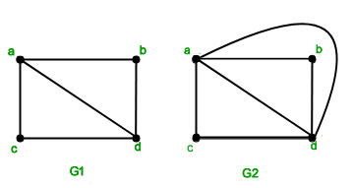
- Solution – G1 has two vertices of odd degree and the rest of them have even degree. So this graph has an Euler path but not an Euler circuit. The path starts and ends at the vertices of odd degree. The path is
has four vertices all of even degree, so G2 has a Euler circuit.

Hamiltonian paths and circuits:
Hamiltonian Path – A simple path in a graph that passes through every vertex exactly once is called a Hamiltonian path.
Hamiltonian Circuit – A simple circuit in a graph that passes through every vertex exactly once is called a Hamiltonian circuit.
A
B

C

Unlike Euler paths and circuits, there is no simple necessary and sufficient criteria to determine if there are any Hamiltonian paths or circuits in a graph. But there are certain criteria which rule out the existence of a Hamiltonian circuit in a graph, such as- if there is a vertex of degree one in a graph then it is impossible for it to have a Hamiltonian circuit.
There are certain theorems which give sufficient but not necessary conditions for the existence of Hamiltonian graphs.
Dirac’s Theorem- “If is a simple graph with vertices with such that the degree of every vertex in is at least one, then has a Hamiltonian circuit.”
Ore’s Theorem- “If is a simple graph with vertices with such that for every pair of non-adjacent vertices and in, then it has a Hamiltonian circuit.”
As mentioned above that the above theorems are sufficient but not necessary conditions for the existence of a Hamiltonian circuit in a graph, there are certain graphs which have a Hamiltonian circuit but do not follow the conditions in the above-mentioned theorem. For example, the cycle has a Hamiltonian circuit but does not follow the theorems.
There are many practical problems which can be solved by finding the optimal Hamiltonian circuit. One such problem is the Travelling Salesman Problem which asks for the shortest route through a set of cities.
- Example 1- Does the following graph have a Hamiltonian Circuit?
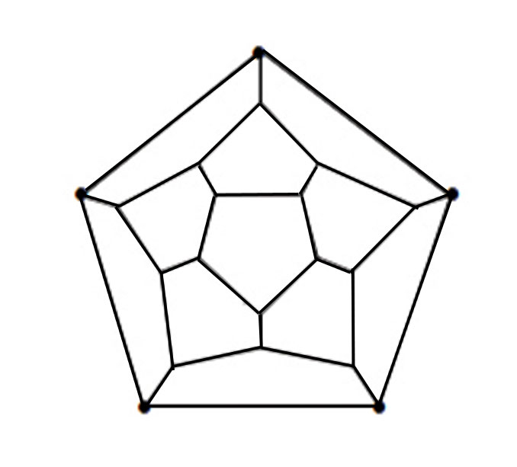
- Solution- Yes, the above graph has a Hamiltonian circuit. The solution is –
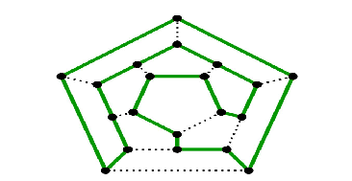
- Example 2- Does the following graph have a Hamiltonian Circuit?
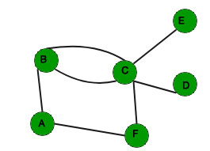
Solution- No the above graph does not have a Hamiltonian circuit as there are two vertices with degree one in the graph.

